Identity Specialist
A Short Story
By Maryanne Peters

My name is Courtney. I won’t give my second name. I work in a sensitive area. Plenty would like access to the information that I have. If I were to give it up people would die. Justice may not be done. I do important work. I turn men into women.

I am a specialist retained by the US Marshall Service to make people disappear. It is not as simple as a new name – not anymore. Images are all over the place. Facial recognition software is commonplace and can be accessed by criminals. A little plastic surgery may work, but what is really needed is that if the technology throws up a maybe, the response should be: “No – that can’t be him.” You get that if the technology throws up a her.

So, it is becoming more common than you might think. It is no longer the fantasy dream of some pervert - deep disguise in another gender is possible and effective. But I am not saying it is easy.

In talking about Tiffany and Cindy I am talking about an extreme example. The main reason is that they were much younger than most and sexually active with it. They worked together at a restaurant in a location I will not disclose, and while taking trash out into the alley late one night they witnessed a murder. The murder was by a major mob leader who should have known better than to do his own dirty work, but the fact is that a murder would put him away. The boys’ evidence was crucial. I was assigned to hide them.

Then one of them received an email from “A Friend”. It simply said “Shhhh” and had a gruesome picture of two dead guys. It looked real to me. It certainly was to them.

The DA told them that these criminals would never believe that these guys could remain silent. Why would they take that chance? The only guarantee of their silence was to kill them. It is just that simple.

I explained what I did and initially they were just disbelieving, and then scornful. But as I explained, The options were simple but stark – become girls or die.

I explained that nothing was permanent – unless they wanted it to be. But I was not talking about a disguise they could just pull off, like a fake beard or a prosthetic nose. It would last and breast implants would need to be removed, hair follicles in the face would need to come back, hormones would need to be flushed out.

I remember that Dylan and Vince (as they used to be) howled together that there was no way they would accept that particular disguise. I did say that they could be made African American, but that did not mean their dicks would be any bigger, and that people who went down that route were rarely happy.

They looked at one another, and agreed to follow my calls. Like I said - – become girls or die. No choice really.

I have a small group that work for me. Beauty commandos if you like. I recommend real hair extensions, chemical skin peeling on the face, full body waxing and female hormones with male hormone blockers. Changing the body chemistry may sound drastic but it also helps with the new learned behaviors, which are just as important as outward appearance.

Sometimes a little surgery is called for – a heavy brow, a big broken nose or a lantern jaw don’t make it easy to pass as a woman, when that it the extreme disguise choice.

Of course, a computer model of the prior face is maintained so that restorative facial reconstruction can take place if requested at some future time. But it is amazing that it is not often called for. People move on after an experience like this. They leave the old person behind. They go a new identity with a new face. I suppose it makes sense.

These guys needed very little work. Their bodies responded well and they quickly lost male muscles. The skins softened and the hair on their heads came on quickly just as all other hair growth subsided. They turned out to appear and very attractive young ladies, even without makeup at aal.

But that is just the physical side of things. After that my team really steps up, and this is where I do my work too. How to pass as women. I was not always one myself, so I should know. There is no trace of a man in me, but I would say I had the advantage of always being female inside. These young guys needed to unlearn boy, before they started to learn girl.

There are times when you just shake your head, but they have to learn and if they can’t get the voice right then there is a surgical option, which is hard to undo.

Once they were both squeaking at one another, it seemed as if they were ready to put manhood behind them, for as long as was necessary.

It did mean that when they gave evidence from behind a screen we needed voice modulation. Yes, they were well down the track when they gave their evidence. Organized crime always delays trials for as long as possible to get to the witnesses, so it was over a year before Tiffany and Cindy were led into Court as staff of the DA’s office to appear in closed court.

By that time they had grown into their roles in more ways than one. After the conviction was handed down I explained that the risk was reduced, but they were still as risk of a “revenge killing”. My recommendation? Stay in this disguise a while longer if you can.

“Can you do something about … below the belt?” Tiffany said. “I cannot wear a bikini”.

“And if guys want to go to second base … well, we don’t have a second base to go to.” said Cindy.

It turned out that this pair were so horny that they had discovered that the best way to satisfy their urges was to flip over. Does having men make them gay, or are they now really just heterosexual women? I am guessing that I know what they think they are.

But what is pleasing for me is to see that their change was a positive one in other ways. As young men I considered them shallow and diffident. They seem to have acquired purpose as women. They are taking pride in their appearance and feeling better about themselves.

Perhaps it mirrors my own experience. I actually started out as a witness too. I cannot give any more details than that, as there are people out there who would still want to see me dead. But when I was offered a new identity I asked whether it could be a female one. It was what I really wanted.

So why not for them too? The state looks after witnesses, so I managed to get approval for the full surgery for Tiffany and Cindy. Now they look great in bikinis as you can see, and the have all the attention that they could ever want from guys just like what they used to be. Strange, huh?  I thought that it was just that they were so young that they could not bear to be out of sexual circulation, and they were prepared to change to adapt. But since their case I have been offering sex reassignment to all of my clients in disguise. The truth is that even my older “clients” are choosing to stay female and similarly to change orientation.  As I said, for me it was always confirmation, but for many who went there to hide, it has been a discovery.  Tiffany and Cindy have now joined my team. | 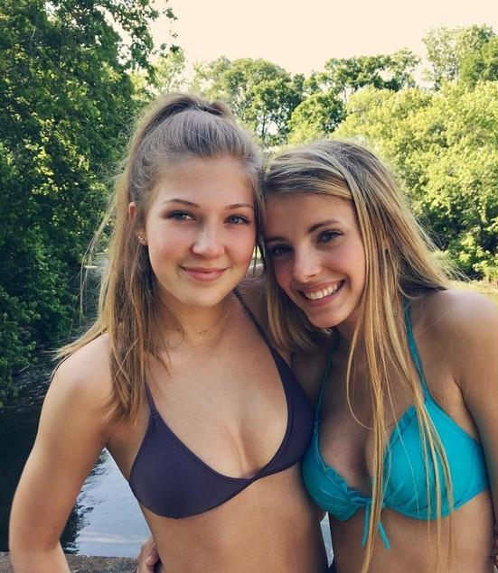

We do important work. We turn men into women. We protect witnesses and do our best to see justice done and criminals locked up where they belong. That’s what I call job satisfaction.

The End

© Maryanne Peters 2020

From the very short piece “Protection Specialist” inspired by a captioned Image from Courtney. I had three reviews calling for much more that the original 260 words!

