Josh’s Girlfriend
Story for John Number 66
By Maryanne Peters

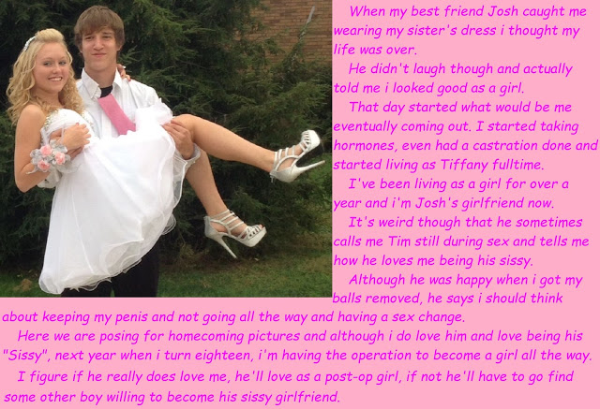

Make no mistake about it – she is a girl. She was my girlfriend. I knew it from the moment I saw Tim wearing that dress. The look of horror on his face was priceless. I had just bounded up to Tim’s room to surprise my friend, and there she was. I just said that this was how she should be.

She was worried that we would not be friends anymore, but I just said: “We will be different kinds of friends – even closer.” The truth is that I could not wait to get inside her, but I needed to take it slow.

He said that he felt that he might be transgender, but he was not sure. But what he did know was that he didn’t want to grow whiskers, he wanted to grow out his blonde hair. I said that if that was what he wanted he needed to act quickly to head off puberty, as I was already well through that. He went to the shrink and got the blockers, and then when he had the liver problem, they said that if he wanted to carry on, they would have to whip his nuts off. That was what he wanted.

That means that his little dick is always small and floppy. That does not worry me too much. I used to tug on it sometimes just for fun. She could still get some ooze out of the tip when I got her squealing. Sissy girls can’t fake orgasms if they do that. If they get hard or squirt some, you know that they are loving it. That matters to me.

The hormones turned him into the prettiest thing, which a smooth, soft body and a great pair of little tits. With that naturally blonde hair past her shoulders there was no hiding the girl, so “Tiffany” was a fulltime girl and my fulltime girlfriend.

I like the name Tiffany, but Okay, every now and again I call her Tim. I guess I just forget.

I just wanted her to stay the way she was. She was my special girl. Like a girlfriend any man would be glad to have on his arm or across the dinner table, but in bed and screaming, oozing exotic sexual thing, with everything a girl should have and more.

But she kept on about the vagina thing.

I tried to be a good boyfriend – I tried to be supportive. It was just that she was special – not like any other girl. And it was the fact that she had been Tim, and still was in some ways. And I have always wanted him … I mean, her.

Then she booked the surgery and before I knew it, her little love lever was gone. There was just a bloody hole instead. She told me that I just needed to be patient – it would take time and then we could make love as man and woman, and perhaps husband and wife.

But I suppose it took me that wait to realize that is not what I wanted. She said that for now her ass still belonged to me and that nothing had changed, but that is not true. It had changed. She was just like the rest. As they say: All woman are the same hung upside down.

Of course I am sad that we drifted apart. We were friends, you see, me and Tim … I mean Tiffany. She was my girlfriend.

The End

My Dream Life
Inspired by a cap by Becky (“The Housewife”) commissioned by John Number 67
By Maryanne Peters

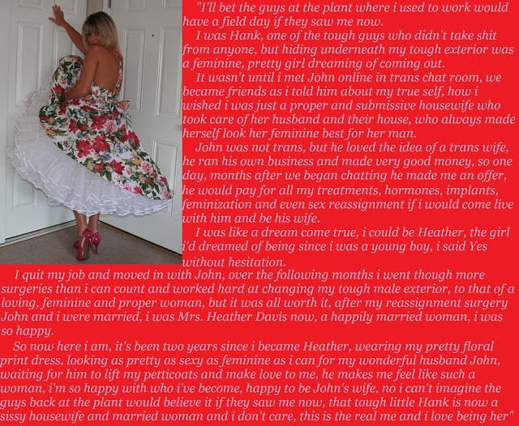

I had always thought of myself as being about as heterosexual as you can get. I mean I have always loved women and making love to women, and I could never imagine ever having sex with a man, but my eye was caught by an image of a beautiful transwoman and it just got me thinking. It was on a video I think, and she was saying about how much she wanted to be completely female and that meant being more of a woman than somebody born that way. Like a hyper-woman, I guess.

So I went on line and spent a lot of time viewing images of post op transwomen. It seemed to me that some of the most beautiful were women who had been regular looking guys before transition, but through hormone treatment and surgery had acquired the look and body shape of the perfect woman.

And it seemed that the most feminine were those had been manly men and had become girly girls. Some had kept some strong bodies, but that appealed to me. I like women like that. Somebody who is strong enough to push back as you fuck them. That is the kind of woman that you like to have under, or on top writhing like a cowgirl on my bronco.

So I swallowed hard and went on a chatroom. The guy’s name was Hank. He worked at a precision tool plant. He had beers with the boys two or three times a week – more in football season. But all that he wanted was to be a woman, and hopefully a wife. He could just never share these thoughts with anybody, except me. She wanted me to call her Heather and always refer to her as she.

When you communicate with somebody like this, you know that you are talking to a woman by email or chat – you just know. I wanted to speak by phone but Heather said that she had a man’s voice. I offered to help. I did want to hear her, but not a man.

She started with training through an online coach I paid for. That could mean that she could develop a female voice but still go to work and be Hank. But once we got talking I just wanted more and more. To me that voice on the phone was a woman trying to climb out of a body that was like a cruel trick on her – the hard hairy skin of a man that did not belong on her.

I have my own business and it is successful. I have money, so I offered to pay so that she could be free of this awful thing. I thought that it might be hard and I was going to suggest that it be done slowly, but she just said: “Hell no, I will quit the plant and fly to Thailand and get everything done.”

I just had to pay. She put me in touch with the clinic so that I could pay them direct, which is what I did.

“I will owe you,” she said. “More that you could ever imagine.”

“Then maybe you will consider marrying me,” I said.

I have to say it that when she arrived at the door I almost regretted that I had said that. I suppose that you could say that it was Hank at the door. He had shaved his body and was wearing a dress and a wig, but this was clearly a man. Still, the clinic had all the information that they needed and the assured me that Heather was just waiting under the skin like a butterfly in a chrysalis.

Her actions were clumsy and embarrassing too, but only as she found her feet. That would happen, but she was basically doing the change cold turkey. She was committed, and I was supportive.

After the final surgery we were married but in a private ceremony. I got what I wanted – a transbride. But I guess it was not until I snapped that photo of her in the floral dress and the petticoats that I knew for sure that it was all worth it.

She is beautiful – nobody could believe that she was not always a woman. Her body is fantastic – I mean it is a fantasy body with all the curves that I wanted and that I commissioned the surgeons to build for me. And her vagina is made to measure too. Sex is great. Transwomen know all about the male anatomy. They know what works, and what sends you into orbit. Heather does that – all the time. Her thighs are stronger than a regular woman.

She behaves like a woman. Some people might call it the behavior that men expect of a woman, but what the hell is wrong with that? Give me more of that.

She loves to serve me. People might say real women are not like that either. But she is exactly what I want. She has three priorities in life: Me, me and me. What is wrong with that? She keeps my house clean, my belly full and my balls empty.

And what she says is that hers is her dream life. Well Baby, it is my dream too.

The End

Pom Poms
Inspired by a cap by Becky written for John Number 68
By Maryanne Peters

Okay, so they are a bit on the big side. I just wanted a pair of look-at-me boobies. What’s wrong with that? When you walk around as a guy for 16 years then when you put that behind you want to go right to the other end. You want to be as girly as you can be.

I could not wait for my hair to grow. I had to get extension. Nice long extension so I can add curls or waves. It takes more to look after long hair and it blows in you face and into you mouth, but these are problems a boy never has, so I wanted to have them.

I cot wait for the muscles to go too. I starved myself when I went on hormones. That just means that you body robs from the muscle to redistribute the fat. The guys said I was scrawny, but that is what I want to be. Muscles are for guys. I wanted to get into a size 6.

No chance of that now, with the breasts. But I just love them. The guys can’t take their eyes off them. And nothing says: “I guess Adam means it – he really is Ashley” better than a pair of tits like these. No more running for me. There is not a sports bra made that will stop these puppies from bouncing around all over the place.

And I am a little front heavy. Maybe I will need some implants in my butt to balance me out? I like wearing heels because they make my legs look so good, but way up there on my now skinny legs and with two melons on a rack out front, it is positively scary.

Oh well, this what being a woman is like, which is exactly what I want.

As for all the guys who want me back on the field as a cheerleader, they may have to think again. I have a got a built in pair of pom poms and I cannot throw those around on the pitch. Sorry guys. Maybe the bedroom.

The End

The Perfect Dress
Inspired by a cap by Becky written for John Number 69
By Maryanne Peters

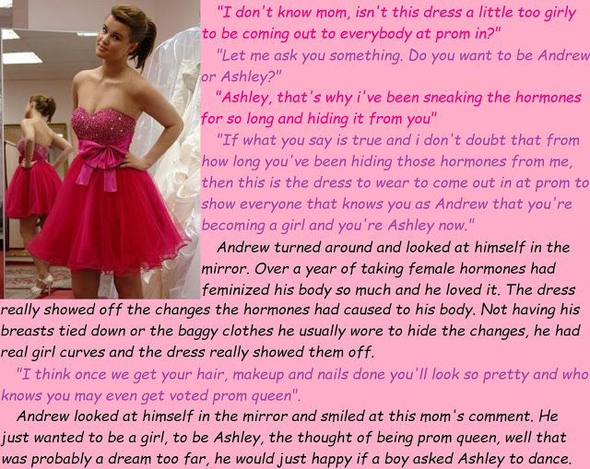

The strange thing is that I was not the only transgirl at our school. Katie was a couple of years ahead of me and announced that she was transgender before she had taken any steps. The day after she came out she turned up to school in slacks and a shirt with a pattern on. She just stepped out of her male shell an inch at a time, with every advance drawing stares and generating comments.

I was transgender just like she was, but I just decided that I wanted to turn up at school as a girl. But to do that you need get started with your transition but keep your changes secret. You need to hide the growing woman until you are ready for the big reveal.

Through on line gaming I had the connections and the money to buy the blockers and the hormones. It was surprisingly easy. I had told my mother that I was trans and I wanted to transition much earlier on, but she was not in favor of the drugs. She talked about me being too hasty. I needed to get in before male puberty wrecked my body.

I started taking the drugs and things started to happen. It was easy to hide the physical changes at school by binding the growing breast tissue, but when I got home, I wanted to massage them back into shape and nestle them into the training bra I slept in. It was getting too hard to hide things from Mom in the long term.

Growing my hair out was easier. I just kept in it a long greasy tail down my back. But I needed to wash it and keep it in condition, but it was getting thicker. What I really wanted was to at least wear it out at home.

So I decided to tell Mom what I had been doing. She went apeshit. She went on and on about how irresponsible it was to start on this course with medical supervision and counselling.

I just said: “Well its happening now, so are you going to help me be the girl I want to be, or not?”

She hugged me. Mothers can never hold their anger for any length of time. Within a few days I was sitting at home in a dress with Mom putting curlers in my hair.

But I was still Andrew at school. I wanted to be Ashley, and now Mom was on board we cold pick the time for her to step out.

We decided that it should be the prom. What better time could there be? I would be at my feminine best on that night. I would be able to show what I had and make it clear that transition was already done and dusted. I would not be like Katie going to school as some in-between creature for over a year. I would be Ashley, accept me or get out of my face!

Mom said that we needed to speak with the principal of the school. We needed to give notice but ask that the information be kept until just before the prom, when I would take the day off to get ready to present Ashley to the world.

I said to Mom that I still needed her guidance on the choice of dress, but I have to say that when she showed me the red flouncy one with the low sequined bodice, I was a bit uncertain. It was girly alright, but was it too girly? And those shoes?

But Mom was adamant. “You have breasts, so show them. You have legs, so show them. The flounces will hide anything in front that is out of place in a young lady, and the color says sexy and proud to be it!” I guess she had a point.

I had my hair put up and my makeup done by the salon. I practiced walking on those shoes all the afternoon of the prom, and Mom even led me on a few dance moves to get used to them. I was just not sure if anybody would ask a transgirl to dance.

When I turned up at the prom some people were milling around outside. I decided to keep my eyes front and walk up. I could feel lustful eyes on me, which felt great. But nobody called out to me. Once they had an eyeful of me, I could see that they were all looking behind me.

I went up to Mark, who is a guy I knew who I guessed would be kind to me. I said: “What is everybody looking for?”

He said: “I haven’t seen you before. You must be somebody’s partner arrived early. But what we are all waiting for is to see this guy Andrew who is going to be turning up to prom dressed as a girl. He is trans you know. We all want to get a look. He wants to be called Ashley from now on.”

“I’m Ashley,” I said. I was about as proud as I could be.

Good choice, Mom.

The End

Fate and Future
Inspired by a cap by Becky for John Number 70
By Maryanne Peters

Don’t think for a minute that the Gillian Freear Academy is one of those special feminization academies that you may have heard about. I doubt whether such places even exist. No, the GFA is a girl’s only school with openings for transgirls.

I have to say that I never believed that I was trans when I was sent here. I always considered myself as just one of those rebellious teenagers who gets some special pleasure from annoying his parents. The long hair, eyeliner and nail polish was just my way of saying – “I’m different, so just get over it!”

My mother said that if you want to be somebody other than a man, then be a woman, and she told me that I was being sent to the GFA. I could have refused. I could have rebelled against that too, but I have to say that I was curious. I thought – ‘why not check this place out? If it sucks I am out of there, but here is a place doing things differently.’

It certainly helped that they teamed me up with Tim on Day One. Although I thought of us as very different, we got on really well. Different because Tim – now Tiffany – really was trans. But Tiff was a bit of a rebel too.

I knew that Tiff was on hormones, but what I did not realize that I was on them too. We all were – all the girls classified as trans.

I suppose that it makes sense. This is a girls only school. What parent of a real girl is going to send their daughter to a school for girls with guys in skirts roaming around. Whatever they were putting in our morning beverages certainly killed off any boyish urges, and it may well have replaced them with a whole new set of urges. Whether it was chemistry or just the exuberance of my new friend Tiffany, I just found myself become more girlish every day.

I had the opportunity to quit when I went home for the holidays but the truth is that I could not wait to get back to school and all the other girls. I just figured that I must have been wrong – maybe the source of my bad behavior was that I was trans and I had been fighting it.

When I carried home the consent forms for the castration my parents asked me if that is what I really wanted to do. To be honest I was up in my room straightening my hair at the time so not really paying much attention, but I just said – “Sure. I don’t want whiskers. I want to keep my hair and grow it right down to my butt.”

Because Tiffany and I had discovered boys. Boys like girls with long pretty hair, and they don’t like girls with nuts and hairy ball sacks.

And in the senior year, if you are of age, sex change surgery is included. Now that is what I call graduation! You go in as … whatever I was, and you come out … well, as the new me!

Looking back I was just stumbling through life with no objective in mind. Now understand my future. I am going to be a woman. I am going to be beautiful and win the heart of a man who will keep me happy for the rest of my life.

Who was Steve anyway? Some loser. Look at me!

The End

© Maryanne Peters 2022

