Cheering for Brittany
Inspired by a Captioned Image
By Maryanne Peters

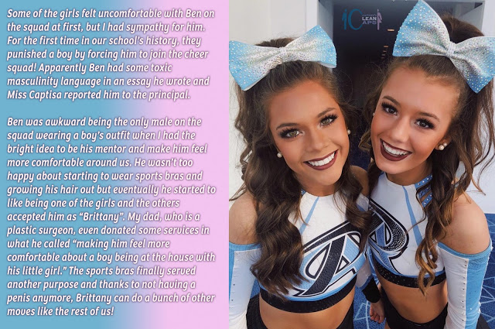

I now understand myself. I found myself completely by accident. I hid the real me for years.

Maybe that essay was a call for help? It was full of the most hateful things. I deserved punishment. At the time I thought that three months on the cheer squad was just the worst thing that could happen. I really thought that it was, before I understood. It was an attack on my masculinity, but as it turns out, that masculinity as wafer thin.

I could have done my time as the only guy on the squad by being the only guy on the squad, but cheering is a team thing. Somehow when I put on the skirt and the wig it just made more sense. I was already in the squad, so would be getting a hard time from the guys, but dressed like the rest people would say: “Wait a minute, which one of those cheerleaders is Ben?”

I was good. I had the right shape, with good legs. The only problems I had were the hair, and the crotch. Fortunately, Katie had both of those things covered.

A wig does not work for very active cheers. Plenty have tried it. I had enough hair to anchor good quality extensions. Katie’s family are super rich, so she paid. Bingo, I had long beautiful hair. When you have hair like that, it is hard to be Ben. Even in jeans and a T-shirt, with that long hair down my back, or tied up in a high ponytail, I did not look like a Ben.

I had to look after it. Extensions need care. Washing and brushing. Keep my hair clean and shiny. Check it in the mirror as I walk past. Guys look at you differently when you have girl’s hair.

When you are cheering you need to work on your face too. A guy does not wear makeup, but a cheerleader does. You can take it off afterwards, but not the shaped eyebrows and the tinted eyelashes. They are still there in the morning, along with the hair. You have to forgive a little lipstick, even during class. The look just seems right.

Katie’s family has money because her father is a very successful plastic surgeon. He is very protective of Katie and did not like the idea of a boy on cheer squad, much less a boy turning up at his place for a cheer squad sleepover. When Katie said that I had a problem with some of the high kicks and stretches, she said that he could fix it for me.
The problem is that the moves mean exposing your crotch. I don’t have to explain the problem – I can show you the problem. How can you do this with your nuts popping out of your shorts – right?

So, Katie’s Dad said that he could do a procedure to just tuck away all of my junk and give me the confidence to do the high kicks. Nothing permanent, but surgical. I would be effectively without a dick for as long as I was on the cheer squad. I think that suited him too. He felt happier that the only boy on the squad would be dickless for the season.

My parents had enough of a problem with the hair and the eyebrows, but they were very unhappy about somebody playing around with their little boy’s dick. But I was all for it. I said that it would be more embarrassing to have my bits pop out in the middle of a performance in front of the entire town. My Dad could see that. Better to have his son invisible as one of the girls than that.

So I went into Katie’s Dad’s Clinic and I had the job done on me. After that it was sitting down to pee and wiping with a tissue, and wearing skimpy little panties instead of boxer shorts, for as long as I am on the cheer squad.

But as I said, I found myself. Katie’s dad showed me who I really was.

He told me that he had given me some shots and some slow release chemicals had been planted into the site of the surgery. He said that it was essential to keep my stitched back dick from stiffening, as that would be very painful for me. The side effect of the drugs would be “female secondary sex characteristics”. They did not appear straight away. Not for a couple of weeks anyway. When they did, I guess that I should have been shocked, maybe even revolted but what I saw, but I just loved it. I loved the little tits and the rosy nipples. They just seemed so perfect.

Now when I stand in front of the mirror, I see the person that I was meant to be. That is me on the left, with Katie on the right, my BFF.

Naked I have breasts and a lovely smooth crotch, but Katie’s dad has told me that he can give me a pussy too. Katies is very keen for me to get one, so that we can prowl for guys together. The thought of it sounds exciting.

But anyway, my three months is up tomorrow, and I have to tell my parents that I have no intention of leaving the team – not just the cheer team but the girl team as well.

In the meantime, the other members of the cheer squad have put together a special cheer for me:

“Go Brittany Go. Lose the balls and join the gals. Go Brittany go.”

The End

Fundraising  Inspired by a Captioned Image  By Maryanne Peters  “Dave, the key to winning is not just to look like a woman but be like a woman”. That is what she said. I got the new skateboard for entering, but if we won I was going to get the skateboard and cash as well. And I was in desperate need of funds.  “That means you need to live as a woman in order to win this thing,” she said. | 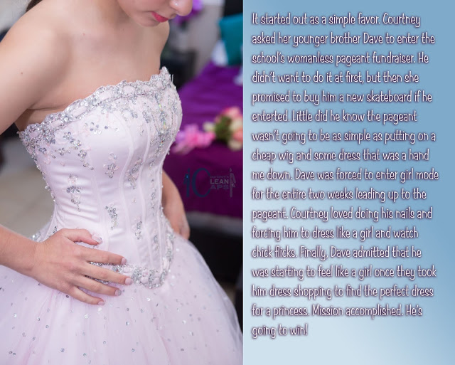

She told him that everyone would be doing it, but he was not sure who else was in it. They were all in his sister’s year. He would be the youngest competitor.

His sister did all that she could to bring out his feminine side, by involving him in girly things with her friends, but it all went over Dave’s head. He was just thinking about the skateboard and the cash.

But it was trying on the dress outfit with the corset that changed everything. When It tightened around his midriff and pushed up, the inserts in the bra cups seemed to become his wobbling flesh, and the smooth belly and wide hips came into view with his hand resting on them, Dave felt that his body had been transformed.

An with that his young face looked girlish, even without makeup, and his mop of hair looked like a pixie cut even before it was styled. And he needed to see the real him.

“Please can you do my hair, Sis,” he said. “Do my hair and makeup. I want to look pretty.”

And he did. And he won. And Dave will never be a boy again.

The Distaff Side
Inspired by a Captioned Image by Courtney
By Maryanne Peters

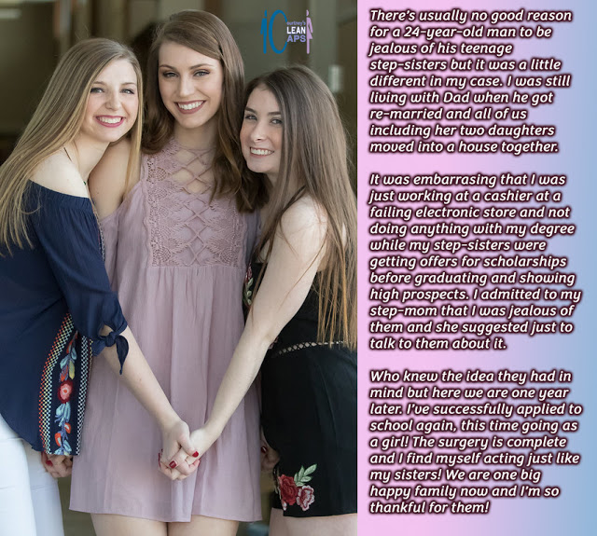

Wow, wow, wow! I feel like I have been reborn. I was a slug, living under a rock, and now look at me. How could I have been so stupid for so long? How could I not have seen who lives the bright life – the right life? Not men, that is for sure.

My father had expectations of me, but he was always going to be disappointed. I am not that kind of person you see. I don’t respond well to pressure. Not that it matters. I have an older brother, you see. He is everything my father wants and making his own way in the world.

I am still living at home, and I was working just to get me out of the house. But that was before, when I was a slug.

Sarah and Juliet changed everything for me. My new stepsisters, and their mother Erica, gave me a new outlook on life. The three of them were women, you see, and I wasn’t. Not then, anyway.

You could well say that living with women should not make you want to be one, but it was not like that. They just showed me that half of the world can have a different outlook on life. It is not about working for a living, it can be just about living.

It was like my stepmother Erica said: “My girls don’t have to work hard if they look good and they know how to use those looks.” She did not say that she had used the same strategy to win my father as a husband and live in luxury in the Hamptons, but you can work that out.

What about the scholarships? A it turns out, adequate academic grades and high personality scores. Silky hair and straight white teeth are more important, it seems.

“You should try it,” she said. “Not every guy could get away with it, but you could. Come on over to the distaff side.” I didn’t even know what that meant. Do you?

And to help me on my journey I had three of the most beautiful hum beings on the planet. Women of course, like I am now.

Erica was right. Maybe my shoulders are a little broad and my hands and feet a fraction over average, but with the assistance of hormones and skin and hair treatments, I became a gorgeous girl. Just as good looking as my stepsisters – maybe even a little better looking. What do you think?

My father threw up his hands. Of course, he objected, but the first thing that a new girl learns is that a man must keep his woman happy, and if there are four woman in his life, he needs to keep all four of them happy, number four being me.

He seemed happy enough to hear that I was going back to finish college. But when I sidled up to him in my pretty short dress and said: “Daddy, I would like to ask if you could pay for something I need desperately, please Daddy please.” It was like he had become used to those words and that girlish plea from the other three, so coming from his feminized son seemed little different.

“What do you want, Bobbie?” he said.

“I want you to pay for some surgery, Daddy,” I said. “I want breast implant and a vagina in place of all the yucky bits.”

He said no and I burst into tears and ran away, but of course, it was four to one, so in the end he caved.

And of course, when you are strutting around campus with a flush groin and a stent shoved deep inside you, you feel just right, and you know that that you have definitely crossed over.

The End

Cousins
Inspired by a Captioned Image by Courtney
By Maryanne Peters

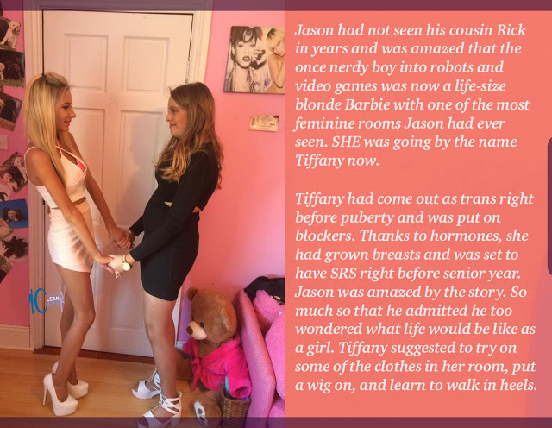

I was close to my cousin, and you don’t just cease to be friends because he gets his balls removed.

We just couldn’t do the same things anymore. We used to do boy stuff together. Like real boy stuff out in the woods and down at the river. Like climbing trees and building rock dams, fishing and shooting stuff with sling shots and BB guns.

It was when he started talking about not wanting to be a girl that we staying spending more time inside with electronic stuff and computer games, while Rick became Tiffany and grew out her hair and her breasts. We still shared a room as we always had done when I stayed with my uncle and aunt, but that room was different.

I suppose got into other stuff while she was into hers, and she lives miles away, so we just did not catch up. But when my folks went off to Europe, I was sent around to stay with my uncle and aunt, and my cousin, now Tiffany.

I got a real shock when I saw her. In the past couple of years her hair had grown down over her shoulders and was now blonde, and her breasts seemed to spill out of any top she wore. Her legs were as long as the Nile, and even longer if she was wearing heels as she liked to do. She was not just a girl, she was a very girly girl.

“This is going to be great,” she said. “We can catch up on everything that has been going on in your life and I can tell you all about my transition.”

Her room was pink, and full of boy band posters and soft toys, and a dressing table piled with beauty things. She had so many clothes that her closet was bursting, and she had boxes underneath her bed full of stuff.

“I am transitioning online and I have become an influencer,” she explained. “People send me things that I have to discuss on screen. I am drowning in girly things. Isn’t it wonderful!”

I had to agree, just because she was fizzing. She was going on about how happy her life was. She had met so many people on line and they all had stories to tell: Some sad but generally happy. She was having her own issues here and there, but she was meeting them with a positive attitude. The attitude sparkled and filled the room.

When my turn to talk came around, I found that I had nothing to say. I spent a lot of time gaming. I had achieved some high levels. I had … not done much. I suddenly realized the contrast. It was depressing. I never even went outside much. Even if I wanted too, I could not imagine Tiffany throwing ball or climbing a tree. I had nothing to say, so suddenly the room was in an awkward silence.

“Why don’t you try some of my stuff on?” she chirped.

Had I wondered what life would be like as a girl? Not until that day, I had not. But she just seemed so happy, and I was not. What would it be like?

Now look at me: The wig, the makeup, the black dress and the white heels, now very lately skilled in walking in them. It was time to go outside.

“Let’s go to the mall and strut,” said Tiffany. “We’ll pick a couple of boys.”

As I looked at myself in one of the many mirrors in her room, for some reason it sounded like a really good idea to me.

The End

Just Jealous
Inspired by a Captioned Image by Courtney
By Maryanne Peters

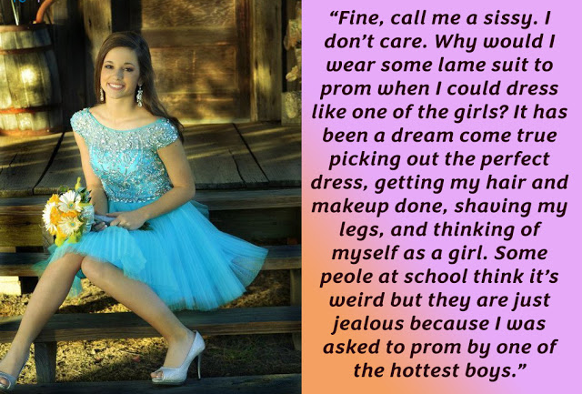

Yeah, I called him a sissy. I knew the guy when he was Pete. I knew him before he started calling himself Petra. We were friends then.

I called him a sissy because that is what he is. I mean, dressing like a girl, speaking in a squeaky voice, flicking his long hair around, and wiggling his butt. It makes me sick. To think that I guy I once messed around with would act like that.

Hayden knows what she is. I should say he, not she, but it is hard to get my head right when I think of her … him. Hayden knows that the girl in the blue dress he is taking to the prom is not a girl. Hanging under those skirts somewhere, is a schlong and a pair of nuts. How do you feel about that, Hayden Hotshot? As if I would dare to ask him.

What is going to happen after the prom? Sure he is going to be slow dancing with her, in a clinch, with his face nuzzling that beautiful hair, and drinking in her perfume. He is going to have one had on that bouncy butt, and the other hand stroking her tender wrist, and he is going to feel those freshly sprouted titties pushing up against his chest. And maybe he will stick his tongue in her mouth, our maybe she will use hers to lick his tonsils.

But what happens afterwards Hayden, you jerkoff? What happens when you get her into your car and run your hands up those lovely smooth legs, right up to … her hairy balls, you dickhead! But you know they are there. Maybe they are not hairy and dangling. Maybe with all the plucking and all the hormones they are just like two little lumps in a soft labia without an opening? Maybe her dick is just a tiny little thing, like a swollen clitoris, but one that shows that the orgasm is real by spitting out just a smidge of sissy cream? That would be the orgasm you give her when your cock is donkey deep inside her between those soft buttocks, with her squealing in the lovely little squeaky voice she has acquired.

Yeah, she’s a sissy. You can keep her Hayden!

The End

© Maryanne Peters 2020

