Moms Birthday
From a Captioned Image by BG Caps
By Maryanne Peters

What son would not do this little thing for his mother? Not my three older brothers, that is for sure. But they said that they would pay to have it done just for her. Be her daughter for the day on her birthday.

That’s right. Go to the salon early and get the full works, and then just go shopping with her while the guys went to the ball game, and out to lunch just we two - mother and daughter. Then together for a family dinner – easy, right?

We all knew that she was suffering. But being the youngest I was closest to her and felt her pain more keenly. I was ready to do it.

I found out later that Dad went to the game with his older sons. They never even told me. I would not have approved. Mom would have been furious.

Anyway, the salon added the hair extensions and did my makeup and they added the stuck breasts that were so perky that I did not need a bra and could wear a strapless top. The miniskirt was Mom’s idea.

“You are young and can wear this sort of thing, and you have such beautiful legs,” she said.

But the smile is genuine. She had just bought me that bag at Jackie Rogers. Mom said that I needed something for all the makeup and hair accessories I would be buying and that - “a great bag should make you feel good just to carry it around”. It seemed stupid that I should ever own a bag like that. But Mom was 100% right. Just holding it made me feel so special. I just could not help but smile while she took a few pictures.

“Maybe I will post these pictures of you on line,” she said. Now I am not so sure if she did uose the word “blackmail” but it was pretty clear what she was saying. She wanted me to stay looking like this even after the day was done.

The thing is that when we had finished all of the shopping and she had brought me a really nice dress to wear out to dinner, and we had both gone back to the salon to have our hair put up, I really started to wonder what it might be like to choose not to go back.

And when we went out to dinner and one of my brother’s friends who was dining nearby told him – “I think that your little sister is the hottest girl I have ever seen” … well, I started to seriously consider my options.

The End

Starting Over  From a Captioned Image (BG Caps)  By Maryanne Peters  The big secret is that I always had a crush on him. I mean, I did love Jenny, and her death from cancer did devastate me, but only because she knew my secret. She was my soulmate. We were like sisters.  When I was in the throes of grief and John came over to stay with me, I really did go to pieces, and John was the only other person that I cared about, so I welcomed him in.  I started by wanting to follow her – to die as she did, of breast cancer. Her own hormones were poisoning her, so even as she lay dying, I began taking them, in some crazy way to share her pain and feel closer to her in those final months.  When I told John that I found myself needing to be close to Jenny’s things – needing to wear her nighties to bed, it was all true, although I had always felt that way, even before she died. Now they just seemed right. | 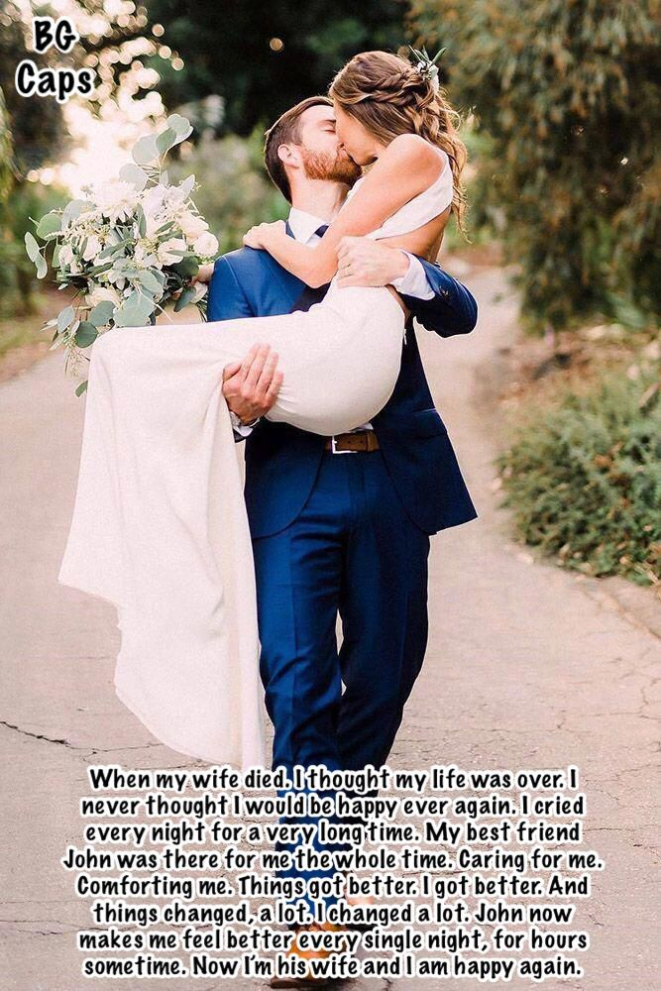

He seemed puzzled at first. He said that it seemed like I was turning into a woman. I told him that it was as if the only way I could cope was to start over, and that it seemed as if she was looking down from above and guiding my path so closely that I was even picking up some of her mannerisms. And I had already developed a pair of breasts, as I showed him.

“Do they freak you out?” I asked him.

“They are adorable,” he said. That was when I knew that he no longer saw me as his old pal but as somebody new. We would be starting over. I would no longer be a guy. I would be a woman – his woman if he would have me.

All that a man really needs is somebody who will love them without question. That is the kind of person that I was with Jenny. It is the kind of love I feel for people. The fact that I was a woman inside never got in the way of my love for my wife, so why would the fact that I was not a woman on the outside get in the way of my love for him? I just needed to be pretty and feminine, and I was.

Now everything is fixed. I am post-surgery and post matrimony. Starting over is the best decision that I could ever have made.

The End

Sweetest Little Girl
From a Captioned Image by BG Caps
By Maryanne Peters

My older brother was an asshole. He didn’t even ask whether he could stay. He just moved into my apartment and tried to take things over.

I was working for Endocrinac the pharmaceutical company at the time. The company was researching using synthetic hormones as neurological remedies to promote mild euphoria and empathetic passive behavior in criminal offenders, and I was one of the technicians. I had access to the drugs, and I just decided that I would try them out on my brother.

Honestly, before you criticize I was close to killing the guy, but you don’t kill your family. It is better to see whether you can correct their behavior, and that was what the company wanted these drugs to do.

Testosterone blockers and the improved female hormone pills was what I used – initially ground up in his morning beverage. Although the company might deny it, the drugs had been engineered so as to be slightly addictive, so that he would notice when the dose was withdrawn and be begging for what he had been taking.

I had no idea what would happen. My understanding was that the feminizing effect was not the projected outcome. Or perhaps I had the dosage wrong? Or maybe it affects some people differently from others? Whatever the reason, my brother’s body changed in only a matter of weeks. Muscle disappeared and was replaced with curves. His skin and long straggly hair became the skin and hair of a woman.

But the change in his personality was even more remarkable. Not only did he become timid and emotional, but he became very protective of me, without understanding the terrible thing that I had done to him. He talked a lot about the obligations of an older sibling that he had ignored as we grew up, and how important it was to be there for me.

He suddenly became very tactile and wanted to hold my arm or stroke my hair. It should not really have concerned me, but it was just that the way he was now looking was creating some real confusion for me. I mean, my brother looked like a sexy woman – like the woman of my dreams. It was weird.

These are not the thoughts that a brother should have for a sister, but of course, I did not have a sister – I had a brother who looked like a sister. My thoughts still seemed sick, and so I had to try to keep my distance and politely deflect all the calls for “a brother’s hug”.

I told him that he needed to get out and socialize. It was me who suggested the makeover. My brother was confused at first, but then happy with the outcome.

I suppose that I felt that my brother ought to be a lesbian, if that makes any sense. As a man he was attracted to women, so why should a little change in body chemistry make a difference. But he brought home a guy, and they ended up necking on my couch.

How did I feel? I hate to say it, but insanely jealous. It was like I wanted to be there, kissing my own sister … or brother, I suppose. Anyway, instead of making things easier for me, it was making things harder.

I decided to stop delivering the drugs. My brother was a pain, but he was not turning me into an incestuous tranny loving freak. She was.

But the withdrawal kicked in. She begged me to explain what was going on, so I told her everything.

“You have to get me the drugs,” she said. “I will go crazy without them.”

I tried to give her placebo instead and had her on those for over a month, but she noticed. I ended up talking to one of the chemists to try to work out how to wean her off.

“The addictive quality is minimal,” he said. “It should wear off a week after withdrawal, so that does not explain your brother’s desperation to feel the effects. It seems to me that maybe your brother likes being what he has become.”

His being a girl may be good for him, but it is not for me.

The End

Properly Presented
From a Captioned Image by BG Caps
By Maryanne Peters

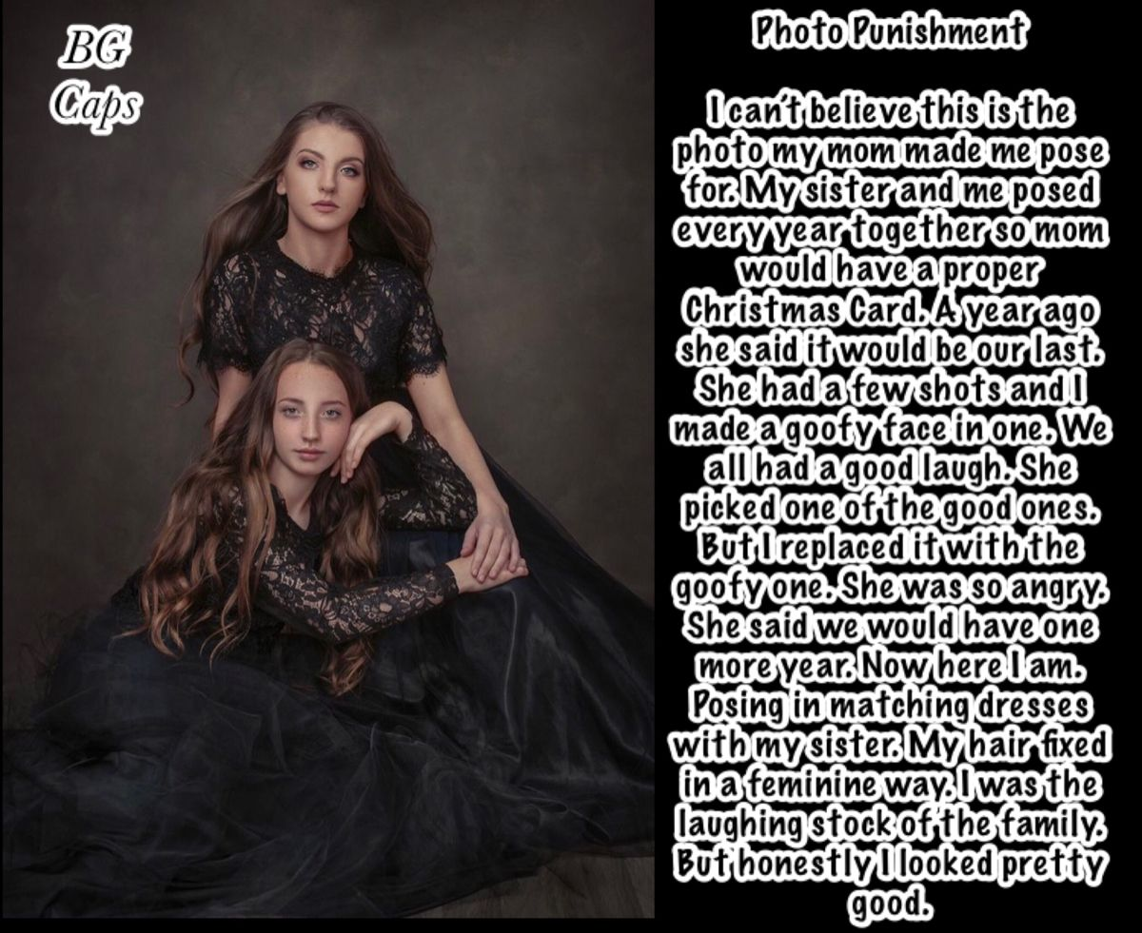

The Christmas before I had insisted that my sister dress like a boy. I even cut a chunk out of her hair while she slept. It was a dirty trick. She needed to get a new cut, and she never forgave me, even though her hair grew out quickly. Anyway, I got my way and that Christmas the cards had both of us as boys, in some outdoor action pose.

She got her revenge though. The following Christmas she insisted that we pose as two girls.

“No, a wig will not do,” she said. “Remember what you did to me last year. No, you will need to get extensions put in.”

But that was last year. Last year dressed as a girl but I played the fool and got the goofy shot printed so that all the cards had to go out with me making fun of my sister yet again.

That was last year. It was supposed to be the last time, but as Mom said I had been so awful we would have one more year, even though I was finishing high school. This time I would be dressed as a girl again, but “properly” as she said it.

I had time to grow out my hair, almost as long as hers two years after I cut it. In those last months at high school I wore it in a long cue down my back, but I would unbraid it and brush it at night and keep it clean. I played with it a little too, and I let my sister use it for hairdressing practice, And I styled hers sometimes too. I suppose that I got attached to having long pretty hair.

By the time that time came to pose for the Christmas cards I suppose I had changed in some more substantial way. Perhaps you can see that on my face. That is me at the back. The prettier one, or at least that is what my boyfriend thinks.

The End

His Property
From a Captioned Image by BG Caps
By Maryanne Peters

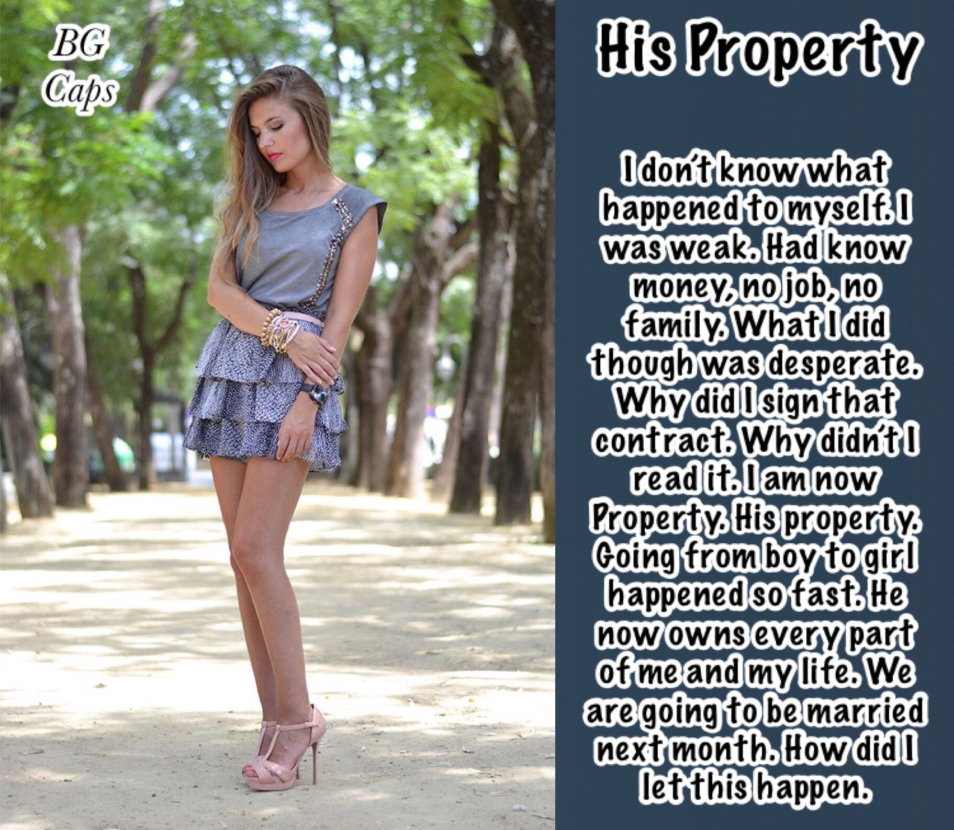

Every now and again I go through all that stuff. He says that it is a panic attack. There are drugs that you can take to calm yourself down, but I don’t use those anymore. I have taken his advice and I have learned how to calm myself down and consider the ways things are.

Firstly, you cannot change what you cannot change. Sometimes you do things in life driven by desperation, just as I did. You make changes, some of them permanent. If you can’t go back, then you just have to face the present the way you are.

Secondly, I am not really his property. The contract was one of indenture. He bought all of my debt and I needed to follow his directions to work things off. It was just that instead of cash it was just days. Not even working days. He said that I could do what I like – even nothing at all – provided I dressed and acted as a woman.

Thirdly, it turned out to be easy for me. I just fell into things. Maybe the hormones helped, and the fact that I was never a masculine looking guy in the first place.

The fact is that he may as well own me, because I am his. He likes to hear me say that.

But the fact was that the tally of days was running out. Actually, it probably had already run out when I reminded him of the fact. That was when he said that he wanted things to continue. But as I pointed out – a contract is a contract. I just simply pointed to my empty finger. As Beyonce says – “if you like it then you should’ve put a ring on it”.

So that is what he is going to do. We are going to be married. I will be his once again, but then also … he will be mine.

The End

© Maryanne Peters 2022

