June in America
A Short Story
By Maryanne Peters

When I missed out a contract the year after our team got to the playoffs all that was on offer was a contract in Japan. The Kobe Sunbears were looking for a big hitting first baseman, and it turned out that I could hit bigger than any of the Japanese guys on their team. One of their coaches was from the States and told me that I would do well. He was right.

I had never been outside of the USA in my life. I knew a few things about the Japanese: They don’t look like us – they look like Chinese people, but different; We had a war against them which we won by bombing the shit out of them, but nobody remembers it; They make cars which we say are shit but they actually run better than ours; They eat sushi which is like balls of cold rice with tasty shit on top – I like sushi. Japan sounded Okay to me.

What I am saying is that I knew jack shit about Japan. I was completely unprepared for the cultural shock. I just assumed that everybody in the world spoke English. There were other languages sure – like in movies – but everybody can talk English – right? Maybe they are just being difficult by pretending they can’t? Well that was just dumb of me.

I had never seen that Japanese writing before I got there. It was on the arrival card, like tiny scratches and scrawls, but there was English too, so that was Okay. Everything was in English right up to the arrival hall and the handwritten sign in the hands of a Japanese guy with my name on it: Joe Drubbin.

His name was Keizo and he spoke English, or so he said. He was there to help me. He was trying so hard that it suddenly became clear that he was not just being difficult. He really did not understand me half the time, and I could not understand him most of the time. But he did speak English – it was just that I needed to adjust to the English he spoke.

He had a car and when I got in I found myself sitting at the wheel. He politely suggested that he would do the driving. In Japanese everything like that is ass-about. He drove me from Osaka to Kobe on the wrong side of the road all the way, but because it was on the freeway it did not freak me out.

We went to the home stadium of the Kobe Sunbears. It was a great set up. As good as anything back home. Better maybe. The American Coach was there, and I greeted him like he was a brother. Honestly, just that drive and all the signs along the road with no English and nothing but that Japanese scrawl everywhere, it was like embracing a stranger like two alone on a desert island.

“This is a different culture,” he said. “You need to get into and understand it rather than try to find America in this country. It is simply not here.”

How true that was.

I met the team. They were a great bunch of guys. Less English than Keizo, but I guess I learned quickly that a smile is the best international language there is. They spoke to me with their smiles and I learned that smiling to anyone in Japan is a good thing – most of the time.

They gave me an apartment. It was small, but “tall size” as they called it. It was very clean and tidy. I mean very clean and tidy. That is how they like things. That was the message. I am Okay with it. I guess I felt that I needed a maid, but my contract did not extend to that.

But the pay was better than good and there were at least two seasons. Good people. Good place to stay. Good money. Different culture. I just had to get into and understand it.

Keizo said that I needed to experience the four key elements of Japanese culture: Food, drink, sport and performance. The first three were way good for me. They were what I do.

I thought sushi was strange but good, but Keizo had me eating all kind of stuff in that first month. I honestly feel that I never had a bad meal in Japan. The first bite maybe a bit weird, but the whole meal could leave me thinking: ‘that was odd, but it was good’. Drink too – Japanese beer, Japanese whiskey are great, sake is something you learn to love and there are so many different types, and then there are the fruit wines which I loved.

Sport is my thing. Baseball was big, and there was soccer and rugby – like American football but without stopping – just running, running, running. Bt Keizo said that this is not Japanese sport. I needed to go with him to see Sumo, Judo, Karate and Kendo. Everyone knows karate, but that was my least favorite. Sumo and Kendo are what Keizo said are half sport, half performance. I learned to love those sports.

So what is performance? Well Japanese movies are there own distinct style, but Keizo was talking about Noh, Bunraku, and Kabuki. Noh was never my thing, and I liked the technical skills in the puppetry of buraku, but when I saw kabuki, well, I fell in love.

This is a hard thing to describe. The performers wear crazy costumes, wigs and makeup, and they talk in a Japanese that even the Japanese don’t understand, but they communicate with movement and gesture. Keizo said that some people cover their ears to better understand.

The show I went to see was a love tragedy. The girl was wronged and betrayed, and the actress looked right at me and seemed to be begging me to come on stage and help her. She was speaking Japanese in a wonderfully soft feminine voice, but it was all in her eyes and her hands and her body. I just felt that I needed to rescue her from her despair – to take her into my arms and hold her, protect her.

You must think me a complete dick. Here is somebody who falls for an actress on stage. I clapped my hands red at the end of the show.

“I know this performer and I know speaking English,” said Keizo. “I can arrange meeting backstage if you like.”

I said that I would love to meet her. I was excited.

We went backstage and there she was, still in costume. She had taken her wig off and I could see that she had quite long hair in a cap, and that under the makeup she had an attractive face set off by huge almond shaped eyes, but there was something odd. I could not put my finger on it, even when she started talking, because the voice was so gentle.

“I went to school in the States. I was in San Diego. I loved it there, but this is what I do.”

And suddenly I realized that she was a man! I did not understand it before, but all kabuki performers are men. Some are so skilled in playing female roles that this is all they do. Like this person – Jun. The name is pronounced liked June – the month – and the girl’s name.

I have to say that it dropped me. I think the word is crestfallen, if that is strong enough to describe how I felt. Like a beautiful dream just beginning dashed by a wake-up alarm.

But he kept talking. He was asking about how I was finding things and I said that I was exploring Japanese culture with Keizo as my Guide.

“Well, Keizo knows my other job,” he said. “You need to come to the Brolita Club in the Hanko District where I do the afternoons. Maybe stay for drinks and a meal. I will get you a discount.”

Who can refuse a cheap dinner and drinks? I had no idea what a brolita club was, but somehow it did not sound Japanese. I said that we would do it, but Keizo looked a little uncertain.

“Maybe you will like it,” he said. “Maybe not.”

Brolita is a thing. You can google it. Japan is full of odd things like that. A foreign idea like “Lolita” with a costume style, that they turn into “Brolita”. I suppose that it all part of some crazy underground sex or fetish thing going on. What Americans do not realize is that Japan is a big country – 126 million people. That is more than the population of the five most populated states in the Union: California, Texas, Florida, New York and Pennsylvania. There are a lot of people and so Japan has enough strange people for everybody to have a club to suit their fetish.

But I thought: ‘what the hell. This is not my country. Nobody knows me, except Keizo and he is up for it. Why not?’ We walked in a took a seat.

Keizo asked to see Jun. We sat there and in she walked. And I fell for her all over again. It was not the crazy make of the kabuki theatre – it was only just over the top, if that. Her hair was a dark blonde – I could see it was a wig. She wore a lace top and a pink dress over it, full and very short. She has stripped stockings on and ridiculous high heels. I thought that she was the most beautiful thing in the world.

“Joe, so good to see you again,” she said. “Thank you for coming.” Her voice was like her kabuki character – feminine and alluring. I was allured.

She said that she had worn something not too outrageous because she thought the three of us might go out afterwards – she was not on at the theater that night. Apparently, what she was wearing would draw no attention in the bars of Kobe, and she was right, when we did go out afterwards. But there in the Brolita Club some of the other “girls” were dressed outrageously, with way to many frills and way to much pink. Even a guy like me knew that.

“In Japan many men like to come to a place like this and be served by somebody exotic,” she said. “And what could be more exotic than a guy dressed like this?”

She gave me a little look. Keizo caught it on his cellphone camera. She was just so cute I could not see her as anything but a girl. Who could not?

The crazy thing was that this Club’s busy time was after work, so Jun was free by 10:00 p.m. and that is when Kobe City is just getting started. We went out to a bar and Jun was just a girl the whole time. She said that it would be easier for he if she could just be my girl – like hang on my arm or whatever.

“Sure,” I said. How could I say anything different.

We did some dancing and stuff. I sort of wondered if anybody knew that it was a guy I was dancing with, but I thought: ‘Hey. This is Japan. It’s a foreign country. Everything is weird here. How could this be more weird than that other stuff – bathing in noodle soup or playing pachinko.

But then when we went outside, she said that she needed to get up in the morning and go to work.

“I thought that you worked at the theater and the Club,” I said. “You have another job?”

She just smiled. She asked me whether we could go out again, sometime soon.

“Would you be dressed as a girl?” I asked

“If you like,” she said. “I get very busy on weekends, but I have Monday off. We could spend the day together. I will dress in very girlish clothes.”

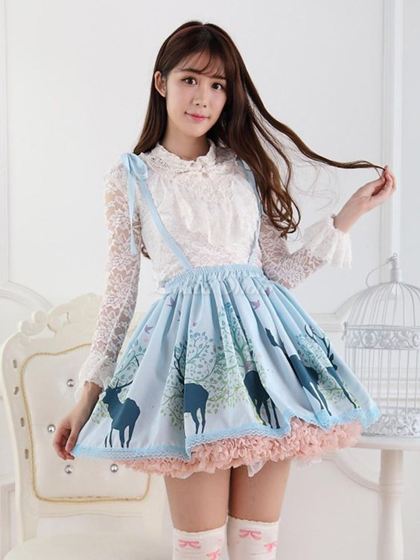

I thought that it had to be a joke. She met me wearing this crazy outfit with a lace top, short dress and petticoats.

“I thought you would like it,” she said. “You want me to look like a girl – right?”

“Is that your own hair?” I had to ask.

“Yes”, she said proudly. I can tie it back if I have to but I have been growing it for years. I wear wigs when I perform but this is my hair.”

“Are you performing for me today?” I suppose that I might have been upset – maybe a little angry.

“I think you are different,” she said. “With other people I pretend. I know very well how to act like a woman. But somehow with you, I actually feel like a woman.”

Honestly, the way she was looking at me, I just sort of melted. I mean, I am a professional ball player. Making a living in sport is tough. I am not a wishy-washy guy, but in that moment I was. We were out in the park or something, me the big American walking along with her, and she was holding my hand and looking up at me. I just had to kiss her. She kissed me right back.

“Do you do this with other men?” I said.

“Not with Japanese men,” she said. “But like I said, you are different.”

I have thought about this since. I spent a lot of time trying to figure out whether she went with guys or with girls when she was not dressed as a woman. It was never really made clear to me, and I never bothered to ask. It was as if I didn’t want to know the answer to the question so I never asked.

That night we had sex. It was anal sex. Not the first time for me, and not for her either, but she certainly let me know that she had never had anything as big as me up there before. I went gentle, and we used lots of lube. She tried to hide her little tassel away, which was a cute thing to do, but I suppose that I was so carried away that I really did not care what was flipping around when I was in my strokes.

If what I did makes me gay, then I suppose I am Okay with that, but I am not about to call myself a gay man. June is a woman. That is all there is to it.

When she came to the games she came as my local girlfriend in the area set aside for WAGs (wives and girlfriends). Nobody guessed that she was not a woman. She was just so good at being one. It was her job.

She stayed doing the Kabuki, but only women’s parts. I had learned that she sometimes played men’s roles too, but I told her that I never wanted to see her as a guy. I never have. She had to keep everything secret. The crazy thing was that if she told any of her new WAG friends that she did Kabuki they would know immediately that she was a guy. But under all that makeup they wold not see it was her.

So, for the same reason I asked her to quit the Brolita Club. Working there marked her as male. She knew that I could not accept that. It turned out that her day job was working in translation and using her English, so she just turned up and asked whether she could do the same job as a woman. They agreed because she had skills, but there were so issues.

As she describes it, the situation for transpeople in Japan is a little strange. There are tranvestites all over the place, and shemale prostitutes, and transsexuals on game shows, and gay and trans porno all over the place, but to the Japanese that is outside of work where you can do what you like. The workplace is like another world. Old-fashioned and conservative.

Maybe it did not help that June’s choice of clothing was often a bit over the top. I guess you might call it hyper feminine. You might think that she was even doing drag and making fun of things feminine if it were not for the fact that she was so goddam pretty.

I told her that at the end of my contract I would take her back to the US and she could have the surgery. And that is exactly what we did.

She likes nothing better than being my little housewife.

But there is no Kabuki in my hometown, and no brolitas, and no need of translation although she does some of that on line for added income. No, so guess what my wife June does to earn some money and pass the time these days?

She runs etiquette and deportment for ladies, that’s what she does! Nobody knows that she was once a guy. She was at the beauty salon one day getting her hair colored and curled and the ladies remarked on just how pretty she was, and always turning men’s heads.

“Ah, yes,” she told them, in the way I know too well. “The face and the hair and the body are only a small part of beauty and desirability. The true beauty of a woman is revealed by the movement of her had, the way her finger touches her chin. Or her hair. The way she tilts her head, or uses her eyes. In Japan we know this very well. We can make any man adore us if we know these movements.”

No she runs classes three days a week, and people are still signing up.

Guys are noticing a change in their womenfolk. The guys who used to tell me how lucky I was to have June re now taking an interest in their own wives and girlfriends, provided that those ladies have taken the course my wife offers.

Those guys seem to be wrapped around the fingers of their women. Some guys can be like that, I guess.

The End

© Maryanne Peters 2021

Author’s Note:
Erin suggested: A baseballer on a contract in Japan brings home a "wife”. I though maybe a Kabuki actor who moonlights at a brolita club – that could be a story.

