The Governess
A Short Story based on American History
By Maryanne Peters

It was in the year 1703, 20 years ago, that I first came to work for Edward Hyde, His Lordship Lord Cornbury, then His High Mightiness the Governor of the Colony of New Amsterdam, now the state of New York in the Americas. Now I am Lord Cornbury, soon to die, while he who once was His Lordship, leads the life he always wanted on those distant shores.

I was born in the colonies, to a hard life where a man learns to be resourceful, and devious. But I had the good fortune, perhaps, to have received a good and classical education. I express some doubt simply because as I lie here, I wonder if a life of ignorance and without the fantastical ideas that led me to this, may have been easier and happier for me.

Education gave me ambition and a hankering to achieve a status in life that was denied to me. I would have preferred to have been a king, but would be happy enough to be a lord, and live in a fine estate, in England across the ocean.

It was a fantasy, but it became real. You see, I had a striking resemblance to Lord Cornbury, and that appearance won me employment with His Lordship as his double. By having somebody to pretend to be him, he could take time to be somebody else, somebody he always wanted to be – Mary.

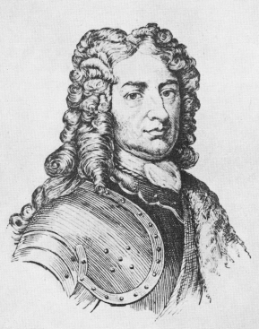  Lord Cornbury, a military man. | 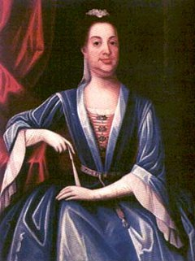  The other Lord Cornbury, a woman

I am no philosopher, and I cannot explain what could possess a man, in particular a man with the status and wealth of Lord Cornbury, to pretend to be a woman, but that was his inclination, odd as it sounds.

Nobody could question his connections. The Queen of England, Queen Anne, was his first cousin. He was a protégé of the Duke of Marlborough, the great general whose wife was the Queen’s closest confidant. His Lordship was trusted to protect the colonies from an attack from New France to the north during what was known as “Queen Anne’s War”. By good fortune rather than great leadership, our province were never attacked and shortly after I left the land of my birth, a treaty was signed settling European positions in North America.

Lord Cornbury was not well liked by many, and he was accused of being “corrupt, loutish and perverted”. For a time he was removed from office.

His nemesis was one Lewis Morris, at all relevant times a member of the New Jersey Provincial Council and at odds with His Lordship on many fronts. Before His Lordship suffered his own removal he had twice suspended Colonel Morris form the upper house.

Despite this obvious conflict, the two men seemed somehow drawn to one another. They did work together on things that interested them both, such as the university they established that was then known as King’s College.

His Lordship was married to an aristocratic Lady, born Theodosia Capell, a daughter of Baron Capell of Hadham. But the lady was sickly in her final years. Lord Cornbury would make use of her dresses for outings in the city. Sadly, she died in 1707 and from that point on, I never saw Lord Cornbury in male dress ever again.

I found myself doing his job as his double, something that I pride myself, I was able to achieve somewhat better than the man himself.

The only business that was conducted by the original Lord Cornbury, was anything that involved Colonel Morris. That gentleman referred to His Lordship as “Mary”. They would meet regularly and in private.

A year after the death of his wife, Lord Cornbury was recalled to England. The suggestion was that he was too passive in progressing the position of his provinces in the war raging inland, and that was probably true. The fact is, that if you look at his military achievements prior to his dispatch to the colonies they read as retreat and compromise rather than action. All of his great military endeavors after his return to England were not his. That was me, you see.

“Mary” wanted to stay in the colonies. Although it initially seemed like an outrageous idea, “the Lady” suggested that I return to England in “her” place. The opportunity that was being offered to me was literally, a dream come true. I could rise to a station that could never be achieved by me in any other way. Even in New York, I was recognized as him, and in England, even among family, slight changes and lack of familiarity could be explained by an extended absence from that place.

But what about Mary? She told me that she had found a place as the mistress of Colonel Lewis Morris, and would be housed by him as Mary Capell, taking the maiden name of the late Lady Cornbury.

But once I was committed to this course, things started to go wrong for the new Lord Cornbury. After my recall but prior to my departure, in December 1708, I was put under house arrest by the sheriff of New York City for outstanding debts incurred because the New York & New Jersey Assemblies had refused to appropriate funds for the governorship. It was within the power of Colonel Morris, and I dare say his mistress, to free me, but it would seem that I would stay under their oversight, and in some comfort, until I boarded a ship many months later.

In England I coped very well with the strangeness of it all, having never seen anything so grand as the city of London and the palaces of royalty where I was a regular visitor.

Although difficult with the great distance and slow voyages, I maintained a correspondence with Mistress Mary Capel of New York. I told her that I enjoyed a pension and apartments in a royal palace and that I dined with the royal family several times a week. She told me that she regretted nothing – that she was happy with her decision, happy to be mistress to Colonel Morris, and she made the right decision to stay in colonies and to live there as a woman.

The End

© Maryanne Peters 2019

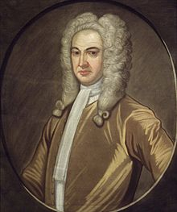  Lewis Morris, an original New Yorker | 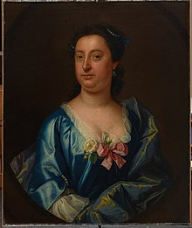  Mary Capell, his mistress (ex Lord Conbury)

Author’s Note: Is it true? Did colonial New York have a cross-dressing governor? In his history of the city Herbert Asbury refers to Lord Cornbury as “exhibiting some erratic behaviour … two or three times a week, but always at night, His High Mightiness appeared on the streets of New York wearing Lady Cornbury’s clothing. He was invariably drunk and disorderly, but he was not molested, for the night watchman realized that to interfere with the Governor’s little outings would imperil his job, and probably his liberty as well.” A 2018 editorial in The New York Times on gender issues suggested that Cornbury was transgender. The happy ending for “her” is, like all my happy endings, pure fiction.

