Finding A Way To Be Loved
By Soul-Controller

For the homeless Nick, life in the busy streets of the city couldn’t have possibly been any worse. Not only had he been kicked out of all of the shelters due to previous incidents with judgmental staff, but he was constantly being hassled by over-eager cops looking to “enforce safety” in the wealthy area of the metropolitan city. Both parties knew that the frail 25-year-old posed no risk and just wanted to find some sort of shelter, but authority had a funny way of corrupting people that were meant to protect the town’s citizens.

While it was clear that Nick wasn’t the luckiest man in existence, he had to admit that the past week or so had been much better. This was mainly due to the universe blessing him during one of his late-night scavenging attempts in the dumpsters of a local tech facility. Although he had mainly been eager to just find any sort of food scraps that he could snack on, the discovery of a watch in a clear case was a pleasant and unexpected one. Thinking about the pros of having this watch, he decided to take it for himself. The main benefit of the watch would be the fact that it would allow him to have a way to time the nightly police patrols. If he could figure out the exact time the police came around, he could easily avoid them by leaving the area early to save himself any future strife.

With the watch now wrapped onto his wrist, Nick returned to his favorite spot of an alley between two high-rise apartment buildings. After an hour or so, the ringing of police sirens indicated that he was once again going to have to deal with power-tripping cops. As the officer approached, Nick checked his watch and noted the time (12:15 AM) for future reference. Unfortunately for Nick, the cop that was approaching him wasn’t the usual one he dealt with. Instead, this cop was a man with an impressive physique decked out with incredible muscles and a gorgeous face. The man clearly gave off an intimidating vibe, which was only further realized by Nick upon witnessing the cop immediately begin to verbally harass Nick. Despite his best attempts at trying to deescalate the situation, the cop wasn’t having it as he smirked to Nick while stating that he was taking the homeless man into the station for loitering around the wealthy properties.

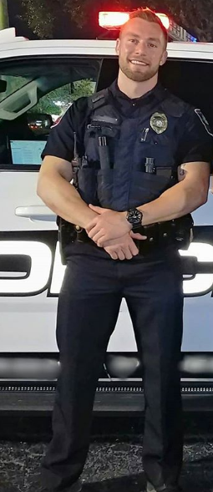
Of course, Nick resisted, but there wasn’t much he could do with the huge man overpowering him. In a last ditch effort, he grabbed onto the man’s wide forearm with his watch-adorned arm and gasped at what happened next. As a shock coursed through both of their bodies, Nick stared in confusion as the officer grew rigid immediately. After wiggling his way out of the bulky man’s clutches and running behind the man, Nick looked in awe as the officer remained absolutely frozen in place. Asking the officer if he was ok, Nick received no answer from the hulking man. Reaching out his hand to try and seemingly wake up this cop, he tapped on the man’s shoulder blades. But, instead of firm muscle and bone, Nick’s hand simply just went through the man’s body until he was wrist-deep in the man. “Holy shit!” he exclaimed, moving his arm further in and out of the man’s seemingly hollow body.

Eager to test the limits and also toy with the asshole officer, Nick pushed further into the man until the majority of his body was inside the larger man. With his curiosity piqued, Nick pushed further in until his body was completely inside the frozen man. However, as he fully slipped inside the cold body, he suddenly felt a heat spread throughout his body as the body began to spring back to life and Nick suddenly found himself looking through the officer’s eyes.

“What the fuck!” Nick exclaimed as he looked down and saw the sight of bulging pecs straining the dark blue uniform of the officer. As he continued to frantically look around, he soon realized that he was in complete control of the officer’s body and his own body was simply inside the host. With a smirk forming across his new face, the new cop swaggered back to his car as Nick made plans to give himself a full meal courtesy of Officer Lucero and spend the rest of the night in the cop car admiring this bulky physique he now possessed…

* * * * *

It had been a few days since that unbelievable night and Nick was optimistic for the first time in his life. After going home in the officer’s body to his empty apartment, Nick was able to learn more about the new power he had. Rolling his shoulders revealed the ability to exit the host’s body, which Nick was relieved to discover. As much as he admired the amount of power and strength that the officer had, he wasn’t entirely eager to live that life. He knew his circumstances were worse as a homeless man, but his identity was important to him and he wasn’t entirely eager to sacrifice that all to become some cop forced to enforce idiotic rules against people similar to him.

So, upon slinking out of the bulky man’s back, Nick kept track of time as the man slowly swayed in place for around 15 minutes before shaking his head and returning back to consciousness. As this was happening, Nick quickly rushed out of the apartment before Lucero gained complete awareness of what was going on. He was relieved to see that the bodies don’t remain a lifeless husk, he didn’t want to be responsible for the comatose state of those individuals even though he was teaching them a lesson!

* * * * *
It had been a few days since the man’s possession of the cop, but Nick found himself incredibly eager to try out the power again. As he resided at the entrance of one of the alleyways, his eyes looked around in search of a new host. After what seemed like hours of searching, he smiled as he watched a couple from one of the buildings walk down the street. He had always admired them for the past several months, but with this watch, he now knew that he could actually be them rather than admire from afar…

The couple, who Nick had learned to be named Bradley and Claire through eavesdropping on their conversations while walking down the street, was quite the attractive couple. However, there was one member of the couple that had always turned on the homeless man. Bradley was an absolute stud and on those cold nights where Nick would sleep in those alleyways, his sex dreams with the hunk would certainly keep him warm. While Nick had no real sexual interest in Claire, he couldn’t deny that the woman was conventionally attractive as well.

Despite their appearances being incredibly attractive, their personalities were even more attractive to Nick . Every time the two passed by the homeless man, their faces weren’t showing an expression of disgust and judgment but rather one of compassion and empathy. In fact, they didn’t even care about the fact that he clearly hadn’t showered in months or was living on the streets with ratty clothing. Instead, they would often make small talk with the man as they began to walk towards their destination. It was nice to have someone check in and care for him, but it was even better when they would return from their dinner dates and give Nick their to-go boxes.

While he felt slightly bad about the concept of possessing one of them, Nick was eager to finally have some fun for himself with this new power. So as he watched the beautiful couple walk down the street and give him a friendly wave, Nick began to formulate a plan about how to use the watch to fulfill his deepest fantasy…

* * * * *

Given the fact that Claire and Bradley had treated Nick like a friend during their convos, he was able to easily learn a lot about their schedules and jobs. Bradley seemingly had a busy job that required him to spend some weekends out of town, so Nick knew that this was the perfect time to enact his plan.While sitting out at the entrance of the alleyway, Nick eagerly waited for the arrival of the caring woman. Right on cue as he checked the magically-infused watch, the man watched as Claire began to march down the street by herself in some sort of workout attire. It was a relief to see, especially since that seemingly indicated that she was once again alone for this weekend. “Hey Claire!” Nick said, a smile forming on his face as she looked over and glanced at the poor man.

“Oh, hey there Nick. How are you doing today?” she asked in response, which Nick responded with by stating a simple “Doing the best I can” and letting a slight chuckle escape from his lips. Clearly, as he said this, the woman’s smile turned into a slight frown as she sympathized with the man’s life struggles.

Knowing this and using it for his own gain, he began to ask her if she would be willing to
check out a new ring that he had found while scavenging one night. “I don’t know if it’s
real or not, but it would be good to get your opinion before I take it to the pawn shop…”
he said, which caused the woman to agree with a smile and follow him further down into the dark alleyway. His mind scolded him for taking advantage of Claire’s innate good-natured personality, but he had a craving that he was absolutely dying to find a fix for.

Upon getting far enough into the alley, Claire begins to ask to see the ring that Nick was
asking about. While still wanting to maintain their friendship post-swap and not wanting
the last thing Claire remembered to be him attacking her, Nick calmly said “Just a
second” as he rummaged around in an empty bag. With her attention focused onto the
right hand searching through the bag, Nick slyly latched onto the woman’s wrist with
the hand with the watch on it. Immediately, he looked up as the electric surge coursed
through both of their bodies until Claire was now left completely frozen in place. “I’m sorry Claire, but I just need to be with Bradley…” he regretfully says as he removes his hand and begins to move towards the back of her smaller frame.

Letting a slight grin manifest on his face, Nick looked around for any potential witnesses to see the upcoming possession. After checking two times and verifying no one was there, Nick exhaled and began to press himself into Claire’s small back. It was a strange and alluring experience to be doing this on purpose in comparison to the incident with the officer, but Nick couldn’t deny loving every second of it. It was so hot to watch his hairy arms push into Claire’s thinner and hairless limbs and gain control. He wiggled her fingers, chuckling as he stared at her dainty hands and well-manicured nails. Nick didn’t really have an interest in women, but he couldn’t deny that he was quite turned on to be in control of such an attractive young woman.

As he continued to push himself further into her body, he slowly regained control of her
legs, which gave Nick the weird sensation of feeling so revealed due to the woman’s
skin-tight pair of blue leggings. With those new hands of his, he eagerly rubbed onto the curvy yet firm legs he possessed. “Fuck, this is so hot!” he cried out as he fully pushed his upper torso and head to complete the possession.

After a moment of absolute darkness, Nick regained his vision to confirm that he was
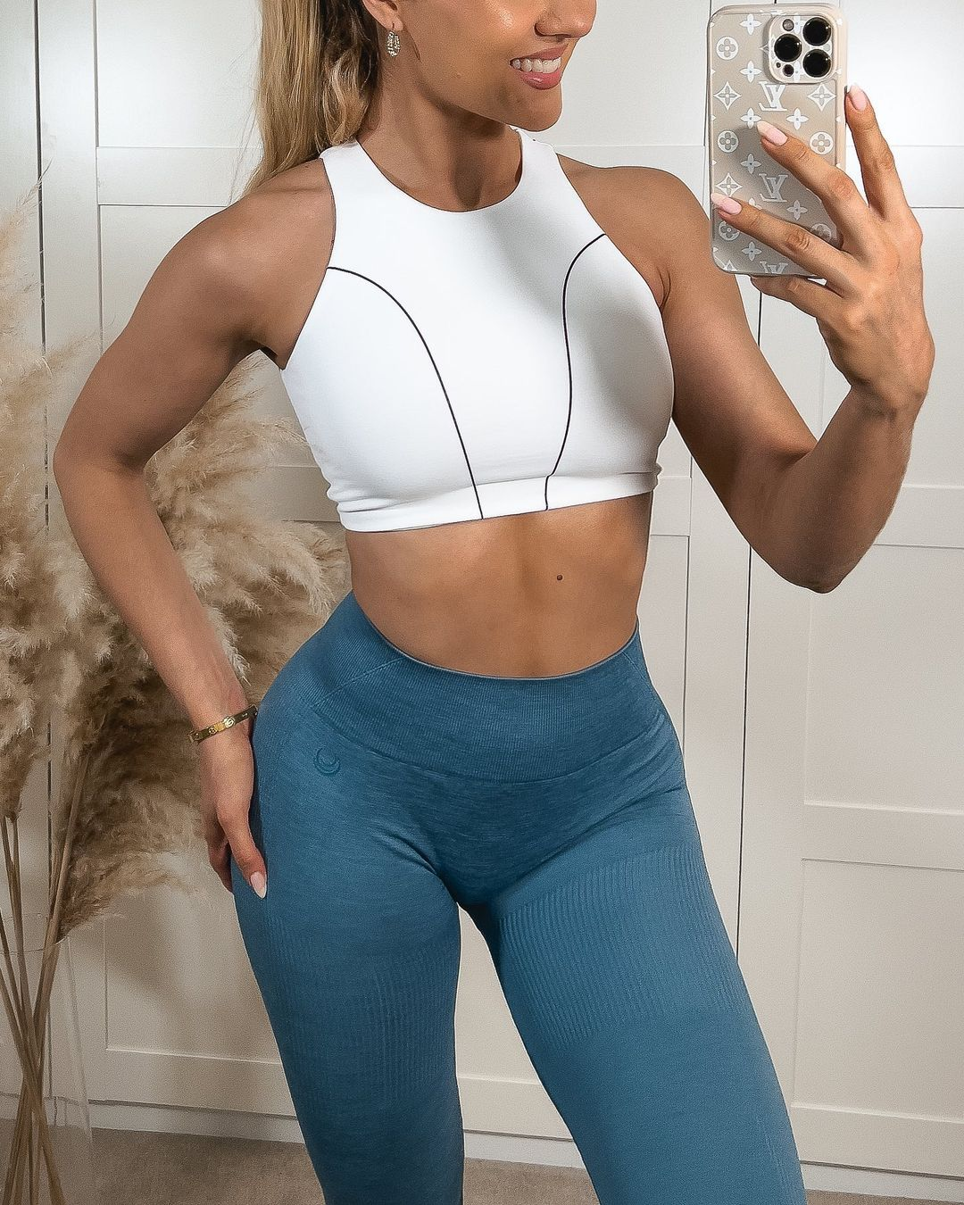
now in fact fully in control of Claire’s body. “Holy shit!” he exclaimed, feeling himself tingle in erotic emotion as he heard her feminine voice coming out of his mouth. This change was still quite strange, but he paid that no mind as he now had a clear goal in mind. He absolutely needed to return to Claire and Bradley’s apartment and give this body a closer inspection! Upon fishing out the apartment key from her purse, Nick delicately paced back into her apartment complex and up the few flights of stairs up to the couple’s place.

Pulling open the door and entering, Nick was incredibly eager to look around and see what kind of apartment the couple had. However, décor was of little importance to the man as
he now found himself in the body of both his crush and a body of the opposite gender!
After dropping off the woman’s purse on the kitchen counter, Nick smirked to himself as he headed into the bathroom. As soon as he entered and saw Claire’s body staring back at him in the wide mirror, he was incredibly turned on. Moving his hands around while beginning to rub his new body, the man found himself increasingly turned on by the flowery perfume that Claire used. It was alluring and he loved smelling every possible whiff of it! Wanting to waste no more time, the homeless man began to eagerly peel off the woman’s clothes until the woman’s naked body was staring back at him.

Moving his dainty hands towards his chest, Nick gasped and moaned as he grasped
onto Claire’s modest breasts and gave them a squeeze. The feelings that rippled through his body were absolutely immeasurable, it just felt so fucking good! It was incredible to know that he now had breasts, but as his eyes moved downward, he focused on his new sexual anatomy. Moving his hands down her smooth hairless body, Nick found himself incredibly turned on and his genitalia growing wet from the erotic nature of this possession. If it always felt this good to be in control of a woman’s body, Nick figured that he might have to stick around!

Feeling around his new genitalia, he swirled his finger around the well-trimmed vagina he possessed. He couldn’t deny feeling slightly irresponsible to resort to such sexual acts, but his curiosity was piqued and from any outside perspective, HE was the real Claire now. As such, he pushed those thoughts away as he pressed one finger deep into his new wet slit and began to moan from the pleasure coursing through his body. With a primal lust emerging in his new body, Nick wasted no time rushing out of the bathroom and into the bedroom in search of some sort of sex toy. Luckily for the new woman, it only took searching through 5 drawers before Nick stumbled on a drawer full of dildos, Fleshlights, and other various sex toys. Seems like they have quite the active sex life… Nick thought to himself as he grabbed a dildo and jumped into the couple’s bed.

It was strange pushing the foreign object into his new pussy, but the feelings that
coursed through his body had him desperate to do it more. So for the next 20 minutes,
Nick struggled to understand the female sexual response through a hands-on approach as he tried his best to get himself off. Of course, such an intense struggle for orgasm had caused Claire’s soft and supple body to become slicked in sweat. While this would gross out most people, Nick found it incredibly erotic as he lifted up his arms and smelled the mix of flowers and sweat that radiated off of her armpits and chest.

Just as Nick began to feel himself reaching a similar feeling of near-orgasm, he suddenly found himself interrupted by the sudden opening of the bedroom door. “Claire, what the fuck!” Bradley said as he walked in on his girlfriend sprawled out naked on the bed attempting to get herself off. It was incredibly awkward, especially as Nick slowly pulled out the dildo and attempted to formulate some sort of response.

“Bradley! What are you doing here!” Nick said, his voice dripping in embarrassment and
shock given how he had assumed the man was gone for the weekend. Based on him
standing in front of Nick while carrying a suitcase, it seemed as though his plans had
changed. With his hand raised to his temple, Bradley stated how his bosses had randomly called him on the way to the airport and said that he no longer had to leave town. With a newfound excitement, Bradley recounted how he had quickly ordered a taxi and rushed home to surprise his girlfriend upon returning from her usual gym routine. So, Nick could then understand Bradley’s shock to find that his girlfriend hadn’t gone to the gym but rather had taken the time to get herself off instead.

“Oh, I’m sorry babe. I’m at least glad you’re home though…” Nick attempted to say,
sitting up from the bed and crawling across it towards Bradley. In a desperate attempt to try and get Bradley to forget about the experience, Nick attempted to allure the man with his girlfriend’s feminine body. As such, it was funny to Nick as he watched the man scramble and stutter his words as he saw his naked girlfriend approach him in a seductive manner. But as Nick caught sight of the intense tenting that was occurring in the front of Bradley’s dress pants, it was clear that he loved every second of it.
“You’re glad I’m home huh? Well, would you rather trade out that toy for the real thing?” Bradley seductively responded as he began to walk towards his girlfriend. It was incredibly erotic to watch his crush behave so sexually towards him, but Nick was savoring every second of it. This body clearly enjoyed it as well as an extreme wetness emerged from within his pussy that he was incredibly eager to satisfy. As Bradley slowly peeled off his dress clothes and revealed his impressive body, Nick wasted no time using Claire’s mouth to pleasure his new boyfriend. Bradley was clearly enjoying it as well based on the large amount of pre-cum that Nick could already taste on his lipstick-lined lips.

But after a few minutes of this foreplay, Bradley and Nick were both clearly eager for the main event to finally begin. As Nick laid out in the bed and spread his legs, Bradley wasted no time mounting her and beginning to slide his impressive dick deep within his new pussy. “Oh fuck Brad!” Nick moaned, gasping in between the mighty thrusts that Bradley gave him. “Hell yeah, you like that? Tell me how fucking badly you want this cock babe” Bradley smuggly responded as he used one free hand to grab onto his girlfriend’s bouncing breasts. Such behavior had understandably left Nick absolutely ready for Bradley to shoot his load inside of him, which he made abundantly clear through his moans and grunts. Clearly picking up on this, Bradley obliged and wasted no time beginning to climax deep within his girlfriend’s cunt.

While this was occurring, the timing was nearly impeccable as Nick himself experienced his first female orgasm. It was different yet familiar, intense but not really all at the same time. Clearly, it took much longer to get a woman off in comparison to men, but Nick certainly didn’t mind it when the end result left his body buzzing that much afterwards. He hadn’t been too excited about the concept of possessing Claire, but if this was the end result of being with the man he always wanted to be with, he could easily get used to it!

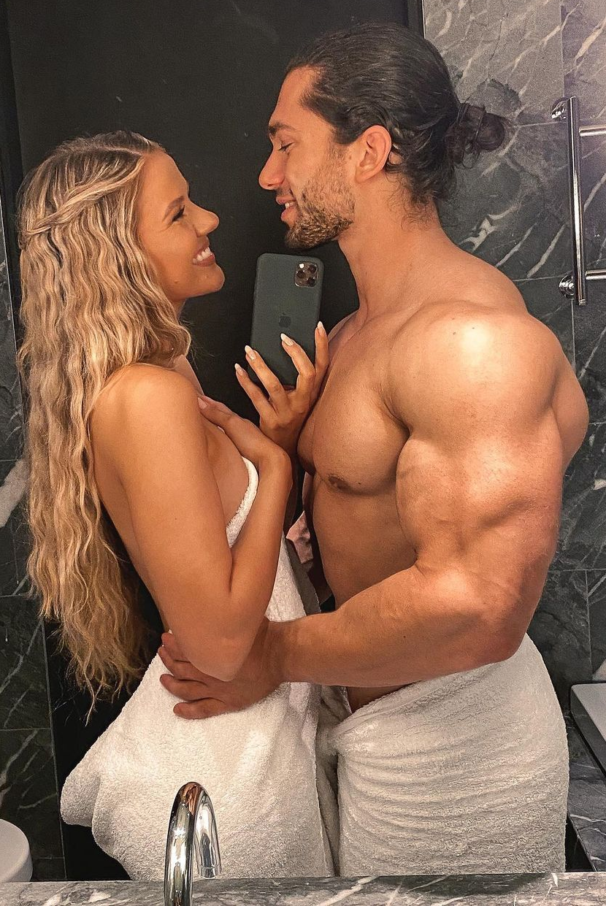
With both of their bodies now caked in sweat, Nick ran his tongue against Bradley’s buff torso and shivered as he tasted his sweat. It was incredibly alluring and Bradley clearly didn’t mind as he chuckled while the couple cuddled onto the bed.

Eager to explore more of Claire’s life though, Nick broke up the cuddling session after a good 30 minutes and began to inquire about going out and doing a random hangout with some of their best friends. He was curious about the concept of fooling all of her friends and seeing how different life could be in this body, so he was incredibly relieved to hear Bradley agree to the request. As Bradley sat up, he extended his hand out towards “Claire”. Upon placing a dainty and well-manicured hand into his wider one, Nick felt himself suddenly pulled to his feet and into the bathroom as they began to shower and prepare for an incredible night on the town.

* * * * *

For the rest of the weekend, Nick experienced one of the best times of his life as Claire. Being next to Bradley as they walked down the street hand-in-hand, Nick felt so happy and filled with joy. Even while still trying to adjust to the tight and revealing clothes that fully comprised Claire’s wardrobe, Nick felt extremely comfortable when leaning on his hunky boyfriend throughout the night. It was something he hadn’t felt in years, so it was absolutely something he savored and craved more of. Plus, the slight anxiety he had in regards to meeting Claire’s friends was totally pointless as Nick was easily able to bond with the girls to the point where there was no way they could tell that their blonde friend had been replaced by a man. As such, the whole group was easily able to get both Nick and Bradley absolutely wasted until the early morning hours.

On Saturday morning, it was no surprise then that Bradley and Nick opted to just lounge around the apartment while attempting to curb the prominent hangovers plaguing their bodies. While Nick was still eager to go out and explore life as Claire, he quickly found himself ok with the lounging about as it allowed for more sexy time with the long-haired stud.

When Sunday morning rolled around though, Nick was extremely excited to wake up and find Bradley’s shirtless body standing over him in an attempt to wake his girlfriend up. As the man leaned down to give Nick a passionate kiss, he quickly got off of “Claire” and told her to start getting ready for their workout. Given the fact that he hadn’t had the privilege of expensive passes for state of the art gyms and healthy living, Nick was understandably excited yet nervous to accompany Bradley to the gym.

After heading into the bathroom though, those anxieties began to weaken as Nick focused more on just enjoying the company of Bradley as they continued to make out in between getting ready for the gym. Once Bradley had pulled on a workout tank top and pair of athletic shorts, Nick took the liberty of looking as sexy as possible by pulling on the tightest and girliest pair of leggings and sports bra onto his curvy and sexy new body.

Making their way out of the apartment into the complex’s parking garage, Nick felt butterflies in his stomach as he watched Bradley jump into the front seat and turn the car on. With his buff arms fully exposed and his hands wrapped around the steering wheel, the man looked like an absolute sex dream come to life in Nick’s eyes. Add in the fact that the man was showing off by revving the engine with a cocky smirk on his face, it was no surprise that Nick’s new female anatomy was growing wetter due to his incredible thirst for the hunk. This was especially true as Bradley looked in his girlfriend’s direction and gave a knowing stare that left the possessor eager to lean over the center console and pleasure the man’s surely throbbing cock…

Despite the fear Nick had about Monday morning rolling around and thus forcing him to return to Claire’s job as a personal trainer at a local gym, he still remained absolutely thrilled with what he was experiencing. Not only was the sex better than ever imaginable, but now he had a life where he got the man of his dreams, a body that turned said man on to peak levels, and a rather lavish and wealthy life given their careers. Everything about this new situation was better than what he had, so why would he ever want to leave it? Sure, there may be a few hiccups along the way, but Nick knew that he was a rather smart and resourceful man and thus could figure out the life of a gorgeous fitness hottie. Although he had some slight remorse for completely taking over Claire’s life for his own selfish desires, he wasn’t really willing to allow himself to talk himself out of this new setup. This was the dream life and now it was all his… forever!

