Staring  Inspired by a Captioned Image  By Maryanne Peters  “Well, in answer to your question, I can tell you that … no I would not be standing where you are.”  “Oh, come on Joe, every guy in school wants to fuck Mary Jane.”  “Well I thought I did, but … well maybe I have changed my mind. Maybe I have another object of desire.”  “Oh yea, well me ang MJ are going to do it tonight, so … will you stop staring at me like that. You are giving me the creeps.”  “I just can’t get over that great hairdo of yours. Is it really your own hair?” | 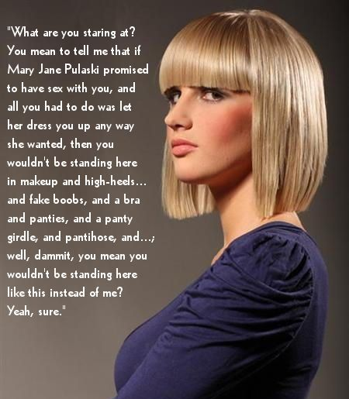

“Unfortunately, yes. With a blunt bob cut like this and the bangs and blonde color through it, I will have to get a buzz cut after this is all over.”

“That would be a shame. It looks really good on you. And the makeup … wow.”

“Yeah. The girls at the salon spent ages on it. They showed me how to reapply my mascara and freshen my lipstick too. I’ll show you. You just roll it up like this and, just a minute … like that, and … that and … mmm – mwah! Done. Easy.”

“Fuck, that is sexy. And what’s with the tits? What did you say you were wearing under that dress?”

“Panties and a panty girdle”.

“What’s that? What’s a panty girdle”

“Its like a thing I wear over the lacy panties to give me the shape Mary Jane wants. Like, round in the back and smooth in the front.”

“Show me. Go on. Show me.”

“You’re a pervert.”

“No, come on. You’re dressed like that, looking like a sexy chick. Show me what you’ve got, Sexy.”

“Well, let me just lift up the hem of my dress here. Oh look, is that a run. No. That’s the pattern. It goes all the way up. All the way up to … oh, there’s the gap between my legs. See. No willy here. Just a smooth front. That’s what this panty girdle is all about. For some reason MJ wants me to look like a chick.”

“Mary Jane has to be a lesbian. There is no future in that for you. You need to find somebody who really desires you.”

“I don’t care what it takes. When this thing comes off she is going to see what a man looks like. But until then, if she wants to think that there is a wet little pussy hiding inside here, I don’t care.”

“It sure is a nice thought. The cute blonde chick with a warm pussy.”

Hey. Stop that!”

“You’re driving me crazy”

“I said stop. Stop. Hmmm. No. Don’t stop now.”

“What about Mary Jane.”

“Who?”

The End

The Makeup Bar  Inspired by a Captioned Image  By Maryanne Peters  HR people always seem to get a bad rap. We are just doing our job. We don’t like dragging people in for the formal warnings, or terminating employment, especially where the grounds are thin. We say that we understand because we are not blind to the despair. But we do our job.  One thing I knew was that I did not want to be on the receiving end. And in my case, there was clear cause for termination. Putting up with the crap they put me through seemed like a small price. Just the embarrassment of appearing in make up every day. | 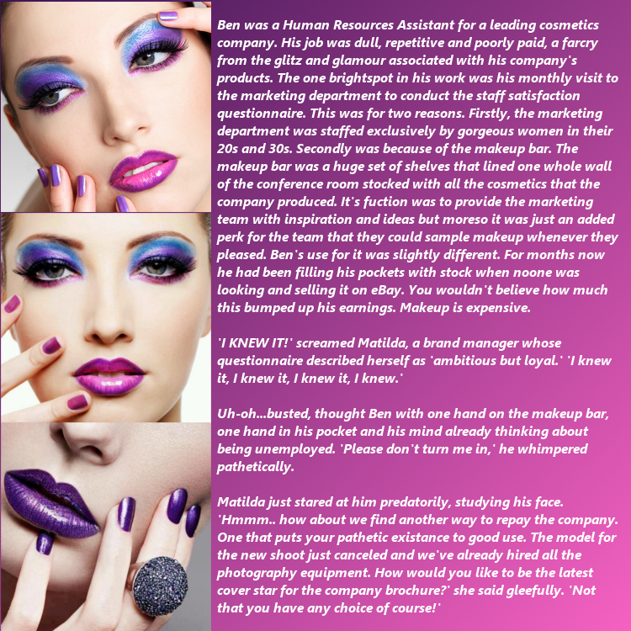

But hey, I work for a cosmetics company, right? A guy can wear his employer’s product, just so long as he doesn’t steal it. But that is what I had done.

The expert said that I had a perfect face shape for it. I had a long nose, wide set eyes, and a solid chin, all she needed to do was plump up the lips a little. That and pluck the eyebrows. Everything else could be done with makeup, after a close shave. Concealer for the beard, foundation, some highlighting for the nose, then apply the colors and snap off the shots. Too easy, right? Wrong.

When the shoot was over, I was still in full makeup, for as long as Mattie wanted. She had the information, including CCTV footage, that could destroy my career. I was to be a mannequin for the company’s products. That meant skin treatment which ended up destroying my beard, and foundation and highlights, eye makeup, and lipstick, and even nail polish. It doesn’t matter if your hair is short, with that look there was no way that I looked like a man. So, nobody treated me like one.

The guys in management started to call me Beth, and then everybody followed. The Head of Accounting found out my shoe size and bought me a pair of high heels. He said that I should wear them anytime I came up to his floor.

If I was a real girl, he would not have got away with that, but I was not a real girl. In fact, it became pretty clear to me that nobody liked me very much. In HR I was just doing my job, but maybe I did enjoy delivering bad news a little too much. No everybody was letting me know.

It got so bad that I started to wear the makeup home and learn how to do the basics so that I could do my face before I got to work. The reason is that I really did not look like a guy anymore.

Dress code is strict, which seems crazy for a cosmetics company. Our GM is straight out of banking and insists that corporate dresses “professionally”. That means a suit and tie for guys, but things were relaxed a bit for me, because it was accepted in the office that I was “a person of indeterminate gender” – a POIG. What a great joke at my expense. Still, I never liked ties, and I was able to wear an open-necked shirt (provided is was patterned and colorful) over my pants. And my hair could be a little longer as it used to be before I joined the company.

Then one of our European managers arrived to work on a quality audit for a few weeks. His name was Sergio. He knew nothing about me, and he assumed that I was a woman, right up until I opened my mouth. Another huge joke with me the victim.

He clearly felt sorry for me. He asked me whether I had considered a transfer to our office in Milan. After all I had been through, it seemed very attractive.

“We have an opening in HR that would suit a person like you,” he said. “We have a very modern policy as regards minorities including transgendered people.”

I was going to open my big mouth and tell him that he misunderstood, but I could see a reflection of myself in an internal window. There I was in full make up with my long hair slicked back, wearing a feminine blouse and with high heels on. It just seemed a better idea to stay quiet. And then when he pushed a little more, to whisper in a voice that could almost be a woman’s: “I would certainly like to look into that.”

That was three years ago. I took the transfer, but I did not stay with the company too much longer. Milan is just such a wonderful city to be a woman in. God knows what men do in this town, but for women it is the best city in the world. And that is what I am now.

Sergio insisted on the surgery before he proposed, but somehow saying yes to both were the easiest decisions that I ever made in my life. I don’t have to steal a few lipsticks to make a dollar these days. I am a kept woman, living a life that little girls dream of, even though I never was one.  The End | 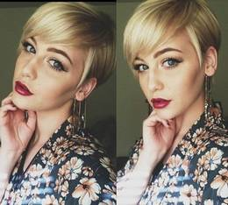

Sold Off
Inspired by a Captioned Image
By Maryanne Peters

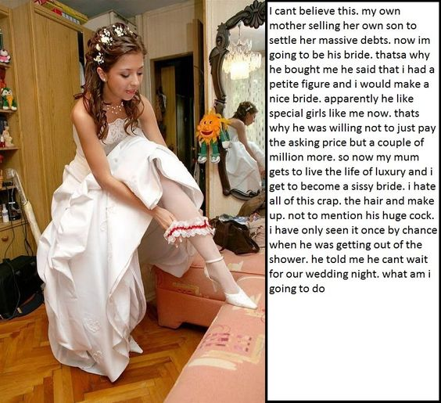

I never thought that this kind of thing happened for real, but there are strange people out there.

I suppose my mother was strange too. She always had a hankering to see me dressed as a girl. She told me that she did it when I was a baby, dressing me in pink just because she liked to hear people say: “What a pretty little girl”. Any chance to put me in a dress for Halloween or fancy dress she always said: “Go as a princess. Let me get you the outfit.”

She always encouraged me to wear my hair long, and she would like to brush it when I was doing my homework. Sometimes she would lift it up at the back and twist it around – just playing with it as if it was girl’s hair.

You might think that being treated like this would turn me into some kind of sissy, but I never was like that. I wasn’t a jock either, but I found my place with a good bunch of guys, and we did fun things together. Everybody understood that my Mom was a bit wacky, especially when I turned up to a Halloween thing in the princess get-up.

“Don’t tell me. This was your Mom’s idea”. Same thing every time. I just shrug my shoulders and check my lipstick.

My mother loved to take photos of me dressed as a girl. She would say: “Strike a pose. Look like a princess longing for her prince”. Embarrassing stuff like that. It was her thing. How could I refuse?

I knew that my Mom was a failure in business. I guess she was a failure in relationships too. She only had me, and as it turns out, she was happy to trade me to get out of debt.

I didn’t know it, but she had been posting pictures of me dressed as a girl on the internet, or some of those dark places on the internet where people are interested in such stuff. She ended up in deep correspondence with a guy called Victor.

I didn’t learn details of the deal until much later, but Victor was looking to marry a sissy boy. It must have been that he couldn’t find one, because Mom volunteered me, for a price. For money she would prepare me to be his, and in return he would buy up her debts and forgive them over time.

To give her some credit, she was not just selling me. Victor lived in another state, where marriage to a minor was legal, and so was marriage between a man and a transwoman, but my mother would be moving to live with us too. I suppose that I can see why it worked for Mom, but she never consulted me.

All I knew was that she started me on “vitamins” and “flu shots” and had me washing my hair with some miracle growth promoting stuff.

You know how this ends. Where are you reading my story? So you know what was happening to me, but I didn’t. At least I didn’t until one day I looked at myself in the mirror and I saw tits, and my hair hanging down almost to those big rosy nipples.

The End (?)

The Plumbers  Inspired by this Captioned Image  By Maryanne Peters  Young Dave Kerrick was fresh out of his apprenticeship and Rick Lowe was only a little more senior, but I sent them to the Academy as a bonus. They had been working hard and all I knew about the training school set up in the old Feldstein mansion was that it was full of pretty girls. These guys needed some change from the day to day plumbing work my business does.  But old places get blockages that can prove difficult, so I was not surprised when they were still on the job three days later. | 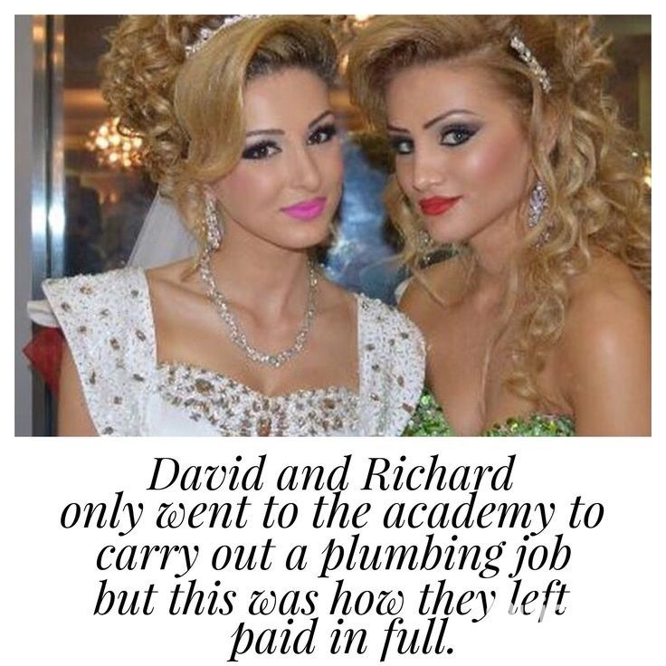

I could not raise them on either of their cell phones so I went up to the Academy to check on things. The moment I arrived I found myself wishing I was still on the tools instead of stuck in the office with my bad back. The place just seemed to be full of gorgeous young women all dressed up as if they were contestants in a beauty pageant. I guessed that was what the academy must be – to teach girls how to win beauty contests.

“Goodness no!” said the older woman, who was clearly one of the staff in charge. She said her name was Marcia. She could have been my age but she appeared much younger and was dressed in an outfit that showed off her perfect hourglass figure with pale bosom almost spilling over – the kind of shape I have always liked in a woman. “No, no. This is a gender adjustment academy. All the women you see here were once men. We pride ourselves in being able to turn any man into the most glamorous of women.”

I have to say that I was amazed. I even started looking at her again. Could it be? Surely not? She just smiled as if she knew what I was thinking.

“Well, I guess my boys must still be working on that blockage?” I said. My thinking was that they would be keen to get out of there knowing that they were in a house full of transvestites. “My boys, Dave and Rick? Are they down in the basement?”

“Oh, that work only took an hour or so. They are here somewhere just enjoying themselves.”

So clearly these fellas did not mind the company of drag queens. They would be getting a hard time from me and the other guys when all this was over. So I just smiled and said: “Well, you had best tell them that the party is over.”

“Maria, would you find Daphne and Rebecca and tell them to come down to the sitting room.”

Now that had me dumbfounded. Now surely, I would not have to face two of my plumbing staff dressed as women parading in front of me. I stood ready to burst out laughing. I turned to her to commend her for distracting them and to explain that their pay would be docked for time not on the job.

But when I turned around, this is the sight I saw. It was them alright. The eyes gave them away, recognizing me as they did, even with all the masses of blonde hair and the makeup and frocks and jewellery and the like. And the look-at-me smiles. And where did those tits come from?

“Boys?” It seems silly that it came out a question. I guess it was as hard to believe as it looks. As they look.

“Come on Boss,” said the girl who used to be Rick. “We’re not boys anymore.”

The End

A New Vocation  Inspired by a Captioned Image  By Maryanne Peters  Jess said that I had the figure for it, meaning that I had no figure at all.  “It is not an accident that these androgynous models are so successful,” she said. “Long limbs, broad shoulders, narrow hips, with no bust or butt, means the clothes just hang there. Guys like you can have a career in modelling women’s clothes.”  I have to admit that I laughed at first. I thought she was joking. Then she showed me the pictures of these guys, like Alexander Bekker, Dylan Stevens, Tima Marso, and Andrei Pecjic (before he became Andreja).  “And you have the face,” she said. That long surfie blonde hair can be straightened and pulled back to expose those perfect cheekbones and big green eyes. You are just what we are looking for.  I told her forget it, but who was I kidding? I had been out of work for months. I needed a job. | 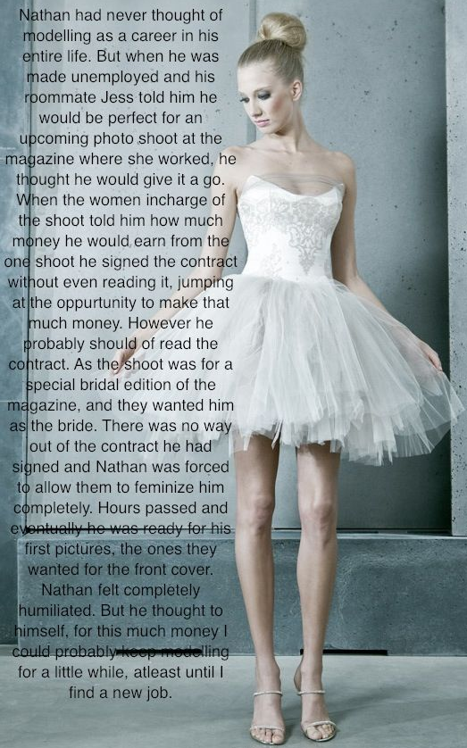

Bridal dresses are fine to wear. I have seen Tima Marso, who is a heterosexual male, model bridal gowns, but it is the bridal lingerie that is the problem. You need breasts and you need a tuck for your panties that seems unobtainable with chemical assistance. I am talking T-blockers and hormones, although nothing about that was said at the time. They called it “body makeup”. It was not until later I found out how the look had been achieved

But I carried on. No real man would ever do that, you might say. But we all have our price.

The way I figured it, everything made up could be brought down, every drug therapy could be ceased, and every change was reversable. I should have said ‘every physical change’. Some mntal changes are harder to undo.

This little bridal outfit was not in the magazine. This is my own wedding dress. It’s low in front because he likes my boobs, and high in the hemline because my legs is what got me into modelling in the first place.

The End

© Maryanne Peters 2020

