The Proteus Effect Chapter 2
By MagnusMagneto
Characters, plot outline, and consultation by Corssan1
Art by Cuddle-Beam

((If you are reading this, then it probably means you’ve supported me on Patreon or a site like SmashWords! If that’s the case, then thank you very much! It’s only thanks to your generosity that I’m able to spend so much time working on stories like this.

If you are reading this and you haven’t supported me, well, I hope that you enjoy the story regardless. If you like what you see, then please strongly consider dropping by my Patreon: http://www.patreon.com/magnusmagneto ))

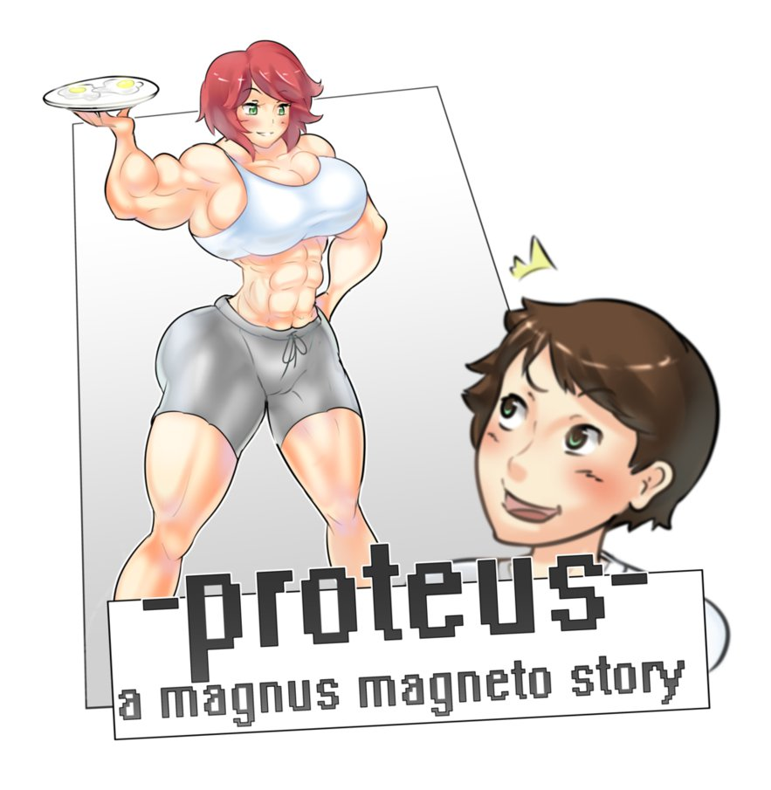

The Story So Far

Eric is an 18 year old high school senior living in a fairly regular suburban neighborhood. He lives with his biological father Norbert, along with his step-mother Camille, and step-sister Selina. One day, in the middle of September, Eric receives an invitation to play an early build of his favorite simulation game, Live-Sim; a game that allows the player to essentially act out a quasi-realistic interpretation of real life. Within the game, Eric recreates the women in his life, including his step-mother and step-sister, alongside three others: his step-mother’s friend, Camille; his attractive Biology teacher, Julia; and his school crush, a cheerleader that he tutors named Chalsey. Within Live-Sim, Eric attaches various traits to the characters he creates. Of particular note, he assigns all of the women the ‘bodybuilder’ trait; which allows characters to both gain muscle faster than the average person, and grants them a far higher maximum muscle potential than an average person. Additionally, he gives other beneficial traits to the girls: Nurturing for Camille, Competitive for Selina, Seductress for Maya, Dominant Leader for Julia, and Super-Scholar for Chalsey; each of which grant bonuses similar to what one would imagine associated with them. Finally, Eric gave each girl a life-goal similar to their personalities and the traits he assigned them.

After creating his virtual town, Eric then directed the girls’ avatars towards becoming immensely muscular, before his virtual self seduced each one. He felt somewhat guilty during the process, but reminded himself it was just a harmless fantasy, and that none of the characters were related to him by blood. Weeks passed, and Eric began to notice strange things occurring. His step-mother displayed a sudden interest for fitness, Chalsey began complaining that muscles were sprouting on her frame, and his biology teacher’s legs looked thicker and thicker every few days. Things continued for a while until suddenly Eric was confronted with the sight of his now-muscular step-mother in the kitchen one morning. In a short amount of time, she had gained a significant amount of muscle. To make matters even more complicated for Eric, his step-sister discovered him touching Camille’s abs, and quickly understood Eric’s secret tastes. The chapter ended with Camille announcing she had outgrown their home gym, and would be bugging Norbert about upgrading it.

1.) A week after the end of Chapter 1, the first week of December: Eric and Chalsey’s latest study session.

“Check it out!” Chalsey exclaimed with a huge grin, confidently shoving a paper towards Eric. He glanced down and noticed that it was a biology quiz; an '89' was written on top, along with the message 'Good Job!'.

“Dang, great work Chalsey!” Eric replied with enthusiasm. “That's a huge improvement.”

She flashed him a toothy grin. “I have to admit though, I kind of wish I did better, and finally got that damn A!”

Eric was surprised by her apparent determination. “Well, I'm sure if you study enough, you'll make it.”

Chalsey nodded. “I think that spending all of this time with you is making me… smarter. It's hard to explain, but I feel like my mind is getting better at absorbing information. I was never really one to study before, but now it's way easier than ever before.”

Eric quietly gulped, thinking back to the Live-Sim character creator. Not wanting to come across as too awkward, he started up another conversation string: “Well, finals are coming up. With some hard work, I’m sure you can get an A on that, and really prove your new knowledge.”

A strange look met Chalsey’s face, “yeah, finals…” she replied wistfully.

“Something wrong?”

Chalsey lingered for a moment before responding: “With the semester ending, what do you think will happen to our study group? We won’t have biology anymore…”

Eric blinked a couple of times. Unless he was mistaken, Chalsey seemed legitimately upset that their time together would come to a close. “Well, Miss Julia is teaching Biology II next semester as well, so as long as you take that, I don’t see why our study group would have to come to an end.”

Chalsey’s eyes lit up. “That’s right! Duh! Oh man… just think about it Eric, what if I keep getting smarter? Do you think that maybe I could become the best student in the class next semester? I mean, I’ve already done too much damage to my average this time around, but next class…”

Eric’s face turned a shade red and he gave a light gulp. Muscles weren’t the only thing that he secretly admired; a woman with a powerful brain was similarly arousing to him. “If you keep trying hard, then that could quite possibly happen.” He explained with a mile.

“Oh man. I never thought I would regard studying as so much fun before. It’s so satisfying though; after a long night hitting the books, feeling your mind pulse and pound a bit, knowing that the next morning you’re going to be even smarter. It really IS like lifting weights, but for your brain.”

Truthfully, Eric had no idea of what the girl was referring to. He figured that it must be another side effect of whatever was happening to her. Perhaps this was the effect of the ‘super scholar’ trait? “Y-yeah. It’s good stuff!” he managed to lie in an attempt to seem empathetic.

As he pondered this, Chalsey began speaking again: “Say, Eric… have you noticed anything different about me? Physically, that is.”

He thought about it for a moment. It was true that Chalsey was filling out her sweater a bit more than he thought she usually did, but knowing how self-conscious she was regarding her muscles, Eric didn't want to say anything. “Uhh… I'm not really sure to be honest.”

“Really?” She asked, her voice slightly disappointed. “I mean… are you suuuure?” Chalsey brought her arms up and placed them behind her head casually, before tensing and untensing her arms a few times; the heads of her biceps danced in response, pressing against the fabric of her long-sleeves.

“Are… are you intentionally doing that?” Eric sputtered.

“Doing what?” Chalsey started with a teasing tone, “Fleeeexing?” she enunciated before bringing her arms down and entering a classic double bicep pose; her arms were nearly fully visible due to the thinness of the sweater's fabric. “I dunno Eric, am I?” she rhetorically inquired before repeating the motion. “I thought you liked this stuff? Muscles on girls like me.”

“I.. I do.” Eric admitted, his face turning a tone red.

“Well, in that case, I bet you'll be very happy to learn that I've actually started lifting weights in addition to all of my cheer-leading practice.”

“But… what about, well, you know-”

Chalsey immediately knew that Eric was referring to her boyfriend, who absolutely did not approve of nor like her changing body. “Who cares. Fuck him. In the, uh, non-literal sense.” she gave a little cough and regained her composure, a rare slip up for someone like her. “The truth is Eric, after watching my grades go up, after feeling my strength increase, after looking at my muscles get bigger and harder… After hearing you admit that you like the way it looks. Well, let's just say that I want to keep improving. Not that I need your validation or anything. I just want to see what I can turn myself into. Become the best possible me, you know?”

Eric nodded, explaining that he understood. The truth was, he understood far more than Chalsey could imagine. After all, he had unwittingly given her that very desire.

2.) One week later, December 8th: in the household living room

Camille was on the phone. Her choice of attire, a tank-top, showed a thick, pulsing arm that bunched up from the mere act of holding the phone to her ear. Camille had gained numerous pounds of sheer muscle in the past two weeks alone, which resulted in plenty of accidental gun-shows for Eric to ogle. It was fairly rare for Camille to use telecommunications at length, so Eric knew that it had to be someone that she was good friends with. The conversation began veering towards personal fitness. Camille went on at length about how she had been really hitting the weights, finding great results in a short span of time. The next few sentences indicated that whoever Camille was talking to also experienced a great deal of muscle growth. Eric’s stomach churned as he wondered just who this mystery person was.

A few moments later, his question was answered: the woman was Maya. Camille explained that Maya had found a new lover that was a personal trainer, who had been pushing her to the absolute limits. She was currently on a business trip at the Caribbean, that was panning out to be more of a vacation, and an excuse to pump herself up to new heights in public view on the beach. This trip was all thanks to a hefty promotion she had obtained, which combined with her new body granted Maya all kinds of new found confidence; not that Maya of all people needed a shred of added self-assurance.

Camille then explained that apparently Maya had been posting a great number of pictures on her new PictureGram account, a popular social media platform for sharing photographs. At Eric’s suggestion, the family huddled around the living room desktop, accessed the internet, and quickly found what Camille was talking about. With a few deft clicks, Eric opened an image of the woman standing on a picturesque beach, proudly donning an incredibly revealing bikini.

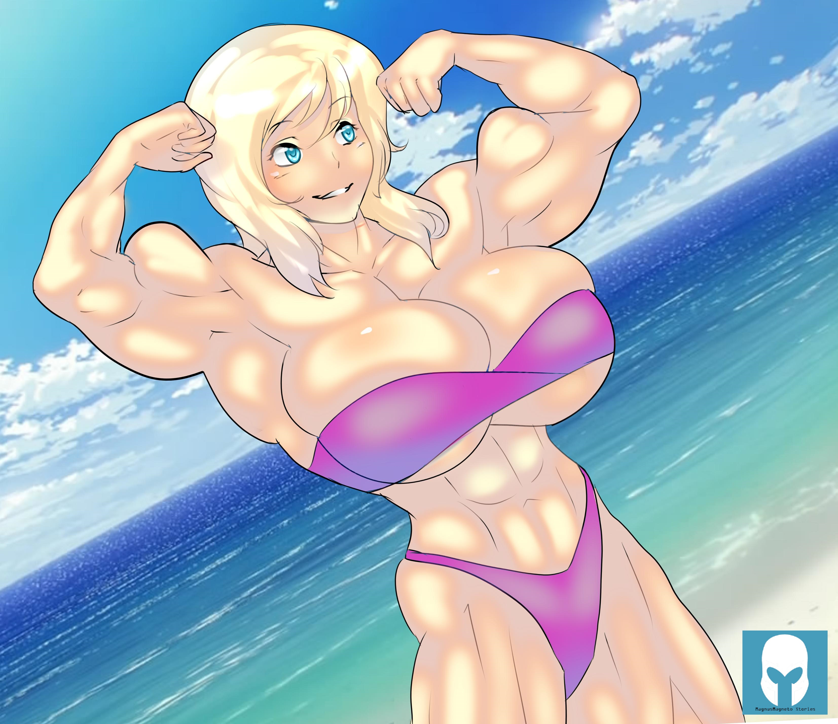

Eric's jaw physically dropped as he looked at the picture of Maya. How could that possibly be her? Saying that Maya had gained a relatively large amount of muscle would be a gross understatement. Based off of his extensive experience with the subject, Eric would wager that Maya was similar in size to a Ms. Olympia competitor; that was to say, she was easily on par with a professional female body builder.

How was this possible? Eric's mind was already jumping to the conclusion that had been haunting him ever since the encounter with Chalsey at the study session, and his step-mother in the kitchen: it was the game. Maya was one of the five girls he recreated in Live Sim, and every other girl other than Selina had packed on a considerable amount of muscle since he played the closed test. Well, Eric wasn't entirely sure if Julia was gaining muscle, but he was pretty certain the continuous thickening of her thighs was the kind he preferred.

Eric turned his attention back to the picture. Her muscles aside, Maya looked even more attractive than before; there was an irritable allure in the way she gazed at the camera. The older woman looked more youthful and vibrant as well, even more so than Camille who had shown similar improvements.

"Say..." Eric started, "What was that you mentioned, that Maya got a promotion or something?"

Camille nodded. "That's right. Maya's making bank! Well, more bank than usual anyways. She's up to the six figures now. I have to say I'm pretty envious of that bod and her paycheck, but, I guess this is how it's always been. My desires aside, I'm happy for her." she said.

Norbert chimed in: "Maya looks great, but no need to compare yourself dear."

Seline spoke up next: "Daaamn. Well, I bet this will be some motivation for you to hit the weights and pump up your guns even further, huh mom?" she asked, winking at Eric.

Camille nodded again. "That's true. I'm glad to see that big muscles do look great on a woman. I was a little afraid of how I'd look, but as long as I end up half as attractive as Maya if I get that big, then I don't think I have much to fear."

Norbert spoke up again: "It's settled then! We're going to all be as supportive of Camille's muscle growth as we possibly can as a family."

"Hey, wait a minute," Eric spoke up, "While I'm all for Camille getting as buff as she wants to, doesn't this all seem kind of weird to you guys? That Maya suddenly gained that much muscle? I mean when was the last time we saw her anyways? Isn't it a bit suspicious that she got that huge so quickly?"

Camille shrugged before responding: "Well, Maya was always in great shape thanks to her pilates, yoga, and aerobics classes. It makes sense she'd gain a bunch of muscle after lifting weights."

Eric blinked a couple of times. "Yeah, but... that much, that quickly?"

"What's the matter Eric?" Selina spoke up, "Don't think that girls can get strong like guys? Haven't you been watching my mom here turn into a champ? I thought you were a big fan..."

Eric turned a shade red. "Don't get me wrong, I've got nothing against the look at all... just, aren't you guys like phased at all by these changes?"

The other three members of the family looked at each other with quizzical smirks. Finally Norbert spoke up: "Son, I think you're overanalyzing things. I know you don't have negative intentions, but it's a bit rude to raise questions like that."

"Sorry. I hope you didn't take it the wrong way." Eric responded toward his step-mother.

"No problem Eric!" The older woman cheerfully replied, playfully ruffling his hair.

A collection of emotions welled within the young man. He thought for sure that people should be reacting to the changes in the bodies of these women. Sure, Chalsey's boyfriend wigged out, accusing her of taking roids... but nobody else has bothered mentioning or questioning anything. It's almost as if they've suddenly accepted that these women are effortlessly gaining muscle like it's their job.

On one hand, this made life a little easier for Eric, as he didn't have to worry about the girls or anyone around them raising a fuss over the changes. On the other, Eric felt a tinge of fear of just what he had done when he recreated the girls in Live-Sim. While he seemed to have improved their lives for the most part, he wondered just how strong they would become. Then his mind wandered to their secondary traits and goals.

That's when the connection first truly settled in: Maya just got a huge promotion, AND she was looking extremely attractive in her picture. He gave Maya the "Immense Wealth" life goal, and the "Seducer" trait. Was the promotion tied to this? Eric wondered in what way they were connected. He quickly came to two primary theories: the first of which was that perhaps Maya was more motivated to do whatever it took to get a promotion and increase her wealth; the other was that perhaps the reality shifts caused by the game were making it easier for Maya to acquire wealth. Both options presented their own set of consequences. Following this train of thought, Eric recalled the other secondary traits he gave the girls, as well as their goals; a chill ran down his spine as he imagined all of the possible outcomes if either of his theories were true.

3.) One week later, Mid-December: Julia’s Biology class.

At the period’s beginning, the class was in an uproar. With finals looming overhead next week, the students were more animated than usual, exchanging notes, complaining about the test, or just letting off stress. As Julia first walked in, roughly half of the class immediately fell silent from her presence alone.

With ever step of Julia’s heeled feet, a tremendous clicking rang throughout the classroom. The young teacher’s heels always produced that distinctly feminine sound, but lately it had become overwhelming. There was no longer any doubt left in Eric’s mind; Julia was definitely gaining a ton of muscle. Her upper body filled out its usual white blouse with ease; her wide shoulders and slender waist gave the appearance of a thick V. Even with dark pantyhose on, Julia’s bulging quadriceps and well formed calves were constantly jutting out at all times.

After giving the remaining students some time to settle down, Julia decided to finally take things into her own hands. She cleared her throat and announced: “Settle down everyone. Class has begun.” Julia voice filled the entire room, oozing with confidence and benevolent dominance. Immediately, every student was rendered silent from that one mere sentence. No other teacher in the high school had this effect on their classroom.

More clicks rang throughout the room as Julia continued moving about. Almost all eyes were transfixed on her. Most of the male students, and many of the females, were watching with lust in their eyes. Julia had always been considered one of, if not the most attractive teacher at the high school, thanks to her age and natural looks; but lately she had taken things to a new level. She started her lecture on biology, going over the various functions of animal and plant cells. Eric noticed that Julia’s tone shifted slightly whenever anything involving muscles was involved. It seemed to him that she grew slightly distracted, as if bringing up that topic led her mind to wander elsewhere. A knot formed in his stomach as he viewed this as further evidence that she was also affected by the game.

At one point during the lecture, she held the ends of her long, thick ruler that often doubled as a pointer in each hand to emphasize a point. With the slightest motion, the sturdy piece of wood broke in two. “Woops… guess I don’t know my own strength.” She explained, a small sweat breaking out on her forehead from embarrassment. “I’ve been having this problem a lot lately it seems.” She thought out loud, “I keep applying too much pressure to things, and they just break so easily. I really need to be more careful I suppose.”

More time passed, and eventually Julia sat down on Eric’s desk again. Just like the last time she did this, her legs were crossed. Eric was confronted once more with the sight of his teacher’s thick, powerful quads bunched up right in front of him. There was something else different about Julia too, something intangible, a kind of aura. Eric failed to properly put it into words, but he felt more and more compelled to listen to and obey her. It was a strange sensation, that of both worry and comfort. He feared the fact that if Julia gave him a command, he would almost certainly carry it out without much consideration; on the other hand however, there was something warming and calming about being in the tutelage of such a wonderful creature.

“So Eric, tell me,” Julia began, turning her attention to him, “In animal cells, what is the function of the-” suddenly she was interrupted by a loud creaking noise. Eric’s desk began to buckle and quake, and a moment later the metal legs on it gave out!

Julia gracefully tumbled off, landing on her feet with a prominent click of her heels. Anyone carefully watching the woman would likely be impressed by the feat, as most individuals would likely sprain an ankle from the footwear involved. “Oh my!” Julia exclaimed. “I hope you’re alright Eric!”

“I’m fine.” Eric replied. The desk was in shambles, but no harm was done to him. Fortunately he had a habit of keeping his desk clear in hopes of enticing Julia to sit on it more often. While the plan worked, it likely wouldn’t work again given what had just occurred.

Julia dusted herself off. “Well, I suppose what’s done is done. I’ll have to be even more careful with my surroundings than I anticipated. Especially if things continue at this rate.”

It was unknown to the class just what was continuing, and at what rate; unknown to everyone except for Eric. He had a very strong suspicion, and if all it would take is for Julia to take her blouse off, or wear something sleeveless one day to confirm his theory.

“Anyways.” Julia continued, “Let’s return to what matters. Studying for the biology final!”

In any other classroom, the ruckus that had occurred would entice a miniature outbreak of noise. Today however, Julia’s presence was too strong, too overwhelming, and too absolute for there to be a reaction beyond a mere few whispers.

3.5) The next morning, breakfast

Over the past few weeks, breakfast at Eric’s house became an increasingly exciting event. It often started after Camille had her first workout of the day, which meant that her muscular body was not only fully displayed thanks to her attire, but her muscles were pumped up further than usual. Due to the increasing amount of food that Camille consumed to maintain her growth, the house often entirely filled with the aroma of protein-packed eggs and bacon. Selina had taken a liking to watching her step-brother acting weak and awkward around Camille. Even when Eric tried to avert his gaze, it was all but impossible for him to not catch glimpses of Camille’s muscular body bulging from even the slightest of efforts.

Per usual, Camille placed two huge plates onto the kitchen table: one with eggs, the other bacon. In the process, her arms - easily bordering on 16 inches in circumference, sprang to life. Camille noticed that her step-son was, once again, staring slack-jawed at her midsection. At this point it was something of an automatic response, so she didn’t hold it against the boy. “What do you think dear? Are my abs looking a bit tighter than usual today?” she asked with a warm giggle before sitting down.

Eric, Camille, and Selina all began taking food from the center of the table, putting it onto their plates. Another phenomenon that Eric was becoming increasingly fascinated by was Camille’s appetite. Despite possessing next to no fat on her body aside from her breasts, Camille kept eating larger and larger portions; seemingly all of it went directly into her developing musculature. Sensing a bit of awkward silence, she decided to spur some conversation: "Mmm. It's a good thing your father bought those new weights, now I can really bring my body to the next level! In fact, I hit new personal bests on every single lift this morning!” she proudly declared.

Eric cleared his throat and collected himself. “That’s great Camille! I’ve read that by now most people who are new to working out start experiencing a ‘plateau’; basically, their progress slows down. Do you think that sort of thing is happening to you?” This question intrigued Eric on multiple levels. First he wanted to try and understand just how much potential Camille really had, and secondly he wanted to know how Camille perceived the changes occurring in her body.

Camille looked slightly confused at Eric’s statement. “Really? Honestly dear, I think that I’m progressing at a faster rate. It seems like every day I wake up and I’m bigger, stronger, harder… all of that good stuff! Plus, my energy is through the roof. I’m so glad that you encouraged me to do this. I mean, just look at this arm!” She announced before flexing her prodigious limb, which caused a thick cord of definition to ripple beneath the bicep’s head.

“Can I feel it mother dear?” Selina asked with a mischievous tone.

“Sure thing!” Camille replied before bringing the flexed arm over to her daughter.

Selina wrapped her hands around it. “Wow mom… this arm is so hard and strong!” she squeezed the limb, completely unable to make it budge. “I can’t dent it at all, it’s like pushing against a big, warm rock! You can’t imagine what this feels like Eric, such a firm, powerful arm, all covered in velvet soft skin.”

This time it was Camille who was blushing, as she did not expect such a performance from Selina. The rest of the breakfast went by without much incident. After finishing their meals, step-brother and step-sister moved into the living room. Once outside of earshot, Selina decided to begin teasing her brother once again: “Wow step-bro, I'm pretty sure that my mother's muscles are like… twice the size of yours now. Doesn't it bother you? Living in the same house as a woman like that? Knowing that her muscles are constantly bulging, squirming, and jumping around? Those firm, powerful limbs that are completely packed with pure power? That every time she works out she's getting bigger, and stronger, and harder?”

Eric's face was beat-red. “W-why would th-that be a problem!?” he stuttered.

“Oh, I dunno. Just the thought of someone like that being around. Constantly all… buff and stuff. Well, don't worry bro, your good little step-sister would never think about following in her path. I mean, wouldn't that just be too awkward? If I started pumping up, letting the blood flow to my muscles, growing bigger and stronger just like my mom? Can you even imagine trying to eat breakfast while being flanked by two immensely powerful female bodies? Ha, just imagine Maya coming over now that she's all huge; you'd have to deal with being around THREE huge, buff beauties. THAT would be too much for you to handle, now wouldn't it?”

Eric gulped. “I… I've gotta go do some homework.” he managed to spit out before taking off.

4.) One week later - third week of December, at dinner.

It was one of the rare occasions where every member of the household was present at dinner. Typically Norbert was busy at work, unable to join in. It had been a while since he actually ate a meal with his wife, son and step-daughter, so he hadn’t actually grown accustomed to the new dynamics Camille’s transformation brought. In particular, Norbert didn’t realize just how much food Camille ate now. Plate after plate of sustenance was shoveled into her face by brawny, bulging arms. She was wearing a t-shirt that once fit her fairly loosely, but was now stretched to its absolute limit across her brawny frame. Father and son couldn’t stop staring at the limbs on display, watching with anticipation as every small movement correlated to another dance of her muscles. Of course, nobody dared mention or complain about the sheer amount of food she was eating; Camille had cooked all of it herself, and it was the very fuel used to build the body they both loved to admire.

What the men failed to recognize however was the sheer amount of nutrition that Selina was also devouring. In fact, they failed to pay any real attention at all to the younger girl. She sat idly by, smirking at their reactions to her mother. Selina was wearing a thick, heavy sweat-shirt, with equally covering pants. This was what Selina had actually been wearing for the entirety of the past few weeks. Had Eric thought about it, he would’ve realized that he hadn’t seen Selina’s bare arms for close to a month now.

At one point, Norbert finally spoke up: “Well, I’ll be the one to say it. You look damn great honey. In fact, it seems like every time I lay eyes on you, you’re better than ever!”

Eric joined in next: “I totally agree with my father. You look amazing Camille!”

Selina rolled her eyes and snickered under her breath. Typically she’d be one to interject a quip, but for now she opted to hold back, watching the situation unfold before her.

“Thanks guys!” Camille replied warmly. “To be fair though, it’s only thanks to all of the resources Norbert provides, and both of your encouragement that I’ve been able to do this.”

“Oh, don’t be so modest. Go ahead and give us the biggest flex you can!” Norbert encouraged.

Camille couldn’t help but indulge the request. She brought both of her arms up before tensing them in unison, forcing the thick balls of power to erupt on command. They were larger than Eric had ever seen, having been brought to new heights from the past week of training. Cords of muscle rippled, and he couldn’t be sure if it was his imagination, but Eric swore he heard a tangible noise of fiber tearing to life. The definition in Camille’s arm was unlike anything Eric had ever seen on a human being in the flesh. The split in the head of her bicep was deeper, and the myriad ridges of flesh more pronounced than even the largest of guys he’d seen in public. A few choice veins snaked their way around the limb, a reminder of the increased blood-flow required to properly sustain Camille’s newly developed arms. Only on the internet had Eric laid witness to a quality of muscle like this. His head began to spin slightly, and it required all of his effort to not make a scene.

Camille saw the light in both Norbert and Eric’s eyes as they feasted on the visual display, which in turn motivated her further. She relaxed her arms before tensing them once again, this time with everything she had. A warm, feminine grunt left her mouth, followed by another ripping sound: this time it was no mistake, the strained sleeves of Camille’s burst open, revealing her round, straited shoulders. “Woops!” she exclaimed with a warm laugh, “Well, I guess that shirt was on its last thread anyways.” Camille brought her arms forward, allowing her thick horseshoe shaped triceps to pop out. They were of similar quality to her biceps. “Want to feel, dears?” she asked, bringing her arms closer towards both Norbert and Eric.

The men accepted the offer, each grabbing onto a tricep. “Go ahead and give them a real squeeze if you want!” Camille offered.

Both Eric and Norbert accepted, and began digging their respective hands into the arm as hard as they could. Despite their best efforts, Camille’s arms barely budged at all. “It’s like grabbing onto a rock!” Norbert observed.

Camille giggled. “You sure you guys are trying? I can barely feel your grips at all!”

“Believe me honey, this is all that I’ve got!” Norbert explained.

“Same here.” Eric conceded.

After a few more moments, the men released their grips.

“Mmm… feels so good to be so strong!” Camille purred, flexing her arms a few more times.

“Say dear, think you can shoot us one of these flexes?” Norbert asked before performing a motion imitating a crab flex.

“You mean… this?” Camille preempted before letting out another feminine grunt as she replicated Norbert’s motion, this time with far more power behind it. The combination of Camille’s hefty pecs pushing against her prodigious breasts, paired with the outward motion of her flaring lats, caused the remainder of t-shirt to fall to shreds. Camille was reduced to a sports bra, which allowed her thick plated pecs and coiled traps to reign free. “Welp, so much for the rest of the shirt!”

Camille continued to pose a bit more while Norbert and his son continued to look on with lustful eyes. She thrived off of the attention, and it further fueled her desire to continue improving. Camille wanted to become as big, strong, and powerful as possible. She wanted to dwarf Maya and every other bodybuilder on the planet. The mental vision she had at the beginning of her fitness journey became clearer and more vivid within her mind. It no longer seemed like a grotesque fantasy; instead it had developed into a goal, something that could tangibly happen - within a surprisingly short amount of time at that. Camille wanted to become more than just a muscular mother; she wanted to become a super-mom, no, an ultra-mom! She wanted to be the ultimate mom. The strongest, hardest, and most nurturing creature on the planet. With her husband and step-son supporting her, she would do everything in her power to make this fantasy come to life.

Meanwhile, Selina watched quietly. Observing the interplay at hand, and taking mental notes. She liked the idea of her mother being a strong, powerful woman, but their ultimate goals did not align.

4.5) A few days later, in the family living room, evening

Eric’s mixed family was gathered once again, spending a cold night in watching television. Usually Eric and Selina would be off doing their own thing, but for various reasons had decided to hang out with their parents. Camille sat on the couch, flanked by Norbert and Eric. She was sleeveless, a common look for her after outgrowing almost all of her sleeved shirts. Both of the men were blushing slightly from the sensation of one of Camille’s thick, powerful arms wrapped around them. Norbert had gone so far as to affectionately cradle the arm in his hands, kneading and squeezing it at times. Camille would playfully tense the muscle when he did so, letting her husband revel in its absurd girth and density. Eric was too timid to try such a thing, he simply sat back, and enjoyed being in the embrace of someone as amazing as her.

In the past few days alone, Camille seemed to have gained even more muscle on her frame. Eric wondered just how large her arms were. If he were more adventurous, he would suggest they measure them, but for right now he just continued biding his time and observing Camille’s transformation. The woman’s muscular body appeared to possess the width of both Eric and Norbert’s combined. This, of course, wasn’t entirely true, but her massive frame did create a huge indent in the center of the couch, which pulled the men closer towards her; in turn giving her an even more dominating appearance.

Selina sat in a recliner nearby, once again observing quietly, bundled up in baggy clothing and a blanket.

After a while, Camille decided to make an announcement: “I suppose it’s time I let you all know. I’m.. Going to be competing in a bodybuilding show in February.”

Norbert and Eric both let a gasp, while a mischievous light met Selina’s eyes.

“Really?”
“Nice! Glad to hear it honey!”
Eric and his father replied respectively.

“Yup. I figured that I should aim for a goal instead of aimlessly lifting weights. Growing is nice, but I’d like to compete against other girls, and see just where I stack up, you know?” Camille explained.

Selina finally spoke up: “So mother, what exactly will be different now? You’re already built like a bodybuilder.”

“Good question dear. I’ll be training even more intensely, and dieting more strictly. Every day I get in one or two sessions in the gym, but from now on I’ll be doing two, three, or even more! I used to just eat everything I’d cook, but I’ll be carefully measuring my macros, and ensuring I have the optimal levels of nutrition entering this body.” Camille replied.

A chill ran down Eric’s spine as he pondered what his step-mother had just said. She was already this big, this strong, and this hard, all without following any specific workout plan, nor any strict diet. But now… now she was going to hit the weights even more frequently, with even more intensity, all while carefully monitoring her nutritional intake. He wondered just how ridiculously strong she was going to become!

5.) Christmas

Eric wasn’t so sure what to expect from Christmas this year. The family gathered in the morning. Camille was dressed in a fairly skimpy Santa’s helper outfit, revealing her arms, legs, and abs. She had only begun her ‘bodybuilder’ training a little under a week ago, but there were already visible results. Camille hadn’t gained much muscle mass, but the meat on her frame had taken on a visibly harder appearance. The ridges, valleys and striations had all deepened, and Camille’s vascularity had increased as a few more large, prominent veins snaked their way across each of her limbs.

After eating a quick breakfast, the family began to unwrap their presents. Almost every gift given to Camille was related to bodybuilding or fitness in some manner. Sports apparel of various shapes and sizes (some even larger than she was now, ‘just in case’), a wide variety of bodybuilding supplements and protein powders, and even more upgrades for the home gym in the form of strange little contraptions to focus on small muscle groups.

The rest of the gifts were of standard affair: lots of video games and game related things for Eric, and lots of clothing for Selina and Norbert. Strangely enough, everyone there seemed far more interested in every gift Camille received. Eric, Norbert, and Selina all imagined just what these presents would entail for her. They thought about the extremely skimpy work out clothing adorning her muscular frame, the unassuming and accidentally neglected micro-muscle groups that could now flourish to their true potential, and best of all: the oodles of even higher-quality muscle building nutrition that would be flooded into her body, repairing those tremendous muscles to new heights.

In the spirit of Christmas, Camille paid extra attention to both Eric and Norbert, giving them a great number of personal gun-shows. For the most part, the day went by without much incident. Eric and Norbert were mostly talking about Camille’s body, all while Selina watched, biding her time.

5.5) One week into January, at one of Eric and Chalsey’s study sessions

Chalsey leaned back, yawning deeply as she stretched her arms upward. The tight sweater adorning her frame rose up, revealing the bottom row of her thick abdominals. Eric couldn’t help but stare at the ridges of power. They were comparable to Camille’s, though their shape and arrangement was slightly different, due to genetic diversity. He glanced over to the side, stealing a peek of her bulging Adonis’ belt, which actually stuck out further and more prominently than Camille’s.

Despite being covered, Eric could see through the fabric that Chalsey’s arms and shoulders had developed to titanic proportions. He knew that she had only actively lifting weights some time last month, so the staggering amount of progress on display was somewhat unnerving. He wondered just what her body looked like underneath the garment. With every breath she took, her sizable breasts heaved up and down, a thick pair of pecs also pushing against the fabric. Eric wondered why she bothered to wear the sweater at all, and concluded that either she was self-conscious about herself, or simply wanted to tease him and anyone else with tastes similar to his.

“Oh, that reminds me.” Chalsey said, “I suppose you’d want to see the results of all your hard work tutoring me.” She said with a wink before opening up her backpack and fishing out a paper, slamming it down on the desk.

It was the biology final from Julia’s class, and there was a prominent 96 circled on the top of the paper. As Eric looked at the paper he felt a concoction of various emotions. Surprise, envy, confusion, fear, and even.. attraction. He was surprised to see such a high score on the girl's paper; naturally envious that she did better than him; confused at what a tremendous increase Chalsey's comprehension of biology had undergone; and ultimately turned on by the thought of this beautiful, buff girl being so smart.

There was no two ways about it, Chalsey had scored higher than he did on the Biology final. Eric wondered if this meant that she was smarter than him overall now, or if this was just one specific incident.

“G-great job Chalsey!” Eric stuttered unintentionally, his mind slightly overwhelmed by the combination of brains, beauty and brawn all in front of him.

“You're blushing, Eric.” Chalsey stated matter of factly, her tone neutral.

“Oh, uh, well, you know, the heat in this room is really cranked up, and I'm in these hot winter clothes…” Eric lied.

Chalsey let out a small laugh. “Come on Eric, I'm not stupid. I know you find me attractive. There's no need to be ashamed. Most of the men I meet, regardless of age, have been visibly attracted to me for years now. After my latest upgrades, it seems that on average, a few less guys look my way, but those who do… It's far more intense than ever before.” she explained with a somewhat mischievous tone.

“Well, sure. Ok. I'm not going to lie. You ARE very pretty. But that's not why...”

“Oooh,” Chalsey started again, “It's the grade, isn't it?”

“What?”

“You greedy little boy. You want a girl to not only be gorgeous AND muscular, but you also want her to be a genius too?

Eric shrugged. He suddenly felt emboldened, as if something within him was pushing him to speak freely and more casually. “Is there anything wrong with that? I think it's better to admire a girl for her merits than to desire for someone to be inferior to you, solely for the sake of feeling better about yourself.”

Chalsey was taken aback by this. It cut deep because that was precisely what was happening in her relationship, which was pretty much all but finished at this point.

“W-well…” Chalsey cleared her throat, “That's good and all. On that note, I think you'll be pleased to hear that I'm by far the strongest girl in the gym. Actually… I'm stronger than the guys too, at least every one that dares lift while I'm around.”

The balance of power had returned to Chalsey's side. Eric was once again reduced to blushing, his eyes darting around as he tried to not think about Chalsey's body pumping iron; not just any iron, but iron heavier than anything he or his other classmates could hope to push.

Chalsey sensed his gathering arousal and decided to continue pressing forward, thoroughly enjoying herself: “And you know Eric, it’s just the craziest thing. I keep getting STRONGER! It’s like every day I walk into the weight room and obliterate my old bests; and it’s not just my body, but my mind too. I don’t want to ever stop. Think about it Eric, since I’m so good at Biology already, maybe I could become a doctor? Ha, imagine that. A bodybuilding doctor with a face like mine! Maybe I could even become a researcher, and make scientific breakthroughs? Cure diseases when I’m not lifting hundreds… no, THOUSANDS of pounds! Maybe I could be a model too! A super strong, super smart, super model! Well, I’m getting ahead of myself here. I’ve got a lot of work to do first. Still… just think about it Eric. Of course, I know you will, regardless if I say that or not.”

Eric’s head was spinning. He excused himself to the bathroom and splashed water on his face. The rest of the study session went by without much incident.

6.) Two weeks into January

Camille’s show was a mere 4 weeks away. As a result, she kicked her bodybuilding training into overdrive, using every possible moment to increase her chances of winning in some way. While there was only so much she could do to improve her body any further, she still needed more practice with posing. There was a tentative plan for her to perform her posing routine in front of Eric, but almost every time this happened, something interrupted them.

Today however, it seemed that there would be no such distractions. Eric would finally get to witness his step-mother’s poses first hand. He was seated on the living room couch as Camille entered the living room wearing nothing more than a stage-bikini and high-heels. Right before she could get into her routine, an interruption presented itself: “Hold on there.” A familiar voice came from across the room.

Eric mentally groaned, was Camille’s show going to be interrupted again? Not that it would really reveal much that he hadn’t seen since her outfit left little to the imagination… but still, he wanted to see just what Camille had in mind with this posing routine.

The voice spoke up again, “There’s a new challenger here!” it belonged to Selina. She was wearing a thick robe, carefully wrapped around her frame. Eric performed a double take; since when was Selina’s body so… thick? A knot formed in his stomach as he had an idea of where this was going.

“How’s… THIS!?” Selina yelled out before dropping her robe, revealing her body in a tank-top and short-shorts.

Eric couldn’t believe his eyes. Selina was… huge! Not just huge, but buff and jacked beyond his imagination! The thick muscles on her frame were actually larger than her mother’s, even if they weren’t quite as sharply defined. While Eric’s eyes grew wide, Selina’s narrowed, as she greedily drank in her step-brother’s expression. She had been planning this reveal for quite some time now, and all of her efforts were finally paying off.

“Mom, Eric, what’ya think?” she asked with a grin, flexing her arms a few times, forcing them to pump up to new heights. Her biceps were easily two inches wider in circumference than Camille’s, and the rest of her muscles were similarly larger in comparison. While Camille possessed an impressive bodybuilder’s X to her frame, Selina’s was even more pronounced, as the younger woman’s upper and lower halves were wider.

“Wow honey!” Camille exclaimed. “I can’t believe that we didn’t notice your transformation. I feel pretty silly now that I think about it…”

Selina giggled. “Don’t worry about it too much mother dear. I actually started working out a few weeks after you, and I made quite the effort to hide my results. I wanted to really surprise everyone, you know?”

“Oh my, that explains it…” Camille started again, “There were a few days where I noticed some of the heavier weights were in the wrong place. One day the bench press had a whopping 30 pounds more left on it than my personal best! Another day, the squat was left at 50 more pounds than what I can manage. I wasn’t sure what was going on, since I’m pretty certain Norbert can’t handle that much weight.”

“Woops. I tried to cover my tracks, but some days I had to bolt out super quickly to make sure nobody caught me.” Selina explained.

A chill ran down Eric’s spine. Selina was that much stronger than her mother? She could squat at least fifty more pounds!? Just how much weight was that anyways? Just how strong were these women?! Another realization dawned on him: did this mean that Selina… was the strongest woman he knew? It must be, unless Maya had continued to make progress at the same rate since that photograph. Then again, Chalsey was definitely becoming very powerful, and he had suspicion to believe Julia was as well…

Mother and daughter both laughed.

“I guess that would also explain why my protein powder and supplement reserves have been dwindling much more quickly than I thought they should be.” Camille noted.

“Oh, yeah. Sorry about that. That stuff is sooo good though! As soon as I started using it, the gains just piled on! My strength skyrocketed even faster, and I just kept growing and growing!” Selina replied.

Camille laughed a bit, “Well, now you won’t have to hide your training or sneak around stealing my supplements! I’m really curious to see what happens when you can liberally do those things.”

“R-really? You aren’t mad? And you WANT me to use your stuff?”

“Well, I’m a little miffed you kept this all a secret, but I’m actually stoked that my daughter is going to reach her full potential! Of course I want to help her in every reasonable way I can. Plus, it might be fun to train together!” Camille smiled warmly, “Still, all of that can wait. I think it’s time to give Eric a bit of a pose down here.”

Selina’s eyes squinted slightly and she nodded. Eric could immediately see her competitive streak flare up, and got a glimpse of his step-mother’s as well.

Immediately, the beefy beauties launched their posing routines. Muscles swelled to new proportions as they became pumped up. Camille kept searching Eric’s face for traces of admiration, while Selina looked for any hints of fear or discomfort. As their muscles engorged further, the difference in size became more apparent. Selina was undoubtedly thicker and fuller. In that sense, she actually possessed the largest muscles of any woman Eric had ever seen in person; or, with even more consideration, the largest of any person regardless of gender, aside from a few huge strongmen with high body fat percentages.

For the first time, Eric began to truly regret having recreated the girls in Live-Sim. Selina was the last person he wanted to grant that much power to, and the fact that she had apparently outstripped her mother in such a short period of time worried him even further. He feared a future where Selina’s growth continued to outstrip her mother’s. A future where Selina kept becoming more and more overwhelmingly powerful, while the other girls simply couldn’t compete with her.

The flex-off wasn’t entirely won on the spot by Selina, however. The young woman’s desire to quickly gain mass presented the consequence of her frame carrying slightly more body-fat than her mother’s. Where Camille had a rippling eight-pack unlike anything Eric had ever seen on a person, Selina had comparatively softer looking four-pack. Where the older woman’s muscles possessed a seemingly unending web of striations indicating supreme definition, Selina appeared to be softer, with less ridges. It was worth mentioning that Selina still held far less body-fat than the average woman, giving her the appearance of a bona fide physique model or bodybuilder; it was just that next to Camille, her definition was slightly less impressive.

“So step-bro, who do you think looks more impressive? Me, or my mom?” Selina inquired, pumping her arms a few times before crunching her abs down, forcing the thick bricks of flesh to pop out.

“W-well, I-I dunno…” Eric replied. Being around two women of this caliber was fairly overwhelming. Then again, he had been around them for quite some time now; he simply didn’t know that Selina was hiding that body.

“I suppose it wouldn’t be fair to make him decide based off of this alone.” Camille explained. “We should help him out a bit.” She moved closer to the young man presenting a tensed bicep, “Go ahead and have a feel dear.”

As Eric brought his hand up to feel the limb, Selina quickly presented hers, “Whoa there, let’s make sure you check out BOTH at once!”

Eric brought both of his hands up, grabbing a bicep in each. He was somewhat overwhelmed by the sensation, but tempered his emotions as best he could for the time being.

“Well, go on, squeeze them!” Selina commanded.

Eric gulped and did just that. He found that Camille’s arm had close to no yield at all to his grip. It was simply too hard, too dense, and too powerful to be dented by him. Selina’s had a little bit of give, but it was still comparable to a large, warm rock.

“WELL?” Selina inquired, growing impatient.

Eric cleared his mind for a moment. “S-Selina, your arm is definitely bigger, but Camille’s is noticeably harder and more compact.” He explained.

Selina let out an audible ‘hmmph!’ before withdrawing her limb and continuing with the posing routine. Following suit, Camille did the same, minus the sound effects. Eric observed the poses for a couple of minutes before the women mutually concluded their motions.

This time it was Camille who spoke up, “So Eric, who do you think would have a better chance of winning at a bodybuilding competition?” she asked with her usual warm tone.

“Yeah Eric? Who!?” Selina was slightly frenzied from the competition.

Eric wiped a sweat from his brow. “Hmm…” he thought out loud, “Being as impartial as I can, like I said, Selina definitely has more mass, but Camille’s muscles are clearly significantly harder. As great as huge guns are, typically in a bodybuilding competition, definition and composition is more important. Therefore, as impressive as Selina is, I believe that currently Camille would place higher on the stage.”

“Aww, thanks honey!” Camille replied with a grin.

“HMMPH!” Selina exclaimed, “Do you REALLY think that Eric? Being all… defined and ripped is the way to go?”

Eric shrugged. “Both are great looks and offer different benefits. In objective terms of winning a bodybuilding competition however, Camille’s defined look is definitely better.”

“Fine then!” Selina began again, “I’ll start doing my mother’s special training. I’ll make my body as hard and defined as possible! When I walk onto that stage I’m going to be the biggest, hardest, and strongest girl there! Just you wait.”

Camille giggled, “While I do want you to reach your full potential dear, I’m not just going to let you win without a fight!”

“Good. I’ll have you know that competition just fuels me to become even better! That’s right Eric, you’ve just set your little step-sister on the path to becoming the strongest woman alive!”

“I… I have some homework to do!” Eric sputtered out before scurrying off to his room.

- To be continued!

