Vlogger
A Short Story
By Maryanne Peters

“You owe me Bro, and I need you to do something for me”. Her words sounded ominous. It was as if I knew that afternoon, that whatever she was asking of me would have consequences – serious consequences. But I suppose that she knew I would say yes. Perhaps because I owed her, but perhaps because she was my sister.

“I’ve been doing a video,” she continued. “I have followers and everything. I did not want to do porn but I wanted something that paid, so I have just been telling a story. A fake story. Now I need your help to take it to the next level.”

“So, what’s your story?” I asked. “And why do you need me?”

She looked very sheepish. It was going to be difficult for her to tell me what she was up to. So I just stood and waited.

“I’ve been pretending to be trans,” she blurted, as if that made it clear.

“What does that mean?” I asked. “Trans what? Trans is what exactly?”

“You know,” she said. “Transgendered. I’ve been pretending to be a transwoman. I have a lot of hits. I really make quite a good looking girl.” She was griining.

“But you are a girl.” As if it needed to be said.

“There’s my problem Conor,” she said. “I don’t have a cock.”

“So, you want to borrow mine?” I joked.

“Exactly,” she said, with chilling seriousness. “I need to borrow you and your cock for a few filming sessions.”

I opened the can of beer she thrust towards me and sat down. I said: “You’d better explain. Just what kind of shit have you got yourself into this time.” It seemed that I was always hauling her out of trouble, but I suppose that is what brothers do.

“Well, you know that I have been playing with vlogs, but never getting any traction. I looked around at some new sites that were getting a lot of hits and I find that there is a whole bunch of internet viewers who follow tranny sites. You know, guys dressing up as girls or transitioning to women. That sort of thing. So, I set myself up as “Stella”, a guy who wants to be a girl. I have 8,000 followers in a little over a month.”

“So what kind of stuff do you put on?”

“Like, clothes, and hair and makeup. All the stuff I did on my girl’s vlog that no one was interested in. But now I am a guy dressing as a girl, I have all these followers. My site is so popular that I am running ads and getting money in.”

“So, what’s the problem?” I asked, taking another slug of beer.

“I am being asked to post nude pix, for money. Like, a member’s only link on my site. I have shown my boobs to some members for money. I told them that I was getting implants, then I showed them my tits. I drew a scar underneath them to show that they are implants.”

“Hey, I think that’s illegal,” I said. “It’s like lying to get money. I don’t know too much about it, but I think that it’s a federal offence when it’s done over the internet. You should bail out of this.”

“I’ll split the money with you,” she said, flatly.

I was short of cash. Somehow my concerns about a potential crime evaporated like a puff of steam. Anyway, she was the one in trouble. She was the liar, the fraudster. I just asked: “How much are we talking?”

“I have got almost $10,000 from members,” she said.

“$10,000! How the hell did you get that much! That is crazy.”

“The guys really wanted me to get the implants,” she protested. “But now they want to see my cock. They will probably want to contribute to sex change surgery now.”

“So, these members of yours think they are paying for you to be turned into a girl? But they don’t know that you already are one? Because you have lied to them?”

She just nodded to all my questions, with a look of total innocence on her face. It was a look I knew. She could do almost anything and look at me like that. Of course, I would help her, and she knew it. I sighed and said: “Ok. Tell me what you want me to do, and I will think about it.”

She explained: “So, I think that I can use the camera to split my top half from your bottom half. I will just cut away and use edits. I need your bottom half to look like mine, except with a cock on it. You will need to shave down and I will paint your toenails. We will just show your cock and then, well we collect some money and then a few months later it is gone, and I am back in front of the camera post sex change. Your body hair grows back and so back to normal. Simple.”

“I like my pubic hair,” I said. This is going to cost you.”

***

“You need to do something with it,” she said from behind the camera. “I will have to prepare your hands and arms. I am not going to touch it.”

“God,” I said. “It would be weird having my sister show off my cock. But what do you mean ‘prepare my hands’?”

“Look at mine,” she said. She held up her soft hands with long painted nails. “I will need you to use stick-ons and apply polish. You will need to match my hands. We need to get to work on softening them straight away. And the hair on your forearms will need to go.”

“Whoa,” I said. “Hiding my girly legs and feet is easy, because I wear jeans and trainers, but not my hands and arms.”

“You are in it now, Bro,” she said. “They are not happy with it just dangling there. You have taken my money, now you have to wave it about, or do whatever you have to do.”

“It’s our money,” I corrected her. “If I am in it, then it is ours. Whatever your members are paying, I get half. Now it is me who expected to perform for them, not you. Need I remind you, they are not interested in a girl. That is what you are. You are just the face, maybe because I could not be pretty enough to draw them in…”.

“All right,” she snapped. “Put this cream on your hands and then let’s have a look at all the things our followers want to see you do, and how many of those things you would be prepared to do.”

She opened her notebook and accessed the messages coming through to the website. What she showed me horrified me.

“This is some pretty sick shit, right here,” I said. “These guys want to see your butt hole and see you shoving things up it.”

“No,” she said. “They want to see your butt hole, behind your hanging balls. And they want to pay you to see it. Right here is what they are going to pay. This guy, and this guy, and this guy. There are a lot of sick puppies in this world. And they have money.”

“I am not sticking anything up my ass,” I insisted. But as it turns out, a guy will do anything for the right amount of cash. It was just that my sister had to agree that this was the point where all the money came to me. She gets nothing for just watching me do that kind of shit.

Do not think that this happened that first day in front of the camera. The first couple of times I was just wiggling my butt at the camera while my sister (who was filming) was saying things like: “Do you like my virgin ass?” Well, they did.

Then the offers came in: This much money to stick a finger up it, or two, or a small dildo, or a big one. The bigger the object, the bigger the cash on offer. And my sister’s commentary was leading them on, with shit like: “No, I can’t do that to my cute little rosebud. No, no.”

The hardest thing was the first thing. My finger with a bit of baby oil on it. It had a long, painted fingernail on it, so I was worried that it would scratch me inside. I almost preferred the little dildo. It was the smallest one she could find. It felt unpleasant and unnatural, but there was money to be made.

After the first thing has gone up there, you start to understand that it is just another orifice. If you keep it clean and well lubed, things can go up there without pain. The only problem is making sure that it closes tight afterwards, with no leakage.

And the audience was happy. It was almost as if I could feel their excitement, these perverts watching me. Even as I pushed my little dildo further in, holding back my shaved ball sack, and fingering my hole with my pink-painted fingernail. It was just for money, you understand.

I think that we nearly blew up our website. Cash rolled in and they were begging for more.

The truth is that they did not want to see my sister’s face, and while her surgery funding site was slowly working towards target, there were more people who just wanted to look at my shaven balls and ass, and were begging to watch penetration, without any pussy in sight.

My bottom half was the star of the show, as I pointed out to my sister. I barely needed her at all, except behind the camera. I was now doing some of the editing, but increasingly the call was for live feed. We could not be putting her head and breasts on what we were showing.

She was pretty pissed that I was now collecting more cash than she was. So, she suggested that maybe I could take it over completely. As she explained it: “I could introduce you as my tranny friend Trixie, and if you don’t need me on the camera after that, I could take a break from this whole damn thing. I could go away and get my sex change and see if anyone likes me after that, and you could still keep then weirdos amused with your floppy cock. But hey, of course I forgot, you don’t have tits and a girly face.”

She was trying to say that I needed her – that there was no way I could make a single cent without her. They wanted a pretty tranny.

“I could be just starting out?” I said. Her point was well taken, but by this point, this whole thing was becoming my best source of income. The printing company that I worked for had laid me off and a bit of freelance design work was not making me enough money.

“You could wear falsies and a bra, I suppose,” she said. “But I am telling you, if you are not pretty you won’t get a fanbase. I have checked out what qualifies as click bait in this scene, and it is not that face. We have a lot of work to do if you want to go solo. And to be honest, I’m getting sick of this. You are right – they are not interested in me. It’s no fun. I will just take my sex change money and quit. It’s all yours.”

Now I should say at this point, that I have never had any desire to dress as a woman or appear as a woman in any way. But the fact remains that most of my body was well headed in that direction. You could see me walking down the street in the winter (with gloves on) as a regular guy, but if you stripped me naked you would find me shaven and plucked with long painted fingernails and painted toenails. And winter was over, and a new manicure every night seemed difficult.

Sometimes money makes decisions for you.

I had no job, and I had been working nights in front of the camera, so I had not seen friends for months. My hair had been longish to start with, and I had been growing it so that I could have it in a high ponytail to which I could add a clip-on for those over the back shots. My face had been hidden from the camera so was not in the slightest bit girly, but if I was to become Trixie, then … ?

“We need to attack those whiskers, and fix those eyebrows,” said my sister. “Maybe after we have you could still look masculine, but maybe not.”

As I have explained, my sister started her video blog doing clothes, hair and makeup, so she knew all about that stuff. I was like, a project for her to work on. She was reinvigorated.

She had some little electric thing which she used on my beard, and she applied all sorts of creams and masks to my face. Then she shaped my eyebrows and gave me a full makeover.

It is a little hard to describe how I felt when she spun me around and showed me my new look in the mirror. I suppose that first feeling was the shock that it was not me at all. How could it be? Then the realization that I was quite attractive as a girl made me feel good somehow. I was better looking than I thought I was. Then the horror crept in. It was the realization that I looked way too good as a girl, way better than I did as a guy. And the eyebrows and the skin. Even if I took all this makeup off, people would be able to see that I was a tranny, in real life.

My sister said: “What a surprise. You’re going to have more fans than me.”

She was right.

A few followers pointed out that Trixie’s penis looked exactly the same as my sister’s. Who would spot that? I thought all penises look alike, apart from size. Who pays attention to that kind of thing? The answer of course, is that the kind of perverts who watch tranny porn do. Some of them may have guessed that my sister was an imposter. There were some comments. But nobody who wanted to see Trixie was in the slightest bit interested about that post-op hag. She was gone. She could retire to the suburbs. She was old news. Trixie was the new thing.

I was Trixie in front of the camera, but who was I when the camera was off? When I put my bathrobe on and took off my makeup and let my hair down, it was no a man looking back.

“Let’s go out tomorrow,” said my sister. “Just as two girls. We’ll go to the mall, maybe catch a movie, then go to a bar or restaurant for dinner. We have money, after all.”

So, we did, the following day when the funds came in. I went out as a girl. Not Trixie – that is a porn name. We agreed that I would be called Theresa. I was pretty, but a little awkward even in fairly low wedged heels, and my hand movements and gestures were, well, ‘tomboyish’. But they improved during the course of the day.

That day made me realize that I could do this. Perhaps I understood that it was easier for me to walk around as Theresa than dress as a guy with plucked eyebrows and no beard. I just merged into the general public. I was a little taller than the average girl, but not super tall. I was better looking than the average girl, that was for sure. I think that you would say that I had ‘striking’ features.

My hair looked a bit ordinary, so after the movie my sister suggested that we both go to the salon to have our hair done together. I had my hair colored ombre, from close to my own dark brown at the roots to honey blonde at the tips. My sister went cabello violeta. I had no idea what any of this stuff was until that day, but by the end of it, I was a hairstyle nut just like my sister.

We took so long at the salon that it was dark when we got out. We went to a place for drinks and dinner and got chatted up by two strange guys. I had to keep my mouth shut, and only talk in whispers because I had a male voice. I needed a lot of effort to develop a female voice over the following months. But in one day I had established that on the other side of the camera, life was easy as Theresa.

But Trixie was still earning the money.

Then one of my followers put down $500.00 towards my breast implants.

One of the last things that my sister did before she left the whole vlog thing to me, was to engineer the bidding war for my new breasts, and then to book the surgery to collect the final payoffs.

I had never wanted any of this, but found myself sitting in front of the camera on a tripod, in my dressing gown with my pretty hair down around my shoulders and my makeup done by my own hand, addressing my loyal followers in my newly developed voice:

“Hi everybody, As you all know I am Trixie, and with your help, I am transitioning. I am on my own now. As you know, my friend has now had her sex confirmation surgery and you have all seen that, but now she wants to live her life the same as any other woman – not in public. I am sure that you all want that for her. She never wanted to be a porn star. She just wanted to live her life, as a normal person. On her behalf I just want to thank all of you, for allowing her to be that person. I only hope that I can be as successful as you allowed her to be.”

At that point, I found myself crying. I put it down to the hormones.

Oh yes, I forgot to explain how that happened. Even before the implant money came in, I was getting pressure to show how my body was responding to HRT. I did not even know what HRT was, but when I found out I was going to write up how I was going to proceed without taking any hormones. I made the mistake of asking my viewers what I should do about hormones. The response was huge, with the overwhelming portion wanting to monitor changes in my body first hand.

I was in the position of going to the doctor and pretending that I was transgendered to get the prescription. But I would never have taken any of the tablets or the shots without first getting clear advice on how the changes could be reversed.

You see, I told you that I never intended to take it as far as I had, so I decided that I needed to set a limit. I needed to decide on the point where I would go no further. I would do what my sister had done. I would have my followers contribute to my sex change surgery and then I would show the results, thank everybody and leave the stage. The end game just required that I show people some kind of fake vagina and the end of it all. I started to consider how I could do that.

In the meantime, my transition story was big time click bait. I guess that I had figured out which buttons I needed to press to excite the viewing crowds. That meant playing with growing tits and my shrinking “clittie” but plenty of verbal material about my feelings and stories of encounters with guys where I did not tell them that I was trans, but I was almost found out. All these stories started as pure invention, but after a while I felt that I needed material from actual experience.

My sister was still around, but just not on what was now my site. She understood what I was going for and agreed to double date with me, with a guy from her work as my date, and a friend of his, for her. Frankly, I just wanted anybody. The important thing was to have something to say on my blog.

His name was Billy. He was a senior executive on my sister’s floor at work. She knew for sure that he had not seen her on her video blog, so he would not have seen me either. She told him that I was a cousin visiting from out of town. This would not be a long-term thing. Just an evening out for us she with her boyfriend Sam, and me and Billy.

I was up for it. It is one thing to be a pretend transwoman doing the soft-porn thing in front of a web-cam, but this was in the flesh, out in the real world. But I was ready. I needed to have something to tell all of my followers.

It was not as if I had never been out. I had. Even after the implants, but just going down to the corner store in a baggy tracksuit. I was not really going out as a woman, but sometimes I was received as one. Now I had to make an effort. I did not want to be seen as a guy with breasts.

When you do a blog as a trans, it is not only the weirdos who watch, but other transwoman. They always have helpful hints on how you should present yourself. Those who do write in with posts or private emails, do not judge you for what you are doing. It is not that kind of community. I was well equipped on “how to pass” from the advice I was receiving. I was good at putting it in to practice. Billy never guessed for a minute.

I am sure that if he had, he never would have kissed me.

The following day I went on the blog with news about my night out. I thought that I was just recounting the story, but all my followers seemed to see something else. Almost everybody said things like: “You glowed from the experience”; “He clearly meant something to you”; or asking: “Is he the one?” or “Are you in love?”. In hindsight the date with Billy did affect me more than I thought to would.

If it hadn’t, I never would have let him kiss me, the way he did.

Billy wanted to see me again, and I wanted to see him, but with me and my situation, there was no second base for him to get too, even I might have let him get to first. My life was becoming very complicated.

And then one of my biggest followers dropped the big one on me. He identified himself only as “Daniel in Admiration”. He offered to pay for the full assignment surgery including breast augmentation. It was a big sum of money. But if I took it, it would be fraud – large scale serious fraud. Somehow, I had convinced myself that if it was lots of people giving a little it would not be obtaining money through false statements, but it still was. But having one guy give you the whole sum? Talk about complications?

I suppose that the real problem was that I now found that my male life was fading away. When I looked at myself in the mirror, I think I saw what Billy saw. I looked female.

In front of the mirror I tried to strike manly poses and expressions, but none were convincing. That’s right. I could not even convince myself that I was not a woman.

And Billy was harassing me. He kept on texting me and asking if I was still in town. He begged me not to leave without seeing him. I suppose all those words touched my heart a little. Or maybe it was the memory of the last date. It had been pretty cool.

I asked my sister if she would do the double date thing, but she was busy. So, I agreed to go out with Billy alone. I felt as if this was the only way to end this crazy “relationship” that seemed to be emerging. I liked him, a lot, and he deserved the truth. But I could not tell him. He would have to grope his way to it. And that is what he did.

It really was a wonderful evening, and when he invited me back to his place I agreed. But I felt that if he learned about me there, I might be in danger, so I hotted things up in the back of the cab. When my hand reached his cock, I found it strangely easy to hold it and feeling it growing in my grip. It should have disgusted me, but it didn’t.

Then, as I thought, his hand reached for my pussy, but it wasn’t there. I felt the moment like an electric shock, even though I was expecting it. I forget the words he said, but the cab pulled over and he got out. And I found myself crying. I could barely tell the cab driver the change of destination. I was in convulsions of distress. Why?

That was that. Time to rethink everything. Time to realize that if you take hormones, your brain gets fucked up. And if you deceive people, some get hurt.

I went on line and told the story of my most recent date. The boy I was dating had discovered my secret and it was over. As I told the story the tears came back. It was not a put on. I really felt that he deserved a proper girl. It was a sad, sad situation.

But, as it turns out, it was not over. I had a call from Billy.

“I ran away because I was shocked,” he began. “I know that it must have been just as upsetting for you. I thought maybe I would say that I wished you had told me, but I understand why you didn’t. You want to be a girl. I get that. I want you to be one too. I want to help you to get there. I want to support you through the change, if you’ll let me. There is a wonderful woman in you who deserves to be free…”.

It was one of the nicest things that anybody would want to here. Understanding, support, and perhaps the promise of love. He could not give me financial support, but he would be there for me.

Most importantly. I felt that he could see the real me. My video blog audience had listened to a pack of lies, but the woman Billy saw in me only came from two dates. That was enough for him to see what I could not see – that I was not a guy at all.

I sent a private email to the guy who offered me the money. I said that if I accepted his offer I could offer him nothing in return. I said that my heart was already taken by another man, who did not have the money to make us a proper couple. That supporter replied with the words: “I want nothing more than to bring into the world the woman that you were meant to be”.

Those words touched me deeply.

We invited him to our wedding, Billy and I. If I expected a pervert I should have been surprised, but I knew that he was not that. He bought his wife who was a glamorous transwoman herself. He was wealthy and they supported transgender causes and privately sponsored people like me.

I can say “people like me” because I have finally come to terms with who I am.

It turns out that I was not lying to the camera at all. My sister was. I barely talk to her these days. I feel badly about all that I did to help her make money from her video log, but my conscience is clear about everything that I have said as Trixie then, and now Theresa. I was a woman, I just didn’t know it.

The End

© Maryanne Peters 2109  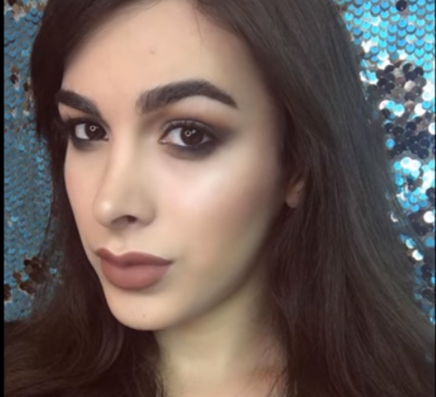 | 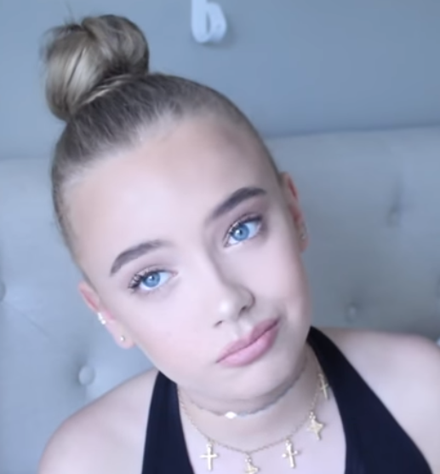
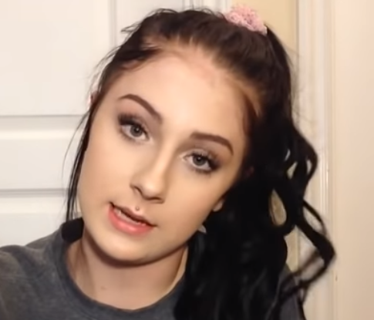 | 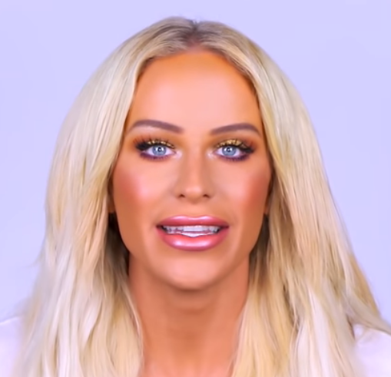
Authors Note:
This one is for a reviewer Brittiniblaire who suggested: ”Maybe a fashion blogger or YouTube sensation”, although Britt, I have had this story in mind for some time.

