Stewardess Forever  A Vignette  By Maryanne Peters  I always thought of it as just a fetish. I was a compulsive crossdresser, a transvestite who had found a special way to get my thrills. I wanted to appear to be an airline stewardess.  I remember as a small boy being bounced on the naked knee of a beautiful air hostess (as they were in those days) or perhaps that was just a dream? Anyway, I was fascinated by them from a young age.  I had a special way of expressing myself. I had a range of stewardess uniforms at home and on weekends I would dress up and head to the airport. It was not enough for me to stare at myself in the mirror. I wanted to be seen and admired, especially by good looking men, and (strangely perhaps) by small boys. The airport was the place to do that. Afterall, it was where I belonged. | 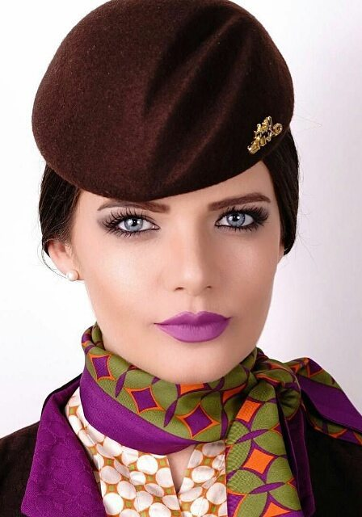

I would prepare myself with a close shave and then wash my long hair that I wore oiled as a man. I would wear my tight undergarments that including a crotch restraint that I knew would be painful if all went well. I would put on my stocking and my dress, and my heels and my hat, my scarf and Jacket. I would brush my eyebrows and attend to my make up and get an Uber to the airport with my small roller case in tow. I would walk the concourse, back and forth, sometimes sheltering in the ladies and sometimes stopping for coffee, but always in a slight rush – looking the part.

People would see me walk by and they would stare. My little clitty would strain against the rigid fabric over the silk and lace against my shaved groin, but the pain was part of it. I might wink at a small boy, perhaps to send him on this path, an admirer and perhaps an imitator like me. The whole thing was just so wonderful to experience that I could never imagine it to be wrong.

What happened was never expected, or even contemplated. A man saw me and came over. That had happened before. I would just say in my practiced feminine tones – “Sorry I am late for my flight”, and hurry away. But this man was not there to chat me up. He was flight crew from the airline I was pretending was mine – a captain.

“Are you the replacement?” he said. “They said that it would take hours for you to get here.”

“No,” I said. “I have just come off …”. I always picked times when I would not meet a crew from the airline I was dressed to serve. “… a connection after a long haul flight.”

“I don’t care. You’re on our plane and I will authorize any bonus. We are two short on the flight to Paris leaving in 5 minutes. Come with me. We need to go straight out to the tarmac.”

The sensible thing would have been to tell him then and there that it all just pretend, but there was something about the moment that seemed as if it was a fantasy fulfilment. In such moments your mind seems to go blank. You are in the fantasy so you go where the fantasy takes you. Where would that be?

“Yes, Captain,” I said. He sprinted off and I tottered after him in my heels.

I was shown my station in business class. As the captain explained I was a last-minute ring-in so I should enjoy lighter duties than the heavy demands made of crew in coach.

“My name is Elaine” I said. For some reason I chose the particularly stupid air hostess in the comedy movie “Airplane”. I could not think of another suitable name.

I watched the other cabin crew at work and I had travelled enough to be able to hand out the towels and the drinks, and then the dinner service. I was delivering my sexy stewardess smile to everybody, and getting smiles and thank you back. It was the real thing. My dream – I was a real stewardess.

The time seemed to fly by. I chattered meaninglessly with the other crew, making comments about the strange passenger in 8D, or the passenger in 5F who had spent also an hour in the toilet. I laughed with them. I even went to see the captain with some refreshments.

“It’s Elaine, isn’t it,” he said. “I am told that you are a real pro. You must be worn out. But when you get to Paris, I will see that you are well looked after. That is the least I can do.”

Paris! I had barely thought about it. By the time that the passengers were gone I simply joined all the crew and passed through crew only entry and into the minivan that took us into the city.

The captain was good to his word. He told me that I would be working the return flight the following day so he understood that I may want to rest rather than go out.

“Actually, I would love to go out, but I have nothing I can wear,” I said. It was true that I did not want to go to bed. I wanted this adventure to last, regardless of the risks. “Everything in my bag has been worn.”

“This is Paris. I am sure we can find you something,” he grinned. “We almost aborted because of crew minimums yesterday, so I will certify it and the airline will pay.”

I don’t only wear stewardess uniforms. I do like a colorful figure-hugging cocktail dress. Others like me will understand. I found something perfect and shoes as well, and the captain paid. He paid for the salon too. Then we went out on the town. Cabin crew and flight crew on the loose in the world’s sexiest capital. How could I think about anything else?

But I was tired when I got back to the hotel. I had my own room, but somehow, I ended up in the captain’s room, and perhaps a little too drunk for my own good.

I should have been more careful, but for the first time in my life I had spent more than just a few hours as a woman, and it was almost as if I had become what I dreamed of being. But anatomy does not lie, especially when I was lying on his bed.

“Oh my God, Elaine!” he said. “You have a bit extra!”

It was just like that. Like “You have a heart-shaped mole under your belly button” – just pointing it out. He seemed more amused than shocked.

“I am so sorry Captain. I need to get back to my room.” I struggled to pull myself up and together.

“No, please. I have never before … I am an open-minded man,” he said. “I travel to all parts – a true man of the world, you might say. I have to be open to everything and everybody. And I am open-hearted too.”

I was not sure what that meant, but I liked the words. I was going to say – “No, no, I’m just a transvestite. It’s just a fetish. Just for the thrill. I don’t do …”. But as before, there was something about the moment that seemed as if it was the ultimate fantasy fulfilment. My mind went a little blank. I decided to go wherever the fantasy took me.

That would that be here – where I am now. I am a full-time stewardess on international flights. My name is Elaine, formally now. I smile and serve and people admire me. I am living my fantasy.

The End

© Maryanne Peters 2024

