Wonderful
Inspired by a Captioned Image by Annabelle Raven
By Maryanne Peters

I guess it runs in the family. Is that even possible? The craziest thing is that I have spent most of my 68 years wishing that I had been born a woman, and I had to wait for my grandson to graduate before I did a damn thing about it.

I had accumulated all this money and I was not happy. I had two sons who had joined me in my law firm just as I wanted, and I was not happy. I had memories of a happy life with my late wife, but even that did not bring me the joy I thought it would. Instead it seemed to me that what had been missing my entire life was the chance to live as a woman and be made love to by a man.

Back when it all started for me, in the 50s and 60s, it seemed to me that I must be the only person in the world to have such strange thoughts, but as it turned out I was not alone – not even in my own family.

Dave and I agreed that Kyle could have whatever he wanted as a graduation present. Dave was so proud of his son, and I was proud of both of them. When Dave was born the firm was still short of money, so he never got the graduation gift that he should have. It was overdue.

So, what did Kyle want? He made sure that both Dave and me were seated before he told us.

“What I really want, more than anything else in the world, is to be a woman.”

I have to say that the words sent me to a strange place. I felt touched that my own grandson should share my thoughts, but at the same time I knew his pain. He too would face a life like mine.

“You know what that means?” I turned to my son Dave to see him finish the question. No panic. No protest. He was just looking at his son with a look of concern on his face.

“I know all about it, Dad,” said Kyle. “I have looked into it. Of course, I have. I know is will be a long and painful process, but I know what I am and what I have to do. I am a woman, and my body needs to change to be mine.”

I was still dumfounded. Of course, I knew about gender confirmation surgery. Even when I was Kyle’s age there was such a thing, but it always seemed to me to be close to medical butchery. I suppose I lacked the physical courage at that time, and then just the moral courage to consider it as a possibility as my family and my career took over.

And then I saw the tears in Dave’s eyes. It looked to me like love. My son was at last showing the emotion that he always seemed to bottle up. It had taken his son’s life changing choice to bring it out. Other fathers would have abused their boy, but Dave surprised me with his sympathy.

“Kyle, I understand more than you could possibly know,” said Dave. “Because I fell exactly the same way. Just like you I have always known that I am a woman inside. This is my body, and I take care of it because it is where I live, but I hate it. I want exactly what you want.”

I just sat there. I started to wonder what they must think of me. Did they think I was the only man in the room? I was the only one who was not crying. They hugged, and I was thinking: ‘What about me?’ But something forced me not to join in.

“Is this what you want for a graduation present?” I asked. It was as cool as that. They were both aware that I was in the room and not fuming about what was going on.

“It must come as a shock to you, Gramps,” Kyle said. “But, yes, that is what I want. More than anything.”

“I was actually asking both of you,” I said. “It is clear to me that I can give no greater gift to both of you than to make your greatest dream come true.”

“Me too?” said Dave. He was looking at me as if I was a stranger, or as if I had suddenly gone crazy.

“You too,” I confirmed. “Remember I owe you a graduation present.”

“I haven’t yet … Kyle has clearly been planning this … I have things that I …,” Dave was stammering his way through. What he wanted was now suddenly a possibility. Watching him in that confusion I was started to feel that it might be a possibility for me too.

I decided that I needed to cut him short. I explained: “You and Cheryl have split up, and your son clearly supports you, so all you need to worry about is the law firm, and you and me are the controlling partners, so where is the issue? But sure, this is a shock, so we don’t have to rush into anything. Let me suggest that this weekend be the weekend when the women step out. It will be my treat. Full makeovers. Let us see what the women will look like, and how they will perform. Nobody needs to make any decision until we see what is achievable.”

“You’re OK with this Dad?” Dave was in disbelief.

You find the best place in town to effect a total transformation and I will make the bookings. We’ll stay at a hotel. We’ll go out to dinner, walk around town, go to the shops. Test yourselves. And it can be in the knowledge that if the decision is made to push forward, I will pay for it. My special gift.”

Now was the time for us all to hug. Three generations or transgender women.

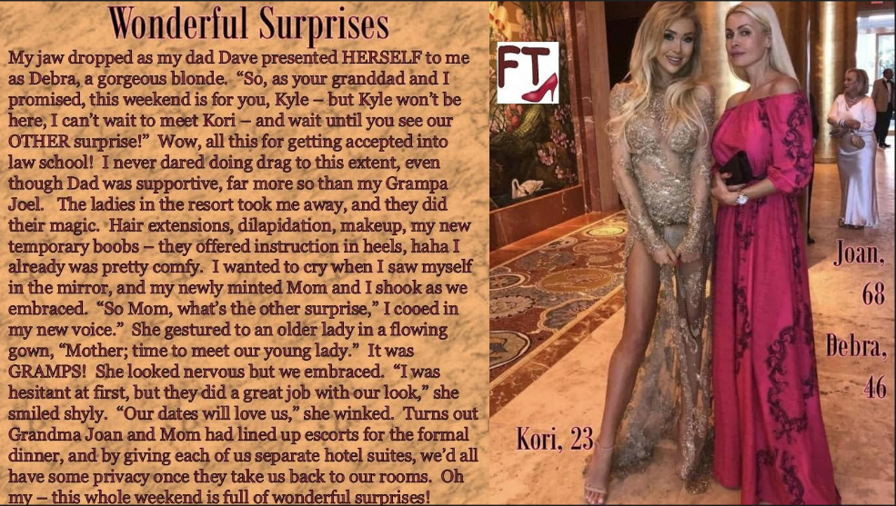

It was only when I saw what they had been able to achieve with this old face and body that I felt able to call the male escort agency.

After all, call me old fashioned but I think that nothing makes a woman feel more like a woman, than having a man giving her his attentions. This lady maybe getting old, but she is still open … to new experiences, of course!

And I have to say, that night was full of wonderful surprises for all of us.

The End

© Maryanne Peters 2020

Leaving the Nest
Inspired by a Captioned Image (suggested by Annabelle Raven)
By Maryanne Peters

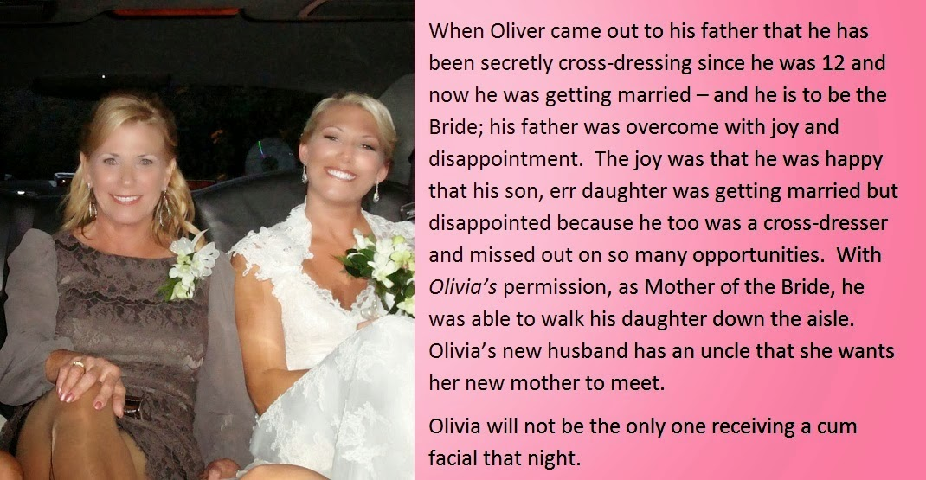

Please understand, I loved my wife. I loved her so much that I became the man she wanted me to be, although I was never that man.

She was religious, and while I was never a believer, I went to church with her and hung my head when they all prayed. She prayed that I would never go relapse into the perversion I had told her about before we married. She could never understand my desire to dress as a woman. I never could either.

When Oliver came back home from college in a dress, she hit the roof. She blamed me, although I never knew about him, and he never knew about me. She cut him off. She said that she could never accept that her son could become a woman.

But I have always loved my son Oliver, and I will always love my daughter Olivia. It was the difference between us that ended our marriage.

Olivia could not understand it at first. It would have been impossible to explain to Oliver, but to Olivia it was easy. “I’m just like you,” I said. We held one another and wept – two women born in male bodies.

She was already well advanced with her hormone treatment and feminine appearance, but I worked hard to catch up. I had some surgery on my face and chest, and hair extensions. Wen she told me that she was getting married I wanted to be there as mother of the bride. Her real mother had cut us both off by then.

I had always thought that loving that woman the way that I did meant that by becoming a woman I would be forever alone, or perhaps find a lesbian willing to take an ex-man as a lover. I never dreamed that I would ever meet a man like Marcus, the uncle of my daughter’s husband.

Marcus knew all about who I was, just as he knew that the bride had not always been a woman. He had met Olivia many times, but he did not meet me until the wedding.

He was a little older than me, but his children were younger. He still had two of the four at school and living at home with him, his wife having died many years before. He struck me as being a person very much like me – a man who believed in love and family before everything.

Olivia seated us together at the reception, and we talked and we talked. Then after dinner we danced, up close. It is one thing to know that you are a woman, but when a man holds you like that, nothing is more certain. It is often said that a transwoman does not need a man to be a woman, but I think it helps.

We were both staying in the hotel above the reception venue. He asked me whether I would consider coming up to his room for a nightcap.

He had his arm around my waist as the guests bid good night to the happy couple. Olivia winked at me. I think that I might have blushed.

He took me by the hand and led me to the elevator. We were alone inside it so Marcus took me in his arms and kissed me. Nothing has ever seemed so right. I could never have imagined myself in this position, but now that I was here, I knew that I belonged there. There in his arms.

I wanted to have sex with him the moment that we got into his room. But I told him that I was incomplete. He could see that it upset me to tell him so. He said that it did not matter.

“It’s only temporary,” I said. Whatever I might have thought before that night, I knew that my days as a man would soon be over forever.

But until then we needed to use what we had. His fondling my breasts was enough to send me through the stratosphere, so the least I could do was to give him the blow job of his life.

The End

© Maryanne Peters 2019

No Real Choice
Inspired by a Captioned Image Suggested by Annabelle Raven
By Maryanne Peters

I never found out exactly how Dad lost his job, but it cannot have been good. It might have been something to do with the morality clause in his contract. The company was owned by some apostolic church and they may have got wind of Dad’s “hobby”. Anyway, one minute he had a house and a job, and the next minute we were out on the street.

All he had left was this guy Phil. Phil was going to come to the rescue. Dad had been in contact with Phil for over a year. He had been sending Phil pictures and Phil had been sending him clothes -women’s clothes, and other stuff.

Come to think of it, it is a miracle that Dad had been able to conceal the changes from his bosses at the company. Somehow, he had been able to tuck the hair away and hide the shape of his body and the shaved arms and legs.

Even before he lost his job, I told him that he needed to see a shrink. He just said that it was harmless fun, but it seemed to me it had gone way past that. He says that it was Phil who insisted on more advanced changes.

Before I met him, I wanted to hate him. But it turns out that he really is a nice guy. He is just looking for love, but it seems like his is looking in strange places.

So, Dad said that he was offering us the room above his garage, and he had already moved his stuff in, because we were on the street. He told me that there was a box of my stuff moved in too, but not everything. He said we were turning over a new leaf both of us.

Believe it or not, the redhead is my dad, showing me the stuff on my end of the closet.

“It’s a case of like father like son,” Dad said. “I have a son that likes to wear women’s clothes just like his old man, and Phil has a son Chris who likes his girls to have a tassel, just like he does.”

Well that turned out to be wrong on both counts. I don’t like to wear women’s clothes the way Dad does, I just like the way I look in them, and so does Chris. And as for Chris, he doesn’t really like girls “with a tassel” as Dad calls it, but he says that before we get married, we can get rid of it.

I love him so much now, there is no real choice about it.

The End

© Maryanne Peters 2020
Meet My Girls  Inspired by Annabelle Raven  And this Captioned Image  By Maryanne Peters  I had just turned 30 when my father changed sex. I was married to Fran and we had two sons. The oldest Dean was just 8 - the age when his father is the most important person in the world. | 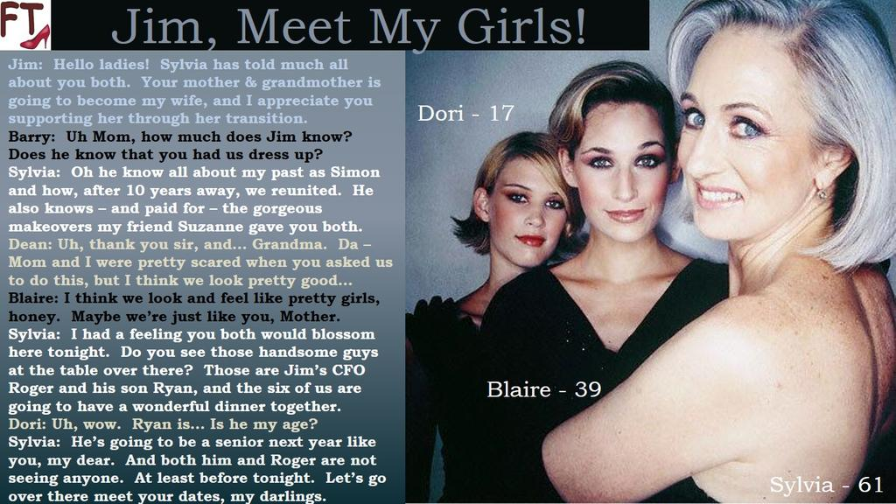

My marriage to Fran was just starting to crack at the time, although I had no idea why. My father asked me to meet him – or rather to meet her – Sylvia.

Sylvia wore a wig in those days. After that she had the facial feminization surgery and the scalp work so that she could grow her hair. She still made a very convincing woman, which surprised me. But the bigger surprise came when she started to tell me that she had at last found herself, and she was free to be happy. I was jealous. I was not shocked at what my father had done to himself, I was envious of the new life that was before her, just as my life seemed to be headed downhill.

The obligation on a parent is a serious one. My father recognized that. He had felt that he was a woman his whole life, but he kept his feelings in check until he met his obligations – first to his own children and then to his ailing wife – my mother. When she died Sylvia could step out, and she did.

I needed to accept the same responsibilities. I needed to see my children raised properly and to build a working relationship with Fran to see that happen. But it was not easy. I watched from a distance as Sylvia grew into her femininity and became vivacious and desirable while I became dull and withdrawn.

Fran thought that Sylvia might have a bad influence on the boys. Of course, as my parent she was with us for family occasions as our children’s grandmother, because they had never really known my mother, their real grandmother. But Fran would not encourage them to visit Sylvia alone. But as I later discovered, they did, or rather Dean did, regularly.

I had no idea of what Dean was going through, but perhaps conditions jump a generation. Or perhaps they just pass through each generation – read this story and decide. But Dean was having issues which he felt he could share with Sylvia but not Fran and me.

Things came to a head when Fran and I finally split. I had the luxury of it not being me to be the first to have an affair, but I did not condemn her. We both knew it was coming. The boys were 17 and 15. They were old enough to know what was happening before it happened.

It seemed convenient for me to move out and stay with Sylvia, and the idea was that Fran could keep the house until our youngest finished high school. But then I discovered that Dean spent almost as much waking time with Sylvia as he did at home. He came to visit his grandmother and to be Dori.

It turns out that not just my father was transgendered, but my son too. He ached to be Dori but was to ashamed to tell his parents – me and Fran. When I arrived to stay with Sylvia she told me that she would not allow it to affect her time with Dori. I had no idea what she was talking about, but then, on cue a pretty teenage girl walked into the room.

Any parent should know their own child, but it took me a minute of confusion.

“Hug your daughter,” Sylvia directed, in a tone that I had not heard since I was Dean’s age, or rather Dori’s age. He eyes begged for acceptance. Of course, I loved her. Of course, I wanted her to live her life as she was meant to be. Of course, I wanted her to be happy. I hugged her and she hugged back as if she never wanted to let go.

I found myself living in a house of women who were not originally women. How is that supposed to affect a man, especially a man in need of a change of life.

Then, Sylvia told me about another regular visitor – her “boyfriend” Jim. It turns out that Sylvia knew Jim before transition, before he moved his business out of our city. Now, after 10 years that business was big enough to return and build its own factory on the bones of the derelict industrial park on the northern edge of town. She said that she thought he might become an important person in her that, and that we should meet him, that night. We would be going somewhere nice as his treat.

I had yet to get all my clothes from home. Sylvia said: “That’s alright. I want Dori to go as Dori, and so in support you should dress as a woman too. You’re my size exactly.”

I laughed, but Dori said with wide eyes: “Would you Daddy? Would you?”

The idea was crazy, but there I stood. I shrugged. “Why not? Girls night out?”

Dori clapped her hands. Sylvia looked pleased to.

“We are going around the corner to the salon run by my miracle-working friend Suzanne,” announced Sylvia. “So be prepared to be transformed – body and mind.”

Suzanne was large and friendly, and her salon was equipped for more than hairstyling. Sylvia directed that I receive “The Works” and that started with a depilation job on my face, chest, arms and legs.

“Your hair is long enough to style,” said Suzanne. “We just need a little bit added to the front to be swept to the side to show that wonderful forehead and hairline that you have. You are all very lucky to have so much hair.”

To be honest, I did not what to expect. She put a little color in the front and used some rollers to get volume. Then she got to work on the makeup with my face turned away from the mirror. I could see Sylvia have her grey bob perfected, and Dori get a cute flip to destroy any notion that there might be a boy lurking inside. They both looked like women, but how would I look?
Like this, that’s how. With Dori looking on as I looked in the mirror and could not help but smile. The hair looked so feminine the way that Suzanne had done it, and the makeup was perfect. I was afraid to talk and break the spell. I just stared.

Sylvia had a black dress for me to wear, and under it a bra with some bands to create a cleavage from the skin on my plucked chest, and gel inserts below to allow a bit of weight and wobble. The hemline was quite high, but my freshly shaved legs, moisturized and with a little color added, would be bare for the evening.

“Are you ready,” Sylvia said, clearly in charge of the evening. And when we both nodded, she said: “Good. Let’s go get ‘em.”

We arrived at one of the priciest restaurants in town. I was still coming to grips with the heels on my feet, and last-minute instructions from Sylvia on how to sit, and how to use my hands. I did not notice that there were others at the table until I was right there.

Even then, the dominant figure was clearly Jim – tall and straight, tanned and fit, with a good amount of grey hair, but there were two other men. They all stood as we drew near.

“Hello Ladies,” Jim said. “Sylvia has told me much, if not all about you both. Your mother, and your grandmother, is going to become my wife,” he said to us each in turn. And to me he added, taking me by the hand: “I just want to say that I appreciate you supporting Sylvia through her transition, as I am sure that she will support you through yours.”

What was he talking about? How long had it been planned that I dress as a woman? Transition? Or was he just talking about Dori?

“This is my CFO, Roger,” Jim continued. “And this is his son Ryan. Sylvia said that you wouldn’t mind. I am sort of coming home, but this is a new town for Roger and Ryan, so they don’t know anybody, and you and Dori are locals.

“Of course, we don’t mind,” said Sylvia. “We want to help you settle in. This is my daughter Blaire, and her daughter Dori, my granddaughter.”

“I find that hard to believe,” said Roger, taking her hand.

“You can keep talking like that,” said Sylvia. And to Ryan she said: “Can you match your father’s charm?”

“Probably not,” said Ryan. “But only because I hadn’t realized that one city could have so many beautiful women.” He might have been answering Sylvia but his eyes were fixed on Dori.

Roger clasped my extended hand. I would normally grip and shake, but something made me just leave my hand in his, as if inviting him to have any part of me. He gently directed me to the seat beside him.

“Are you born and raised here?” he asked.

“Yes, yes I am.” What came out of my mouth was a sultry whisper. It was the sound of a woman’s voice. I did not pretend or imitate it; it was as if I summoned it and it appeared. “I hope that you like it as much as we do,” I added.

“I think I’m going to,” he said, and it was as if he and me were the only two people in the room. And it seemed that way all night.

In the case of my family, it is not that conditions jump a generation, because I discovered that night that I was transgendered too. Either that or I fell in love with a man who wanted a woman, and so that is what I had to become.

There were four weddings in our family in the years that followed. Jim married Sylvia first, with Dori and I in the bridal party. Over a year later I married Roger, attended by Sylvia and Dori. I am pleased to say that Fran was next. She found a man who really was a man, and we were happy for her. And then all three of the recent brides wept in unison as our daughter and granddaughter walked do the aisle to marry her wonderful Ryan.

And nobody could have been prouder than Jim, the man who brought us all together. We will always be Jim’s girls, the three generations, and he knows it.

The End

Surprises
Inspired by a Captioned Image by Annabelle Raven
By Maryanne Peters

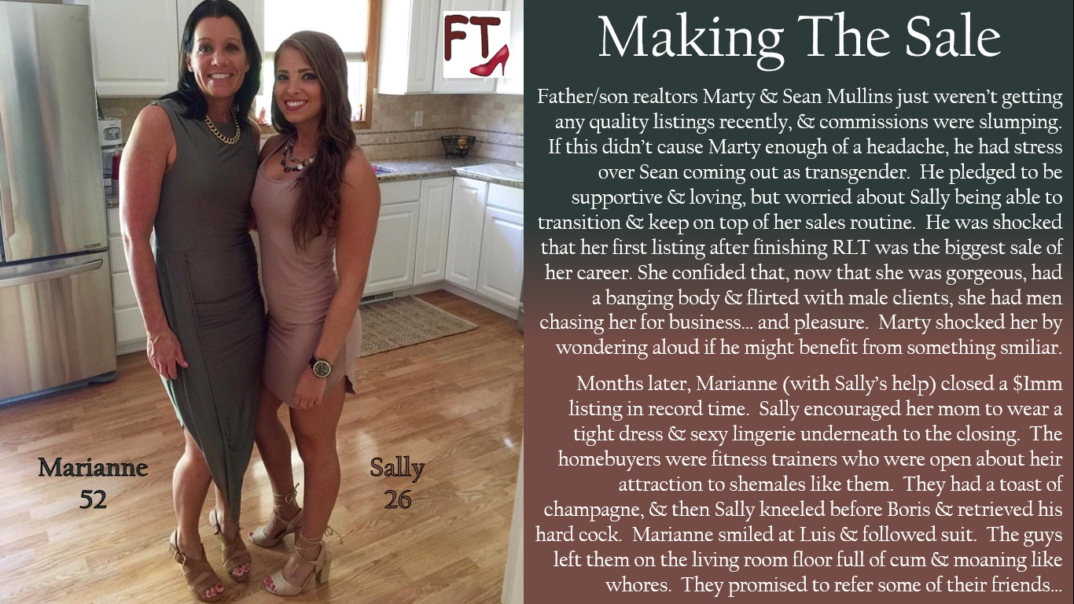

I suppose that the biggest surprise was the sex. It came on top of all the surprises, but it has to be the biggest.

Perhaps the smallest surprise was when my son Sean told me that he was transgender. It was not that he was not athletic, although he was smaller than most young men his age. It was just that he had always been interested in things that a girl might be interested in. He would pick up a women’s magazine in a waiting room, or stop at a dress shop window. They were just little things, but a father ought to notice, especially as we were so close.

The death of my wife brought us closer. She had worked in our realty business alongside me, and after she died, Sean quit college to take her place. I noticed some changes in my son and that was when he told me about her desire to live as a woman.

It is hard for any man to accept that his boy wants to give up a normal life with a chance of a family, for a life maybe outside the mainstream, with potential problems in being accepted and possibly the pain and risks of surgery in the future. But I never doubted that I would offer him full support, which is exactly what I did.

I was a little uncertain as to how she would function from then on, as an effective realtor. So, the second and greater surprise was just how successful she could be. It certainly helped that she was so pretty and that she was able to pay for a body to match, but it is personality that makes an effective salesperson. Somehow, having accepted life as a woman it was as if a burden had been discarded enabling her to open up. She exuded confidence and warmth. If anyone would have guessed that she was not a complete woman, it seems unlikely they would care.

I joked about following her into womanhood: “Maybe if I did, I could close the big sales like you”.

“Seriously, why don’t you try it,” Sally said. “You have all your hair and a nice face. You would make a great looking woman. Let me just arrange a makeover for you and we will see.”

I seemed a crazy idea, but how could I refuse her offer. It was be something we could giggle about. I never thought that it would result in any change of my life – not for a minute. But then, a few days later I was looking at Marianne in the mirror and watching her take over my future. The third surprise was that I really did make a very good-looking woman. Not as good-looking as my daughter, but attractive enough for me to catch my breath.

It was just a wig in those days and padding under my dress. Now it is my own hair, and my own breasts. I had an example to follow, not just in the physical changes but in all the behavioral changes that are needed to become a convincing woman.

The more confident I became in my appearance, the more feminine I became, and the more attractive to men I became. That is not surprise, but the corresponding attraction was. It seemed that if men came on to me, I could not help but flirt back, but I found myself dreaming about men, and not in a platonic way.

Sally was not ashamed to express herself sexually. To say that she used sex to sell is crude, but she was ready to signal to men was makes a woman hungry for sex, and we all know that the best aphrodisiac is victory. When you make a big sale, you want to enjoy it, in every way you can.

I must confess that I thought Boris and Luis were gay. They were the kind of guys that I guess women sigh and wish they were not – both fitness trainers, Boris young lithe, fair and handsome, Luis older and bigger, dark, well-muscled and masculine. But when the deal was done they said that they were not an exclusive couple, and not exclusively gay.

“We understand that you might be trans and I want to say that whether you are pre-op or post-op it does not matter to us.” One of them said it. I cannot remember which. I only remember Sally looking at me and winking.

That was the biggest surprise for me. A few glasses of champagne later and Luis’s cock was in my mouth spurting buckets, and an hour or so later that same cock was deep in my ass and I was tossing my hair and screaming with delight.

Now that was a surprise.

The End

