Sunny
A Short Story
By Maryanne Peters

They used to tease me at school and called me “Stunty” because I was small. It was like my growth was stunted all over – not just height but weight too. And I was slow to puberty. Stunted development – stunted all round, so they said. But when you are small you learn to handle things with humor, or at least that worked for me. I guess I just decided to turn my nickname on its head and learn to live with it. So, I decided to seek my fortune as a stunt man in Hollywood.

There were other reasons. I did gymnastics at high school. Being small has its advantages in some disciplines. For instance the floor is a regulation size, so if you are short you can get more tumbles into the diagonal, and across an edge. Being light I could hold my own in the strength apparatus without having to develop my upper body too much. In fact the advice was to stay lean because muscle is heavy, and my skills were all about being light on my feet.

I did some martial arts too, just because I think all small guys need to know how to look after themselves. My first defense was always a smile, but it is easier to smile in the knowledge that if it does not work, you can dodge and weave and bring an attacker to the ground. I martial arts like judo and tai kwan do, you learn that the bigger the attacker, the better. You learn to use the force and mass to bring them down. I put that to the test just once in high school, and that was enough.

When I graduated high school and headed out west, I was told the same thing in stunt school. It can be an advantage to be small. Some stars are not big guys. You can wear padding and lifts to look big, but not costumes to be small, and being big can have its limitations. For solo stunts it does not even matter that you are smaller than the character – it is just a question of scaling the shot. You use other stunt professionals and sometimes dress the set to stay in scale.

And then, if you are small, you can even do stunts for women and even children. I did support work in a major film based on kids in an action movie, and I always got a bit of work as the woman falling out of a car or a window. But when I arrived in Hollywood the female action hero was on the rise and they needed people who were required to be able to do much more.

I did not know it then but I had a small window when I would be busy. These were the years before CGI – Computer Graphic Imaging – or at least before that became commonplace. When “photorealistic rendering” became believable many stuntmen believed that would be the end for us. It happened with “Iron Man 2” where RDJ broke his leg and was replaced with CGI and nobody noticed. But even before that the guys were starting to talk about other futures.

But I decided to specialize. There were plenty of good stuntwomen out there but I was ready to join their number as a “stuntperson” able to cover female roles. But that did mean learning new skills and making some other changes.

When you deal in any kind of performance you need to be able to watch and to imitate, but when it comes to stunt work you recognize subtlety. If you are portraying an actor then the shot can hide your face but in order to be believable you have to be able to get the gait and the hand movements just right. I guess that made it easier for me to learn feminine behaviors. I was just copying the woman who was the actor. After a while it gets easy to be able to do a generic feminine style.

I also needed to make some changes to my body. There was always padding on the chest and the hips, but I took to corseting to get a better waist. I could actually wear a bikini so long as there was not a full-frontal view. For the same movie (which involved water and underwater filming) I also grew my hair longer to match the star. I just ended up not cutting it afterwards – it could fit under a wig if that was needed.

When I was looking for work, I took to wearing gender neutral clothes. I always used my name (which was unmistakably male) but if you turn up looking to double for a woman, it helps if the stunt manager can see that you look like you can make it work. I ended up getting a lot of work, and it was all female.

If it is not clear to you the kind of person I was then I should repeat that I had always found good humor and friendships as being the best way for a little guy to get along. While I could do things that they couldn’t do (and they knew it) I was concerned for stuntwomen who might be missing out. I tried to share my success with women and to draw them in. I suppose that as I did more work in their space, I became closer to them – even one of them.

Somewhere along the way I just got caught up in it. It was so gradual that I could not even tell you when the tipping point was. I would socialize with the girls and start acting and talking like them, even picking up a woman’s voice to talk to servers. It just became my default.

Alongside all this the girls preferred to call me “Sunny” rather than “Stunty”. Afterall I was not smaller that all of them, and as somebody said “Sunny” described my disposition. I preferred to be called by that name. It could be “Sonny” so it was not a girl’s name, if I cared about that. The fact is that the guys could call me “Stunty” and the girl’s could call me “Sunny” and I was still smiling, either way.

As you will have guessed, I am not naming the movies I was in, but the one that changed things for me was a horror movie set in a girl’s school. There were multiple actresses and multiple stunt artists, all wearing a school uniform – a blouse and plaid skirt under jacket, with bare legs and Mary-jane shoes. Even before we went in for hair and makeup all of us were treated to a spa and beauty treatment, and I was not about to left out. I was just Sunny, one of the girls.

I think the only person on the whole crew who knew I was a guy (apart from the girls doing stunts) was the stunt co-ordinator who had insisted on using me. Everybody else assumed that I was female. And without even trying, that was what I appeared to be.

It happens sometimes. An extra does something that catches the director’s eye and he says – “That’s what I am looking for. Come forward into the spotlight and do that for the camera.” It has happened to stunt people too, even though it is an established thing that if the director (or more correctly the camera” sees you face you are not doing your job. Anyway, he caught a glimpse of me mocking a look of horror off camera, and he came over.

He asked me my name and I said – “I’m Sunny.” Not Stunty the stuntman, but Sunny, a girl.

He said – “You sure are. But just before I saw you looking truly terrified. I want to capture that. But the contrast is great too. Your carefree smile. Maybe we can go back and put that Pollyanna smile earlier in the shoot? Are you an extra?”

I said that I was in the stunt crew and he was surprised. I never said anything about being a guy. Why would I? He was the director. He was running this show. Now he was talking about putting me into the cast. Originally it was not supposed to be a speaking part. I was just one of the class to be killed off early. But then he asked for me to read some lines and then act a small scene to be shot introducing me as a minor character. I was the irrepressibly happy one of the schoolgirls who then dies in terror with the first arrival of the monster in their midst.

And then the director said – “No. It’s too early to kill off Sunny’s character. Her descent into fear could be drawn out a little more. Tell the writer to come to the set.” He was about to grow my role. My role in real life was about to change.

It turned out that I was killed off late in the movie, just before the final scene where every girl on the cast suffers death in a different way, except the star, of course. At the wrap party the director sought me out and came over to talk to me.

We had a professional relationship while we were filming, and I guess he always made a point of keeping in that way, but when he started to talk to me it was clear that he wanted to stay in touch. I guess I should have told him then that I was not a woman. It might have been easier if I had. But I didn’t. I accepted his invitation for dinner – a date, really.

He said that as a director he hated dating actresses. He said that there was always the question about whether they were genuine in anything that they said. He said that the best actresses are almost soulless – they take on the role easily because deep down inside they are empty, like a mannequin in a shop window. You clothe them in a character and they come to life.

I told him that I did not believe that, and that I was told Hollywood would eat me up before I got there, but I had found nice people everywhere. “Including you,” I said.

He told me that it was probably because I was so good humored and friendly that I was getting my own good nature coming back at me – “like a brightly colored beach ball bouncing off a blank concrete wall.” I guess words like that talk about the creativity of directors. I just laughed. He did too. He enjoyed my company, and I felt that – and I liked that.

He asked what was my next project. As it happened it was another stuntwoman job and quite an important one. He said that he would be tied up in post production for a bit, but maybe we could work again – “So long as you promise not to become an actress”.

“In this town you can never say never to anything,” I grinned. He had to agree. So we swapped numbers.

It may have ended there, but it didn’t. I started to get messages, sometimes late at night when I was just lying in bed. I had taken to using a nighttime beauty routine. I used to joke that I needed to be “ready for my closeup” which no stunt person will ever be called to. But really it was him. I had been so close to him that I was scared he would see a blemish or worse still a whisker on my face. I had every hair removed from my face and good part of my body, and I moisturized head to toe.

I had learned about hormones too. I was worried that these might affect my work, but it seemed to me that it was more important that I look like the woman I was standing in for that to be able to walk on my hands. But I could still do that even after weeks on estrogen and blockers.

And through all of this he was texting me about the problems post production, and suggesting that he might need to reshoot a scene with me … with just me in it.

“I know you’re no serious about that,” I texted back, but I think that I wished that he was.

It made me think that his was a tough job, because of all the stress. For a stuntman the only stress is that moment of nervousness before the big jump or whatever it is, but if that is fear then you are in the wrong job. The fact is that if a stunt doesn’t work, it’s the director’s problem. It was all on him.

So, when he got back and he asked me to come around to his place it really seemed like a call for help I had to answer. For that reason I also felt that I had to make myself pretty, which seemed so much easier than had been on that date when I had so much more to hide. It turned out that he just needed somebody to massage his neck, and anybody in stunt work knows how muscles work and how tension is removed.

We drank a bottle of wine and he just wanted me to lie on the sofa with him and as he pit it “just let me swim in the happiness and positive energy that seems to come out of you. He played with my perfumed curls for a bit and then we kissed. Nothing seemed more natural – to him, and strangely to me as well. We had a bond. It was more loving than sexual.

It could not be sexual. I told him that. I didn’t want to lie but I didn’t want to tell the truth either. No it was not about virginity, it was about inability. “I just don’t want to talk about it.” He just wanted for my smile to come back, which it did easily.

He asked me to stay for a few days. It didn’t matter that I had nothing to wear – we could go shopping. He just wanted me around him.

We spent a few days together at his house. It was huge and overlooked the sea. The larder was fully stocked with food including some I had never heard of. He laughed at me trying things – spitting out caviar. He grinned at me parading in front of me in my new clothes that he had paid for. He marvelled at me in the swimsuit he bought, with my flat chested gymnasts body. All I needed to do was make sure that I was tightly tucked and that he never saw me any other way.

He told me that it did not matter that we could not have sex, although he said that he had seen how flexible I was, and thought I must be great in bed. The truth of it was that I had been so busy with work I had no time for relationships. At least, that is what I told myself.

But the whole idea that I could not be attracted to him because I had a penis seemed increasingly ridiculous. He was hopelessly attracted to me, and I adored him for that. He was talented and powerful, and yet in my arms he just wanted to feel my skin next to his. I wanted the same. We slept together but I kept my panties on. I think that it was hopelessly frustrating for both of us.

He asked me to read some scripts that he liked. I really had no idea. He said that one called for a athletic woman and maybe the role was one I could take. I reminded him that I had promised never to be an actress, but it was a very physical role and did get me thinking. Of course the problem was that it was a role for a woman, and I was not that.

He had other projects and so did I, so we parted. Were we in a relationship? Maybe he thought so, but how could I think that? It was by a misunderstanding … no, a lie. He needed to know the truth. We texted tender messages to one another, so I was not about to do it with a few words on a small screen. I needed to meet him, somewhere private but public, and explain to him why we could never be together.

He said that it was the first time that he had ever seen me in tears. He said that it must be serious, perhaps even life-threatening. I told him that it was, for me anyway. He wanted to hold me but I pushed him away. I blurted out my terrible secret. I said that I was ashamed that I had let him fall in love with me. I just hung my head and waited for him to walk away.

I waited like that from what seemed like an age, but when I lifted my head he was still there, just looking at me the way he did.
“What do I have to do to get the famous Sunny smile back?” he said. “More clothes? More caviar? The film role that will make you a star? Surgery to set things right? A wedding ring? I can give you anything you like, if you bring back my sun.”  Which is why I won’t tell you my name, or his, because he gave me all of those things, except the caviar that is.  The End  © Maryanne Peters 2023 | 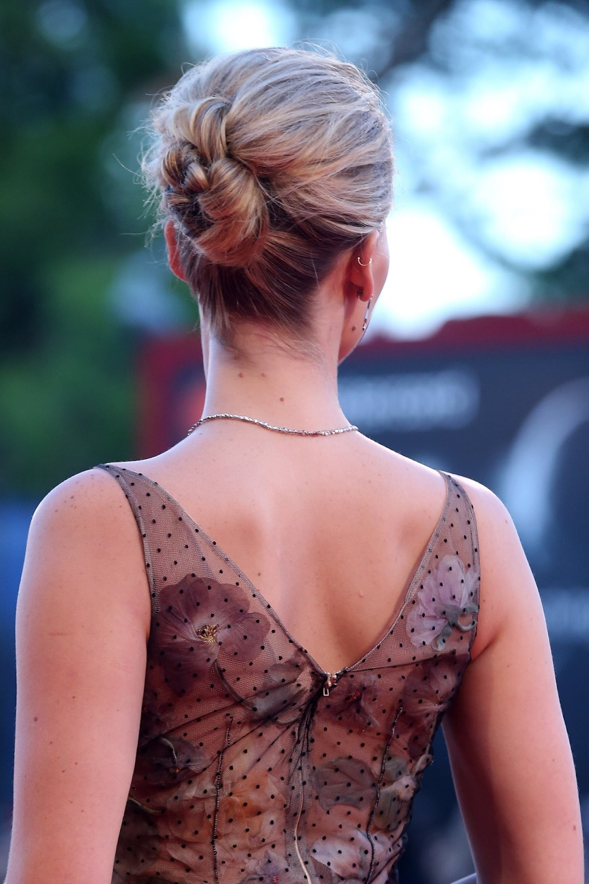

Erin’s Seed: “A very slender young man wanders into a career in Hollywood as a stunt person for kids and women … there were specialists in this kind of thing once upon a time … slowly it comes to him that he enjoys being a girl maybe more than he should?...”
2930

