Frontier Bride
A Short Story
By Maryanne Peters

If it were not for the disturbances that I had caused, and the trouble thus delivered upon me, I would not have gone West. I was a young man who favored the gentle life, though I could not afford it. I was certainly not ready for the challenge of hard work, it having been avoid assiduously for the first 27 years of my life. But needs must, and I was in need of escape.

The people who had gone west were made of sterner stuff than I. And they were (in the main) men. They went to look for gold, to start homestead farms and ranches, and to begin new lives where resources were plentiful, spaces were wide and open, and there was a lot more freedom than back east. However, the many single men who went west soon found themselves to be lonely. They may have had male friends, but it was no substitute for having female companionship. Only a small number of men brought wives or families with them. As we all now know, the number of single women in the west was very low, and far from enough to go around compared to the men who went there on their own.

Men in the west advertised in eastern newspapers for wives. In these posts, they would tell a bit about themselves and what they were looking for in a wife. Interested women who met the qualifications of a particular advertiser would write back. From there, the process from first letter to marriage was much the same as for men who got wives through their social networks back home.

Women who answered the call for wives in the west were those who were not finding men, or men of quality, at home, or those who wanted to get away from home for some reason. Reasons included having strict parents, being the subject of a scandal that was ruining their reputation, or simply wanting adventure or a new start. These women needed to find husbands elsewhere, in places far away from where they lived. Perhaps surprisingly, there was no shortage of women who answered these mail order bride advertisements. Many Old West marriages were made this way.

One who answered the call was my fair Elizabeth. With all the crimes that forced me to flee the east coast, my greatest shame was that I had compromised and betrayed this young woman, but I fear that is my nature, or it was then. But in discarding that last time, I was concerned only with escape, and Eric Neudorf provided that. This is the story of how I became his mail order bride.

It is a misnomer. It would make one think that brides can be selected from a catalogue. In fact the original advertisement had appeared in the newspaper in Boston:

“A widower, merchant and stockman lives in Arizona 46 years old, height 6 feet, weight 210 pounds, brunette, black hair and eyes, wishes to correspond with ladies of same age, without encumbrances and with means, must move in the best society and be fully qualified to help make a happy home: object, matrimony.”

There had been some private correspondence, some of an intimate nature, and he had sent her a trousseau and passage by ship and carriage. All of these things I took from Elizabeth, including her chance of happiness with Eric. But I comfort myself with the knowledge that she did find a husband in the east, eventually.

In her letters in reply, Elizabeth did not provide a photographic portrait, for the simple reason (I suspect) that she was a plain woman. In truth, I made a better-looking woman than she. Which was just as well, because I needed to adopt that disguise for my passage.

It seemed a simple solution. She has passage to the other side of the nation, where fugitives from justice can be lost forever, and I had a need of it. She was reluctant, despite the fondest entreaties from her distant suitor, and her limited options locally, perhaps because of my false affections. All that was required was for me to adopt a disguise that could function for the term of the passage – 5 weeks aboard a sailing ship bound for Los Angeles, California.

I had the advantage of fine features and quite longish hair. I had adopted a style that was popular for young men at the time, with flowing locks and my best effort at mustachios and a chin beard. The latter features were easily disposed of with psilothrum rather than a razor, leaving a face that could further be feminized with just a little kohl and rouge.

I was able to put my hair up, and wind around it a braid of a woman’s hair that I had procured by dishonest mean beyond the ambit of this tale. I had nothing to go on but what was then the new publication “The Ladies’ Home Journal and Practical Housekeeper”, something that became very important to me in the years that followed. I found the look very agreeable, and most others thought so too. I became adept with pins and from the trousseau, some hair ornaments of beauty for evening engagements.

The only other thing that I had stolen from Elizabeth outside the trousseau was a corset, and that proved more difficult to attend to alone. But a private cabin having been procured by my amorous pursuer, I was able to engineer a method of tightening the stays to secure a proper figure, with some stuffing for an alluring bust.

Sea passage was the only realistic option at the time, although that same spring, in May 1869, the rail link between east and west of our great country, as sealed by a golden spike in Promontory, Utah. Until the regular traffic that followed that event, to the prosperity of our western states, we needed to endure those weeks at sea including the rounding of Cape Horn in the southern winter.

Being in the guise of a woman travelling alone, and not being a woman at all, I felt that it was better than I affect an inclination toward privacy and modesty. But the truth is that neither is in my nature. As the voyage wore on, and as my gestures and use of voice became more assured, I became more sociable, even to the point of flirtatiousness. The truth is that there were more men aboard that vessel, even though the gold rush was 15 years over. There was plenty of attention and generosity to be taken advantage of.

Nor was I the only woman travelling alone, and I benefitted from their company too. I have to add that I quickly discovered that I would need to conceal my natural male instincts for the duration of the voyage to avoid my secret being discovered, but instead I learned from my new colleagues of the gentler sex, how to improve my guise and my presentation.

Like me, I suppose, those other women were pursuing their matrimonial prospects in the west. I had been said that in prior years thousands of women made the journey, when there was so severe a shortage of single white women of marriageable age that it was said that "a man had to marry anything that got off the train." Now, with the addition of Civil War widows, there were women available, and women who sought the chance for greater social and economic freedom away from the social strictures of the east. Newspapers continued to run regular "matrimonial columns" and across the country there arose a cottage industry of "heart and hand" catalogs, folded double sheets and broadsides devoted entirely to the matrimonial prospects. I was one of a number, and therefore, largely invisible, as I intended to be.

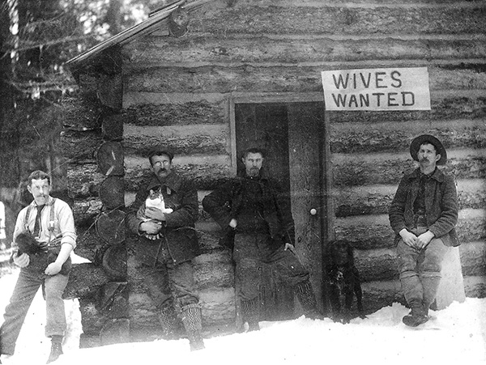

Perhaps it is vanity that made me compare myself to others, but I would say that I was, if not the most attractive of the women aboard, at least in the top few. I found myself taking more attention to my appearance and my demeanor. To that effect, when we arrived at the Port of San Pedro in June 1869 it was a self-assured woman rather than a man in disguise who stepped on to dry land.

My plan at that point was well developed. I would disappear into the city, find lodgings, cash in the trousseau, cut my hair off, and reappear as a new man. But I confess, that of late I had misgivings: What would I be able to do? I had no trade, and my crimes depended on not just my wits but in developing misplaced trust. Starting with nothing would be a problem.

But what I had not considered was that my future husband would be waiting for me on the dock, and that more or less removed the need for further ponderance upon the issue.

His name was Jedidiah Pound, and he was a handsome man. He had a square but almost boyish face, but he had strong shoulders under his coat. If I were to choose one word to describe his appearance on that first meeting, it would be: Determined.

Had I known that he would be present I would have found some way around, but as I was standing by the very portmanteau that he had sent to Elizabeth and wearing one of the fine day dresses that had been packed into that luggage, I could hardly deny that I was not his fair Lizzie, arrived to sooth his longing heart.

He was aware of what history now reveals: That there were instances of fickle mail-order brides whose groom paid her passage, but who chose to marry someone else who seemed a better prospect. He was resolute that the woman he had brought all this way, in some luxury, would not flee upon arrival. Which meant immediate departure from the city, with the first place to stay being a boarding house in a small town many miles to the north east of the town known as the Angels.

I left him in no doubt that I was less than satisfied with the standard of the lodgings, and I admit that I did it in public. I suppose that my intention was to have him grow a dislike for me that might free of my obligations, but the opposite was the effect. For a start the proprietor, a boorish fellow, made some adverse remark upon my virtue. I will not repeat the phrase but it was augmented with the word “uppity” which I had not heard before, but I enjoyed. Jed explained to this fellow, at very close quarters I might add, that I was a lady, and he clearly had no experience of women of refinement.

I was quite taken with the whole thing. I have to say that the feminine instincts that I had developed over many weeks came to the fore, and I did express my gratitude. To be defended by your husband to be might be expected, but it is none the less extremely gratifying.

When we left that establishment in the morning, I dished out my own feast of words to our host, so as could convince Jed that as well as being a lady of refinement as he described me, I was also uppity.

We also had another encounter on our way through to Arizona Territory, being the breaking of a wheel, where I proved myself also to be resourceful. All in all I found it difficult to engender any dislike of me in this man.

I had of course, one final disclosure that would undoubtedly end the relationship, and it became increasingly clear to me that I would need to reveal my deceit without further delay. But this is no easy thing to do, when a man such as Jedidiah Pound did clearly have some kind regard for me. I did it in the manner I thought most polite, but also close enough to company so as to avoid myself any physical injury from a disgruntled suitor.

He was shocked, that was clear to see, but then he started laughing. I have to say that a disgruntlement that followed was mine, expressed in a very ladylike fashion that had him laugh even more. He said that I might just be the perfect wife he did not require intimacy, but only respectability. If I promised to give him that, he said in return he may be able to give me a life of great comfort. I was mightily confused, and remained so until I met the woman who was his true wife.

She was called Pebble, because her name in the Navajo language means a shiny river stone. It turns out that she had been my future husband’s sexual partner for many years, and although she had borne his four children. She well understood that she could never marry him.

It was put most clearly by advocates for Arizona’s statehood who feared that inter-racial marriages would not count as “civilized behavior” and therefore threaten the possibility of transitioning from territory to statehood. Men of the state, especially men like Jed, should marry white women. Women like me. The leaders of the frontier expected that the presence of such women would help to civilize the Wild West by replacing alcohol, gambling, and prostitutes with schools, and churches.

The oldest child of Jed and Pebble did not look at all Indian, and was widely accepted as Jed’s son and heir. Marriage to me legitimized the boy, and by doing that for him I earned his respect and later his love. All of their children, and two more that we did adopt, came to love me as a mother.

But could I become a woman? Well, it turns out that many Indian tribes, including the Navajo and the Paiute, and the Hualapai, have in their midst men who live as women. If I was to marry Jed, I would need to learn the ways of these folk, and to some extent to become one of them.  I cannot provide details, for I understand little about it myself, and some details are too lascivious to recount, but with herbs and treatments, and special garments, over time I shed almost all of my manhood. Even to the extent that over time I was able to provide my husband Jed with pleasures that only a woman can, and sometimes better achieved when Pebble and I did attend to him together.  But way before then I did marry my Jed and become Mrs Elizabeth Pound, a respectable woman and a person of high standing in my community and in the new State of Arizona. And we lived there happily for many years, as I still do, remembered as a founder of my community, and a frontier bride. | 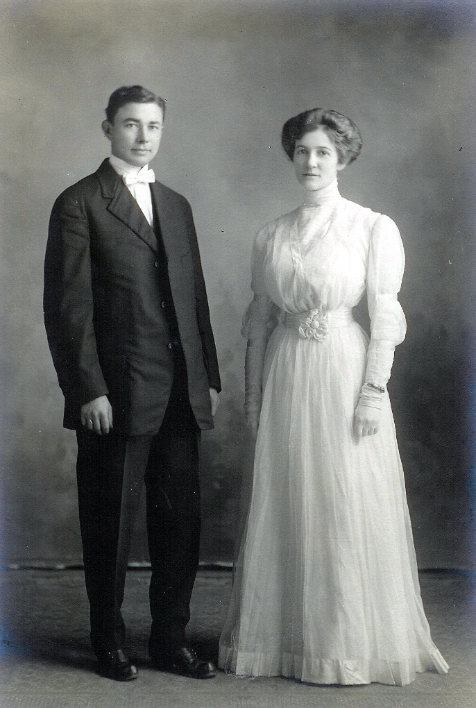
The End

© Maryanne Peters 2019

