S-C Escapes: Austria
By Soul-Controller

“Well, here we are.”

As the small car suddenly lurched to a stop, 23-year-old Luke DeAn found himself gasping as he was hurled forward until the seatbelt firmly stopped him from flying face-first into the backside of the driver’s headrest. Unfortunately, his luggage sitting next to him didn’t have the same luxury as it violently flew off the seat and crashed against the passenger side seat before tumbling into a heap on the floor of the taxi cab.

Despite the abrupt and violent arrival to his hotel, Luke found the journey to be more than worth it as he opened his door and stepped out. As he turned his head and took in the sights of the lavish Austrian resort where he would be staying, the man’s eyes widened and his jaw dropped as if he was in a cartoon. This place was absolutely breathtaking! With the added nature of dense forests and mountain ranges, the man couldn’t help but be happy with himself for accepting the random vacation to Austria.
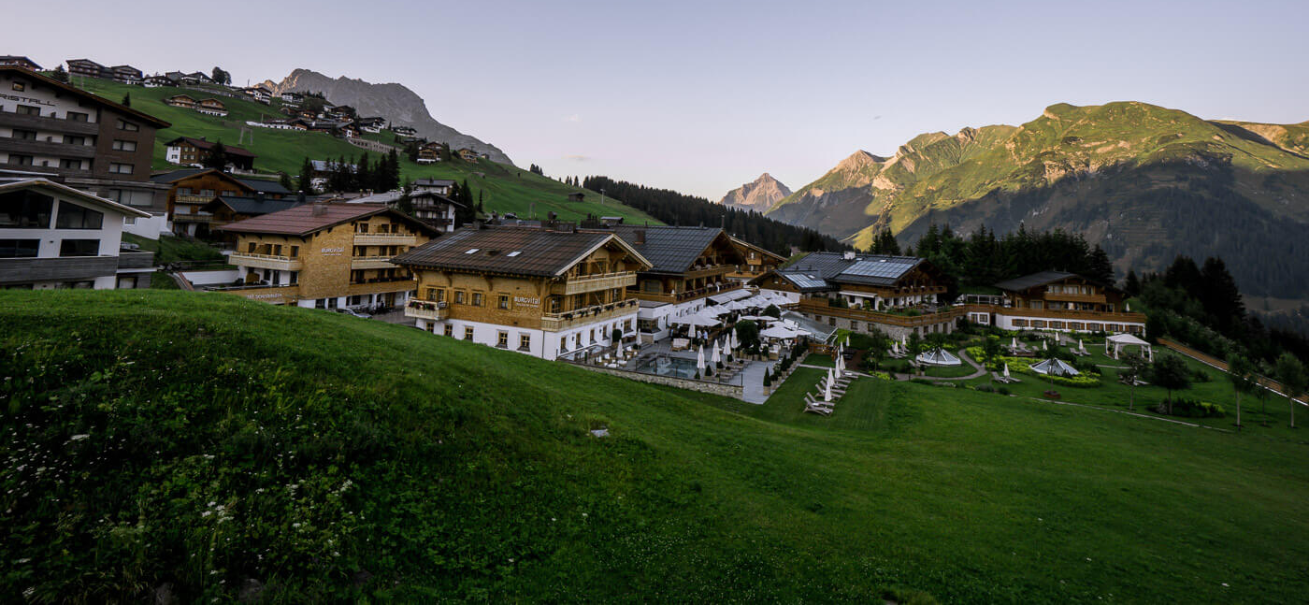
As he made his way towards the hotel with his luggage in tow, Luke couldn’t help but think back and remind himself how he ended up standing where he currently was. When his birthday came two days prior, he had no real expectations beyond some small and sentimental gifts from his closest friends and family. As such, one could imagine his surprise when he came home from the festivities and found a golden envelope taped to his apartment door.

Given the fact that there were no stamps or return address on the envelope, Luke knew that the envelope had to have been delivered by someone he knew. But that concept made little sense given the fact that all of his friends and family had been with him for his little birthday party. With his curiosity piqued, the man pulled the envelope from the door and headed into his apartment to further investigate.

Upon opening the letter and pulling out its contents, Luke was shocked to open up and see that he had seemingly been gifted a week-long vacation to Austria via a company named S-C Escapes. The packaging listed no other names beyond Luke’s own, which only further confused him as he couldn’t envision anyone close to him shelling out so much money to treat him to a seemingly lavish vacation. This was especially confusing as a quick Google search with his phone revealed that he would be staying at a five-star resort that was seemingly tucked in amongst several grand mountains.

Knowing that there was the potential reveal that this was all an elaborate prank, Luke opted to call the phone number listed on the vacation documents to verify its legitimacy. After dealing with the annoying robotic voice of the S-C Escapes hotline by giving his name and explaining his issue, Luke was able to finally get in contact with a human representative. Upon explaining his confusion and asking about the legitimacy of the package, Luke’s eyes widened in disbelief as the representative enthusiastically confirmed that the two-thousand dollar all-inclusive package was in fact real.

Although Luke had no idea what to do on the vacation given his lack of knowledge about the country, the man wasn’t willing to look a gift horse in the mouth. So upon hanging up with the representative, he immediately jumped to packing his suitcase and informing his family and job about the surprise trip that he would be leaving for in two days.

Upon going down that quick trip down memory lane, Luke eagerly made his way up the stairs of the resort and entered the building. Once he was inside, the man was instantly stunned by the lavish beauty of the resort. Seeing the ornate art and stylish furniture that filled the lobby left the man buzzing with excitement. This vacation is going to be the best time of my life, he thought to himself as he entered the line to check in. Little did Luke know that this vacation would change his life in more ways than one…

While he waited to get up to the front, he couldn’t help but look around and notice that the other people in line were all older men decked out in expensive luxury suits. Although Luke felt slightly self-conscious about the fact that his clothing was a simple graphic tee and a pair of athletic shorts, he found relief in the glorious sights before them. The older and intimidating-looking men looked incredible all dressed up like that, which left Luke struggling to conceal a boner as he finally made his way to the front of the line and checked in.
After getting the entire spiel from the front desk attendant about the amenities of the hotel along with a recommendation of local places to visit, Luke merrily thanked the woman and made his way up to the elevator. Upon entering and hitting the necessary floor number, the man smiled widely as the elevator ascended until a loud ding rang out. Reaching his desired floor, the man grabbed his luggage and made his way down the hallway until he arrived at the doorstep of his room.

Once he inserted the room key and saw the flashing green light emerge, the man turned the handle and entered the room. Upon doing so, the man gave a giant huff as he dragged the luggage in and tossed it on top of his freshly made bed. After doing so and unpacking a few necessary items for his week-long stay, Luke took a few moments to explore the lavish suite that the mysterious gifter had purchased for him. Not surprisingly, the room was as exquisite as the rest of the hotel given its memory foam mattresses and the large flat screen televisions hung in both the bedroom and bathroom.

Although the comfort of the soft mattresses made the exhausted young man consider just laying there to take a mini-nap, Luke’s eagerness to either explore the lavish hotel or take the free shuttle service into a local Austrian town made him push that thought aside. Given the fact that this had been a present, Luke felt extra pressure to fully immerse himself in Austrian culture so he could feel less guilty for the expensive present he received. Yet while he did in fact love the idea of traveling into that nearby town, Luke felt that it was a bit too extreme to do today given how long the flight to Austria had been.

So with his mind made up on just deciding to explore the hotel and discover its perks today, Luke decided to go check out the hotel’s pool. The thought of sunbathing along with diving into cool chlorinated water seemed like the perfect way to destress after the long journey he had gone through to get to Austria, so the man wasted no time taking off his pants and underwear and trading them in for a pair of swim shorts. Opting to keep his shirt and shoes on until he made it down to the pool itself, Luke’s outfit change was complete so he tucked his keycard into his wallet before dropping that along with his phone into his shorts pockets. Thinking ahead due to his desire to sunbathe, the man grabbed a pair of sunglasses that he had packed before exiting the room and making his way downstairs.

Upon reaching the ground floor and walking past the front desk lady to gain entrance to the pool in the back of the resort, Luke had a spring in his step due to just how excited he was to relax for his birthday. While he still didn’t know who had sent him the mysterious Austria package, the man had great appreciation as he made his way through the door and allowed the Austrian air to hit him. Taking a deep breath of the quality air, the man smiled as he made his way towards the large pool.

Unfortunately though, Luke’s smile quickly faded as he reached the pool and saw just how crowded and noisy it was. In his head he had assumed that the clientele of the hotel was mostly adult men based on who he was surrounded by while checking in, but it seemed like those older men had brought along their families as the loud screams of kids echoed through the spacious area and left Luke physically cringing. Although there were certainly some areas in the deep end that were free and spacious enough for Luke to float in, the loud noise was an unwelcome disturbance to the point where the man had very quickly decided against the idea.

As he continued to think about the situation at hand though, Luke recalled the fact that he had seen countless lakes during his drive up to the resort. Thinking that surely there must have been a lake nearby the resort that was public access, the man grabbed his phone and opened up the maps app. Scrolling through the area was quick to prove his assumption to be correct as he saw that there was a lake that was simply a ten minute walk from his current location. The concept of finding a less-populated body of water was quite appealing to Luke, so he quickly made his mind up and followed the compass of his phone’s GPS to lead him in the direction of the lake.

Upon passing past the pool and traversing along a spacious patch of land that seemed to be designated for big party events, the man finally made his way to the edge of the property line based on the fact that the well-maintained lawn suddenly gave way to a cluttered forest floor. As he looked around the area, Luke’s eyes narrowed as he took in the sight of a faint and tiny trail that seemed to lead directly towards the hidden lake he was searching for. With his eyes constantly switching between the terrain in front of him and the maps app on his phone, Luke had no way of seeing the tiny “No Trespassing” signs that were attached to a few trees near the edge of the property line.

For the next several minutes, Luke continued to traverse down the uneven terrain as cautiously as possible. Although he was desperate for a space that would be fairly uninhabited, the man wasn’t willing to get too excited in case he accidentally allowed himself to get injured due to not noticing a raised root or rock for him that would send him tumbling down the descending trail. As such, the journey ended up lasting 15 minutes rather than 10, but it was all worth it for Luke as he finally reached flat ground again and found himself standing at the edge of a deserted beach.

Making his way closer towards the water, Luke couldn’t help but grin as his eyes grew wide like saucers. This country was absolutely gorgeous! Not only was the water of the lake clear to the point where he could easily see the light white sand at the bottom, but the gorgeous view of the dense forest to his sides and the grand mountain range in front of him truly took his breath away.

Although he was certainly eager to continue taking in the glorious sights, the crystal clear water was too inviting to resist so Luke wasted no time stripping down. As he dropped his shoes, socks, and shirt a few feet away from the water, the man carefully placed his phone and wallet into each shoe to prevent any potential damage. Despite being slightly uncomfortable with his average build that was neither too muscular or too flabby, Luke forced himself to push aside his fears due to the fact that there was no one around to observe him.

As such, the man chuckled for a moment before slowly making his way into the water. With everything below his waist soon ending up under water, Luke couldn’t help but shiver and grit his teeth from the chilly temperature. It wasn’t shocking given the fact that it wasn’t super warm when he had traveled to Austria, but the initial shock of the cold still momentarily stunned him. In fact, it was seemingly so cold that his body felt an odd tingling sensation beginning to permeate through him the longer he remained in the water.

Before long, Luke found himself wading in the water to the point where everything besides his head was submerged. As he swam there for a minute, the man looked around and continued to take in the sights before him. While he was too busy savoring the gorgeous scenic views, Luke was oblivious to the fact that his body was beginning to transform the longer he remained in the water. If Luke would have done research about the lake that he was currently swimming in, he would have learned about why no one else was here. Unfortunately though, not noticing the “no trespassing signs” along the way caused him to never consider this possibility.

According to Austrian folklore, the lake that Luke was currently swimming in was imbued with magic that seemingly transformed swimmers in unpredictable ways. Legends discussed the story of Laurenz Müller, a beefy 18th century warrior who set up camp along the beaches of the lake. Upon ordering his comrades to wash up in the lake due to their grueling and messy battles that they had previously fought in, Laurenz had no way of knowing the changes that would soon befall all of the troops. As they all quickly washed up and headed to bed, the entire army would wake up the next morning to find themselves transformed into bodies far different from their own. As for Laurenz, the early morning sound of screaming pulled him out of his dream and caused him to sit up with haste. Upon doing so, the man was horrified to find two heavy breasts resting upon his trim and curvy figure. While his crew had also gone through intense transformations, none were as severe as Laurenz’ gender change that would forever alter his life from mighty warrior to doting housewife.

Due to how infamous the story was and how superstitious the country was, the hotel and any nearby properties did their best to try and prevent access to the lake. But the hotel’s attempts were seemingly not enough as Luke merrily swam in the serene lake and allowed his body to begin its transformation.

The transformation worked according to the order in which the water touched the man’s skin, meaning that Luke’s transformation would seemingly work from the feet up to his head. So as Luke continued to swim around, the man was unaware of the changes that were quickly affecting his legs and feet. Luke’s feet began to crack as their anatomy severely altered, growing longer to grow several shoe sizes as the feet also widened significantly. Despite being oblivious to what was occurring to him, Luke couldn’t help but notice how easy it was to propel himself through the water now due to his larger feet.

With his feet now finished changing, the man’s calves and thighs were growing at an exponential rate. The man’s formerly flat and definition-less calves became a thing of the past as they suddenly hulked out until they were now suddenly larger than his original thighs! Given this sudden bulk, there was an intense sense of vascularity due to how wide and expansive those calf muscles were.

Not wanting to be outdone by those calves though, Luke’s thighs grew quickly. Still unaware of what was happening to his body, the man momentarily stopped and began to wade in the water while trying to adjust the sudden tightness emerging in his swim trunks. Due to the man’s medium-sized shorts, it didn’t take much before the increased bulk of his thighs caused the shorts to bunch up due to being unable to completely cover the wide muscles he now possessed.

As he continued to float upright in the water, the man was also unaware of the fact that his legs were also lengthening several inches until the 5’9” Luke was now 5’11”. Due to this increased bulk of his bottom half, Luke became bottom-heavy to the point where the man’s new musculature suddenly pulled him down deeper into the icy water until his head was barely above water. Unsure about what was going on, the man quickly thought of a solution by beginning to wade a bit faster until the motion allowed him to return his head to its original position several inches above the water.

Taking a moment to catch his breath, the man’s shorts soon underwent further attacks via his ass and crotch. While the man’s somewhat flat ass began to suddenly inflate with muscle, the man’s average-length cock was hardening and also secretly becoming several inches longer until he was now rocking an 8” manhood. As the fabric of his shorts began to suddenly strain tightly against his body due to his now huge muscular asscheeks, this led to an unintended side effect in the form of his cock growing girthier as if it was being widened slightly from the pressure.

With this moment to catch his breath now finished, the man gave himself a nod of approval before suddenly pushing forward and beginning to swim through the water. As he did this, the transformation suddenly began to invade his upper half as his torso started to undergo its changes. As the man rapidly swam through the lake, the water behaved like a power washer as it suddenly began to melt away any morsel of flab on the man’s stomach. Although this certainly would have been more than enough for the modest Luke, the transformation wasn’t done as the water crashing against his skin seemed to etch in a six pack that soon began to firmly manifest until it was well-defined.

Now with a glorious six pack, Luke’s chest and overall torso began to increase as his ribs began to painlessly crack and widen until he had a broader chest. To make sure that he didn’t look deformed in his new form though, a similar widening also occurred on his shoulders and waist until he was now forever an imposing figure simply from his width. Not only that, but his torso also lengthened a few inches similar to his legs until he was now solidified in a brand new height of 6’2”.
All at once, the man’s chest and arms began to suddenly inflate with muscle. Luke hadn’t ever really had a solid morsel of muscle in his chest given how flat and ordinary it was, but this soon became a thing of the past. Like a balloon filling with air, each breast began to bulge out with muscle until two prominent pecs sat square on his chest. If he had been aware of the changes that had affected his body, he would have been stunned to see that his chest had grown so large that it would now be a constant struggle to find a shirt that could fit him properly.

With Luke’s arms, the magic of the water moved with haste in removing any hint of body fat that had given the false impression of muscle. Luckily though, the real thing soon manifested onto his limbs as his biceps began to inflate to extraordinary levels. Within no time, Luke’s arms were forced to move away from his chest due to the 18” biceps that he was now sporting. On top of that, the man’s forearms had also severely increased to the point where there was a continued sight of vascularity across all of the man’s gorgeous and beefy physique.

As Luke’s traps began to suddenly inflate and make him look even wider, the man’s hands were altering their composition. With each painless crack and snap of his joints, Luke’s hands were growing wider and longer until he had baseball mitt-sized hands. On top of this, the formation of thick calluses along his palms made it clear that this was the body of a hardworking lifter.

While Luke continued to wade in the water, the man’s neck began to widen while his Adam’s apple also grew much more prominent in his throat. Although he couldn’t tell right now, the man’s voice had now grown much deeper until it was a bellowing voice that would now easily demand the attention and respect of anyone nearby.

Although the man so far had neglected to get any portion of his head wet so far, there was a strange desire overcoming him that left him eager to fully have every inch of his body wet. The slight tingling sensation that had continuously coursed through his body felt so calming and relaxing, so much so that he imagined how great it would be to just dive under the water and see if that water could calm his occasionally anxious thoughts.

Not believing that there was anything detrimental behind satisfying the bizarre desire, Luke shrugged his shoulders before swimming a few feet closer to the shore until he could easily touch the sandy floor of the lake. Given the fact that he wasn’t the best swimmer around, there was a slight fear in his gut that left him worried about drowning. so he believed that the concept of being able to touch the floor would prevent that from happening.

So upon reaching a solid height that allowed him to touch the floor while not fully standing above the water, Luke took a deep inhale of air before pushing up off of the sandy floor and using the momentum to dive headfirst under the water. Although the changes that affected his body were quite well-paced and slow, it seemed as though the magic of the lake itself was eager to finish Luke’s transformation as it immediately jumped into action. While the man kept his eyes closed for a moment, he had no way of noticing that the motion of pushing up from his feet had caused a disturbance with the sand.

As a murky cloud of sandy water passed past Luke’s body, the man’s hair began to undergo severe changes. The light white color of the sand began to affect every pigment of the man’s hair as it appeared to cause it to lighten several shades. The lightening of his hair wasn’t equally dispersed though as the hair on his head and body grew into two distinctly different shades. While his body hair began to lighten until it looked like a healthy mix of gray and white hair, the man’s dark brown hair wasn’t willing to go that light. Instead, it lightened until it was a sandy brown shade that would constantly appear between a light ginger or blonde shade depending on how the sun hit it. As he found himself starting to run out of oxygen though, the sides and roots at the front of his scalp suddenly began to undergo one quick change as they adopted a similar gray color like his faint and occasional body hair.

Now realizing that he only had a few seconds left of oxygen, the man allowed his feet to touch the sandy bottom once more and push him up quickly towards the surface. While he opened his eyes and watched as he rose for air, the quick motion had a sudden effect on his hairline as it suddenly thinned and pulled back several inches until it was no longer as close to his eyebrows as it once was. While Luke’s body looked as though he was a young bodybuilder, his hairline made him appear as though he was middle-aged based on how high his hairline was along with the hints of gray that emerged as well.
With his head finally above water as he started to take in deep inhales of oxygen, the droplets of water that continued to run down Luke’s face initiated the final set of physical changes for the man. Given his body was seemingly being pulled in two different directions between a young and buff body and an older hairline and style, his face suddenly became the battlefield where a victor was finally declared. As the sudden emergence of forehead wrinkles began to appear along with crow’s feet, it quickly became clear that the lake had decided that Luke would fully become an older man. While more wrinkles began to emerge around his mouth and chin, Luke’s facial features were also altering and becoming increasingly masculine. Now in possession of a strong nose and prominent chin, Luke had become an increasingly handsome man that would surely be able to attract the attention of anyone he desired due to his rugged and wrinkled face.

As Luke stood up fully and ran a hand through his thinning hair, the man was completely oblivious to what had occurred to him. His half-joking assumption that dunking his head under the water and allowing the tingling sensation to calm him down was actually true. Beyond the discomfort he felt due to his shorts being too small now, there was truly no indication that something amiss had happened despite turning from an average 23-year-old into a middle aged bodybuilder.

Deciding to take a break from swimming in hopes of getting a good tan, the man began to waddle his way out of the water. This decision soon became quite ironic because while he continued to walk, the man’s skin began to pale until it was as clear as the water he had just been swimming in. Once he exited the water, the man dragged his large feet through the sand towards his belongings. As he took a deep breath and put his wide and callused hands on his waist, Luke was once again struck by the beauty of the location. Although he wasn’t one to use social media much, the views here were so gorgeous that Luke felt like it would be a disservice to not show them off via some Instagram stories. Upon shaking his arms until they were as dry as possible, Luke leaned down and pulled his phone out of his shoe. After unlocking it and scrolling through his apps, the man quickly found the camera app and pressed on it. While he had been so far oblivious to the changes that had occurred to him, this was quickly ruined as the camera pulled open the front-facing camera and allowed Luke to get an up close look at his new visage.

Unfortunately, the surprise of suddenly finding a middle-aged and wrinkled face staring back at him was quite shocking, which was why Luke broke the quiet and serene vibe of the lake by allowing a deep guttural scream to escape from his throat. “Wha- who the fuck is that?!” he cried out, his fingers instinctively feeling his throat and the thick Adam’s apple he was now sporting. “What the hell happened to my voice?” he further inquired, growing alarmed at just how different it was from his previously softer voice.

Desperate for more answers now that his daze had been broken, Luke immediately tilted his head down in search of his phone. But upon doing so, his attention was understandably caught by the two beefy pecs that now jutted out of his chest. Moving his hands gingerly towards the area, Luke gasped in shock as he felt the firm pecs and and even felt the top two abdominal muscles as he continued to feel up the area. Somehow, he had turned into a total hunk!

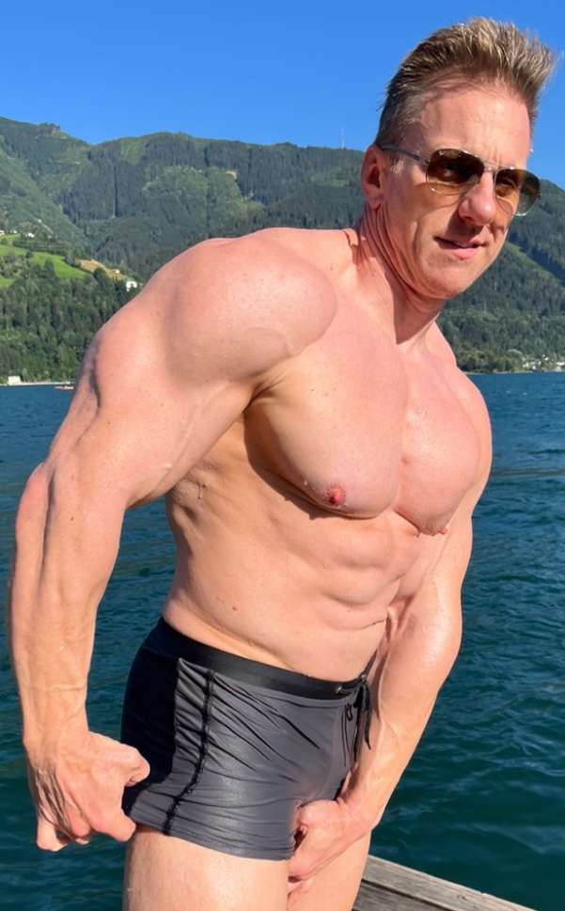
Although he certainly wanted to check out more of his new muscles, the aged face he saw in his camera was a horrifying realization so he quickly returned to his original plan. Leaning forward further to avoid the hindrance of his new pecs, Luke was able to find his cell phone laying screen-first in the sand. Upon bending down (which was a struggle due to how tight his shorts now were), Luke was able to easily grip the phone with his wider hands and stand back up.

Luckily, the camera app was still open when Luke glanced at the phone, which allowed the man to get a better look at his new face. With one hand holding the phone out in front of him to see his face, Luke used the other to poke and prod at his weathered face. It was so bizarre to feel around and notice the rough and rugged skin he was now sporting. However, the man couldn’t deny that he enjoyed his new facial features along with how the wrinkles actually worked well on his manly visage.

While most of his friends and family didn’t know about this, Luke had a huge crush on hunky older men. Yet while he had constantly thirsted over DILFs and loved to imagine getting intimate with one, he never would have considered becoming one himself! Although this was partially due to the fact that he surely had just aged over 20 years during one simple swim in the lake, Luke hadn’t ever considered that he would ever be able to turn his average physique into something so imposing. He hated to admit it, but he looked really hot!

Curious to see how much time had passed since he first arrived at the beach, Luke exited the camera app in hopes of looking at his home page. Upon arriving there though, Luke was quite confused to find that his phone looked quite different. Not only had his phone wallpaper changed from an image of Chris Evans to one that displayed a view similar to the one he currently saw, but his clock had also shifted to match the European 24-hour-clock. What the hell? How is my phone changing? Luke thought to himself, looking through his apps and realizing that there were a bunch missing along with new ones that he had never heard of before.

Although it was strangely hot to go through this transformation into a hunky DILF, the concept of somehow losing his identity and life was something that greatly troubled him. As such, the phone was quite a terrifying sight as it gave proof that what had occurred to him seemingly had a ripple effect that was changing reality. With this concept in mind, the man’s eyes instinctively darted over towards the wallet resting in his other shoe.

Hoping that the changes weren’t already altering his life so severely, the man frantically grabbed his wallet and began to search for his ID. Upon flipping through his credit and loyalty punch cards, the man finally found his license and pulled it out. As he took a look at the piece of plastic though, the man gasped in shock as it seemed as though the changes were already well in effect. Although his name and eye color was still the same, all of his other details had completely changed to match his new body. Instead of being 24 years old, Luke’s new body was officially confirmed to be 50. The realization that this new version of himself had just turned 50 was alarming to Luke, but even more so when he also took note of the fact that he was now 6’2” and weighed over 200 pounds of pure muscle.

Although he had no idea what to do given what was happening to him, Luke felt the overwhelming urge to return to the hotel. While the transformation that had occurred to him was super hot, there was an innate eeriness to it due to the fact that he had been alone the entire time. He had assumed that there had to be someone around that had caused him to turn into this 50-year-old man, so the concept of being secretly observed was quite alarming. As such, the man quickly grabbed his clothing (which had been the only thing to not alter to match his new body) and rushed off towards the hotel. Knowing that there would be safety in numbers, Luke couldn’t help but hope that he could find out who was behind what had happened to him while also potentially seeing what life as a hunky DILF could be like…

