MHA 119
All around us, buildings were on fire, a small village, almost entire single-story structures, ablaze.
Looking to Mina, I didn’t need to say a word, she just nodded, and, turning, started throwing out acid to the left, controlling it clumsily with a gesture, while I Created a ball of retardant, the fluid starting to foam even before it hit the burning rooftop, smothering the flames, and creating a zone of safety as I turned, and realized that I had a power that could handle this much easier.
Reaching out, metaphysically, to the next fire, the blaze raged, but, taking hold of it, but not feeding it, I twisted, and tried to put it out.
It got… smaller?
Yeah. Smaller.
Trying again, only this time instead of a single roll I spiraled, like a crashing plane, arms subconsciously rotating, the fire twisted as I concentrated at it, seeming to compact, but I was flaring its energies outwards as I did so, superheating the air, but, with the point of ignition being tamped down, that still put out the flame.
However, breathing hard, that was… not viable for this, the amount of Flame I could handle in a given time clearly having an upper limit, though I’d been at this for less than a week, so even that much probably wasn’t that bad.
Shifting gears, I went back to Creating foam where I could, apply it as specifically as I could, shapeshifting hands into wide electric mitts to smother the flame manually, and, pulling on Todoroki’s Quirk, just making ‘cold’ was far easier than making ice, and that let me damp down the flames even more.
Glancing over, for every building I put out, Mina put out two, and was, if anything, gaining momentum, pushing her Quirk hard, and, trying to combine her waterbending with it, she was loosing a lot of low-level acid in the process, but her Waterbending movements helped support the thick fluid, letting her normal control of it pick up the slack.
But I kept going, my Creation reserves quickly emptying, when a clang caught my attention, and, leaping over, I saw one of Zuko’s men, on a horse-sized lizard with three wicked looking horns, trying to fight off a woman dressed in greens and blacks, face paint white.
Ah, we’re on Kyoshi Island.
Which Zuko partially burns down chasing Aang.
… Awkward.
And, almost invisible against the orange skies of evening, was Aang, flying deeper into the island on his glider.
Yeah, let’s cut this off now.
Leaping down between the two fighters, hands trailing lightning, I caught the woman’s war-fan with one hand, the man’s spear with the other, and, with a shove, sent both of them back several feet.
“Fire Nation Soldier,” I stated, not having learned their names yet, I pointed upwards, towards the Airbender. “The Avatar is heading to his sky bison, and leaving. Tell Prince Zuko he failed to capture him this time as well.”
The masked man hesitated, before he nodded, and turned his mount around, heading towards the distant shore, the very top of the Wani visible over the tree-line, the iron ship having likely made a beachhead dock to deploy without being spotted by the locals.
The girl, maybe a year or two older than me, looked my way warily, asking, “Who…?”
“I’m here to help, and put out fires. My companion and I have just been doing them as we could, but are there any important buildings that we should prioritize?” I demanded, with the hard tones of command.
When she hesitated, I rolled my eyes, creating a ‘extinguisher bomb’, really fire retarded foam-fluid in a thin membrane, and threw it into the closest fire, the flames melting the outside instantly and the small white sphere erupting into short-lived foam, putting out the flames raging inside a nearby shop.
That kicked the local into motion, the young woman nodding seriously, telling me, “Yes! This way!”
She started to run, though hesitated as I called out, “Mina! This way!”
A moment later, my companion skidded between buildings, swirling herself around in an almost dance-like fashion to try and maintain the mass of Acid she was handling, looking, though I’d never tell her it, a bit like a phantom slug, if one that moved at street-legal speeds.
The sight took the warrior back for a moment, but she pressed on, continuing to move, as I, on feet of lightning, took off after her, Mina following, and, yeah, while for a Hero the green-clad girl was slow, for a standard human she was at near Olympic speeds, directing us to flaming storehouses that other locals, who were mostly wearing blue, were doing their best to save.
They moved aside for Mina and I, as we darted forward, the girl leaping into the inferno as she almost exploded with acid, while I took the opposite end, and, concentrating, and pushing Todorki’s Qurik as hard as I could, let out a single blast of cold that formed frost in a fifteen foot cone ahead of me, extinguishing most of the flames, yet, afterwards, that ability seemed to throb with pain as I let it fade, going back to using Firebending as I went after smaller flames that had survived my blast, mentally rolling them out, one by one.
Looking around, this seemed to be a medicinal storehouse, which explained the panic, and, as I left, a bit tired, and was directed to the next one, Mina looked at me in concern, but I shook my head, pressing forward, as we handled another, and were on our way to a third when it started to rain.
No, I thought, smelling salt, and looking down towards the shore, it was seawater.
Spat out by a fucking sea-serpent.
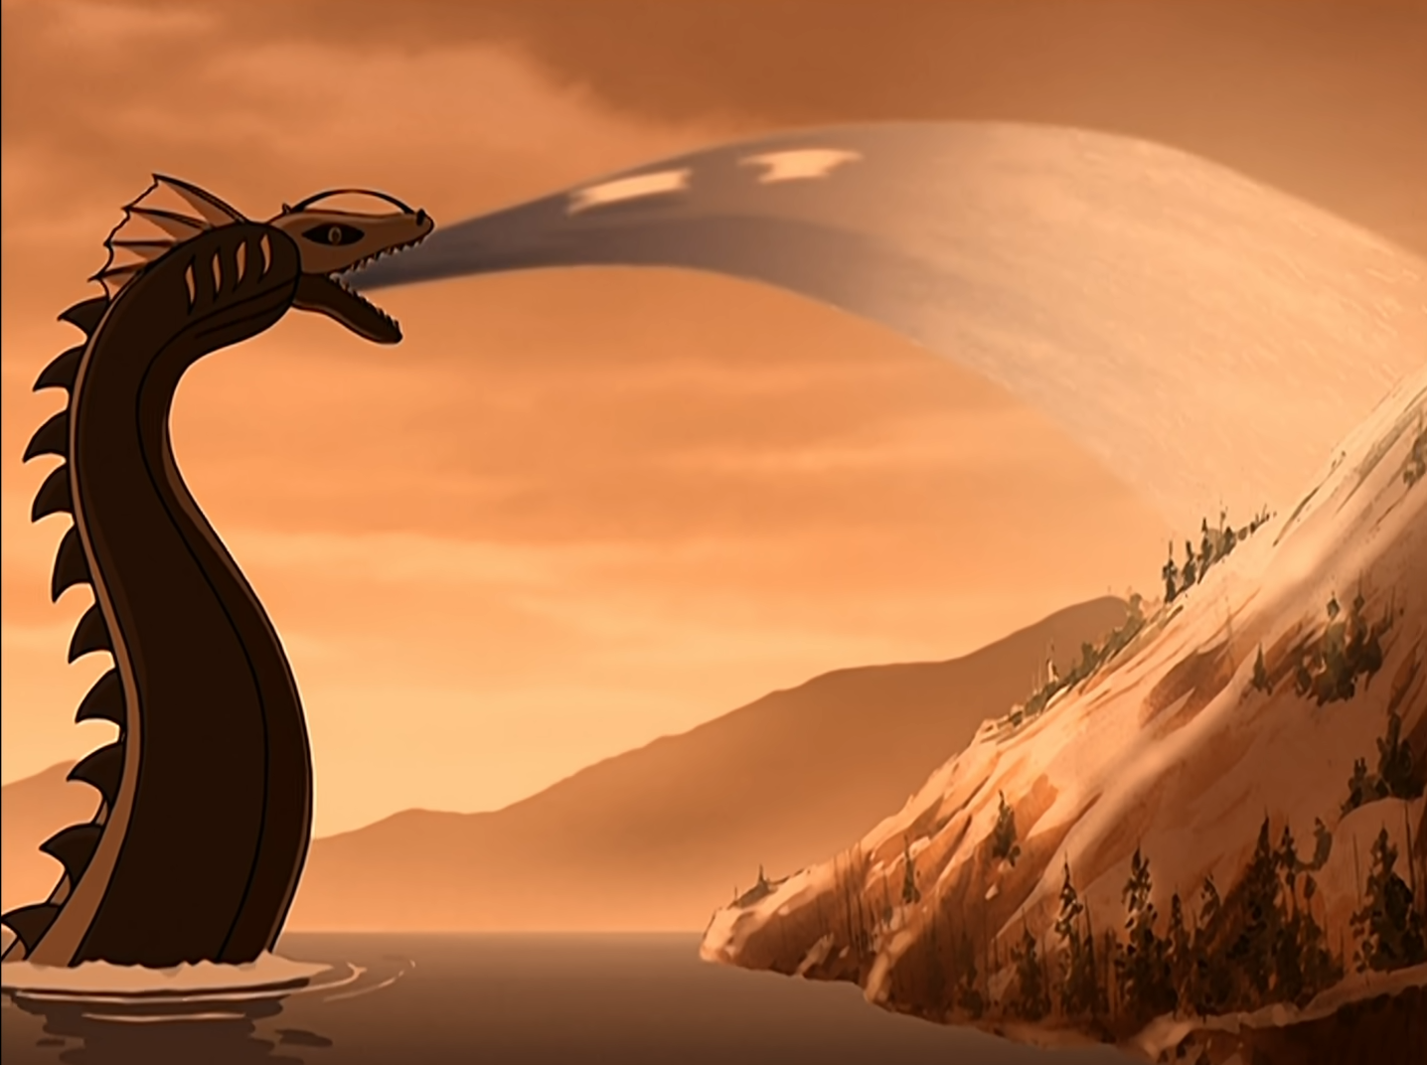
Regardless, it did put out all the remaining fires, even if it’d be hell on the local soil, but, looking around, the few farms I could see further inland were out of the splash-zone.
Sighing, and leaning against a wall, I relaxed, and felt the waves of exhaustion pass over me, but, well, nothing says ‘We Come In Peace’ as much as rushing to their defense, and, while accidental, I’d totally take that opportunity.
“You okay, Sparky?” Mina asked, having dropper her acid, her hair matted down and her clothing still partially soaked, but the wardrobe my Sweet Home made for her was all Acid-Resistant, something we’d only just figured out, and she was very happy with.
“Yeah, just a workout for my Quirks and Bending. Maybe take tomorrow off too,” I offered, the townsfolk watching us warily. “Good save by Aang there at the end.”
One of the Kyoshi Warriors, and, damn, did they multiply? Regardless, the surprisingly quiet green-clad fighter questioned, “You know the Avatar?”
“Yes I do…” I trailed off, turning to address the girl in question.
“Suki, of the Kyoshi Warriors,” the young woman responded.
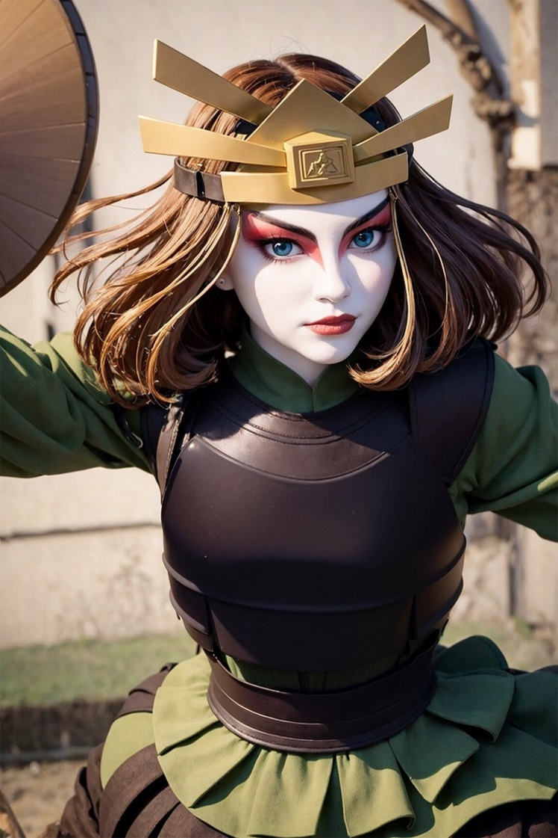
Ah, I see Sokka has good taste, I couldn’t help but think, the girl coming across as somewhat plain in the cartoon, but, no, I could see how the subtleties wouldn’t translate well across mediums now.
“I’m Mina! Mina Ashido! And this lug’s Denki Kaminari!” my partner smiled, as I watched two more Kyoshi warriors drop off of rooftops and I realized they were Chi Users, just like Zuko had described, as, from how the regular people moved, the average citizen seemed to be ‘bog-standard’, and about as tough as those in MHA, maybe a bit less.
“Hiya!” I waved, with an electric hand, looking around. “Is anyone seriously injured? We have medicine of our own we can share if you need it.”
That took the Warrior aback, and, with a few quick hand signs to the others, which were responded in kind, the young woman, frowning, though her face makeup obscured the expression somewhat, repeated a gesture, the other Warrior repeating it in kind.
“I, we don’t have any injuries. Not really,” Suki stated, confused. “It’s, a miracle. Unless you…?” she questioned.
“We just came in at the end. But it sounds like Zuko’s men were pulling their punches,” I stated, adding, at her offended look, “Not because you’re women, but because the Exiled Prince is trying to capture the Avatar with a minimum of casualties, full stop. Mind you, terrible things will happen if he succeeds, but he was exiled, if the rumors are correct, for arguing against unneeded casualties, and the Fire Lord… took offense.”
The Kyoshi Warrior stared at me, before sighing. “Only the Fire Nation would punish someone for not wanting to hurt people.”
One of the others leaned forward, pointing out, “Uh, Suki? Are you really gonna complain about no-one getting hurt?”
“My pride’s hurt,” the leader muttered to herself, but shook her head. “So, um, welcome to Kyoshi Island,” she offered. “We’ve had…” glancing back towards the smoldering village, Suki stated, “better days. Please don’t take this the wrong way, but what are you?”
“Spirits!” Mina announced, with a grin.
Nonplussed, Suki finally looked away, “Yeah. Okay. Makes sense.”
“Really?” I questioned, as she was taking this surprisingly well.
“She’s pink, you have lightning hands, and the Avatar just flew away on a flying bison, after putting out the flames the Fire Prince set by riding the Unagi and turning its wrath, which regularly capsizes vessels, into rain,” the Warrior stated helplessly. “It’s been a day.”
Mina tried not to laugh, while I nodded. “Okay, that’s fair. Um, do you guys need any more help?”
“I would like to know who you are, besides your names,” she requested, politely. “We… rarely have dealings with Spirits, I think I’ve seen… three, at a distance? Our Sages normally handle them, but they’re all… Indisposed.”
“Are they okay?” my partner questioned.
“They’re hiding from the Avatar!” one of the other Warriors volunteered.
Sighing, Suki replied, “Himari, they’re not hiding! They’re spiritually communing.”
“They’re totally hiding!” another added, several of the others giggling.
“Fine, then Himari, Aoi, you two go tell them the Avatar’s gone. As for you two,” she said turning back towards us. “If you don’t mind, can you come with me? With everything that’s happened, people will be worried enough, and, well, seeing a Spirit normally isn’t a good thing.”
Looking to Mina, she shrugged, so I smiled at Sokka’s future wife, and replied, “Sure thing, Suki. Lead on!”

<MHA>

Mina was a bit concerned for her boyfriend, knowing how he would push himself, but he was taking it easy, and wasn’t shaking, like he’d done before, so she had to trust that everything was okay. Following ‘Suki’, who Sparky kept on glancing at, she had to admit the girl was cute, but, honestly, had nothing on Yaomomo. Shooting the guy a look, he just mouthed, ‘Later’, and while he was ‘okay’, he looked beat, so she took the lead, chatting up the other girl. According to her the Avatar before last created this island, which, like, how?
“Aang’s young, and found out he was the Avatar, to him, like, a week ago, a month tops,” her lover explained. “And when they learn to harmonize with the world spirit that they either host or are, well, it gets kind of nuts. Kyoshi… Imagine if All Might just grabbed Tohuko and just dragged the entire thing east a few hundred miles.”
“,,,wut?”
The other girl laughed at Mina’s expression. “You see why we honor her, now, do you not?”
The Heroine turned to look at Sparky, who wiggled a hand. “Remember, All Might, in his prime, punched so hard he changed the weather. The upper levels of power out there are… kinda nuts. That said, even for Avatars that’s kind of nuts, and Kyoshi went fucking hard. But unlike All Might, when they get like that, they’re all power, but… limited skill, and Aang’s, like I said, new.”
“Who is this ‘All Might’?” Suki questioned. “Is he another spirit.”
“One of Justice, and one of our senseis,” Denki stated. “Along with beings of Sound, Slumber, Construction, Multiplicity, Projectiles, Destruction, and Normality.”
The battle-Geisha frowned, echoing, ‘Normality’?”
“Under his gaze, all are unto mortals, and one’s Bending will fail,” the blond intoned, as Mina tried not to laugh, as, like, kinda? But he was being, super extra about it. “He has a soft spot for people, like you, Suki, who train without such additional gifts.”
“Oh, uh, okay?” the other girl replied, taking it as a compliment when, knowing her partner, it really wasn’t, just a statement of fact, so while Sparky was just self-satisfied with his little ‘spirit’ game, Mina stepped in, before the girl got the wrong idea.
“So what kinda training do you do?” the Waterbender questioned, the brunette happy to talk about how she’d been doing this since she was eight, and focused on hand to hand combat, acrobatics, and stealth.
“Wait!” the pink-haired girl realized. “Sparky, they’re Ninja!”
“Ninja Amazons, effectively,” he nodded.
“Who?” Suki questioned.
“Ninja were famous warriors that specialized in stealth and assassination,” Denki explained. “And the Amazons were a group of similarly famous all-female warriors.”
“Oh… Okay!” the warrior replied, and, at Mina’s prodding, kept going with her explanation, Mina offering up her own training regimen, and, bustin’ a move to show off a little, because, yeah, she was kinda awesome like that, though, with a bit of encouragement, Suki was giving it a shot too, the girl having a good sense of balance. Heck, even Denki tried to as well, not as good at it as either girl, much to the warrior’s amusement, though he was definitely trying.
And, able to use his dad’s Quirk, he could’ve just cheated with lighting limbs, but he wasn’t, and Mina appreciated it.
But then she felt… something coming. A number of somethings, like, like waves heading their way, not, like, in a danger way, but like how they looked just moving along the top of the sea.
Except they were coming from the wrong direction.
“Sparky?” she asked, standing up and turning, not pulling out Acid, but preparing to, as, hearing the worry in her tone, with a Crackle, he was up and ready, hands electric claws, as he glanced over, a group of locals turning the corner, but she could… feel them, just as they, stopping and staring, could feel her too?
“Oh, the Sages are here,” Suki stated, adding under her breath, “finally.”
Mina relaxed, hearing that, and, while her boyfriend hesitated, he let his hands go back to normal, though there was still a bit of tension in his shoulders, though she could only tell because she knew him. “Denki, I think they’re Waterbenders,” she stated, finally realizing that the same way she could feel the people, who were now walking up to them, was the same way she could kind of tell the moon was rising, the street cast in the greys and blues of twilight, or which direction the shore was.
“Indeed, we are… young lady,” the leader of the group, an older man, smiled. “I am Yoshimi, the spiritual leader of Kyoshi Village. I heard we have you to thank, in part, for turning away the Fire Nation, and protecting our village. It is our understanding that Spirits find it… difficult to be in the presence of the Avatar, but, you two do not appear to be normal Spirits.”
“Because we’re not,” Denki stated, looking over the group, and Mina could feel something press up against her Defenses, which made her partner stiffen, electricity flaring from him and lashing the nearby grass. “And I would kindly ask you not to do that again, if you wish to survive the next few minutes.”
Suki, surprised, looked between the blond and the new arrivals, confused, and conflicted.
However, the threat also surprised Yohshimi, who quickly held up his hands, and lowered his head. “My apologies, Spirit. I merely was seeking to understand you, as I’m sure were the others.”
“We have these things called words for a reason,” her lover spat, the small fires his bolts created flaring, but Mina moved up beside him, covering her arm in a thin layer of acid, as he accidentally shocked her, but it didn’t actually touch her, Denki pulling his Quirk back instantly.
“I’m sure they’re used to dealing with other local ‘spirits’,” she reassured him, seeing the problem immediately. They didn’t know how actual spirits worked here, and, from the way there were acting, the sages really didn’t mean any harm, but her Sparky, ‘cause he tried to be careful with how he did things, assumed everyone else was the same, when they really, really weren’t. That and, with the sun going away, he was probably feeling extra tired. “I’m sure others aren’t all up front and stuff like we are.”
“I, yes,” the leader nodded. “Most spirits, they are and expect to be understood. We, we cannot feel you, oh Spirit of Lightning, and your companion, please, do not take offense, but she feels more like one of us.”
“That’s ‘cause I’m a waterbender too!” Mina smiled, even if it was a little forced.
“… I beg pardon?” the man blinked.
“Yeah, our boss gave us it for our vacation!” she smiled. “We’ve been kinda bopping about, from place to place. We had lunch with the Avatar in the Southern Air Temple a few days ago! And Sparky helped ‘em with their supplies, though not ‘really’ helped, ‘cause we’re not supposed to, so we just let ‘em keep the leftovers, and the silverware, and the bottles, and the plates,” she teased.
Leaning in, she whispered “It’s okay, Sparky. We’ve got defenses. We can handle it.”
Glancing over to her, with a tense, weary, almost scared look, she met his gaze with a comforting one of her own, and, after a moment he relaxed, noticing the small fires, and, with a frown, and a flip of his hand, put them all out.
“You’re a… Firebender?” one of the other sages questioned.
“So far I’ve used it to put them out,” the blond noted. “Which, yes, you’re welcome for doing.” Sighing, Mina let him go, as he regarded the group. “So. You’re Waterbenders. That’s… new.”
“Ah, yes, I suppose, to Spirits, it would be,” Yoshimi smiled, a little nervous himself, not that she blamed him, ‘cause, if she didn’t know that he’d never hurt her, ‘Danger-Denki’ could be kinda scary. “Our tradition is only a few centuries old. Those villages further inland have Earthbenders, but here, in Kyoshi, we mostly have Waterbenders.”
Though Mina could tell that wasn’t what Sparky meant.
“Then, Katara…” he stated, Suki adding, “The Avatar’s Waterbending instructor.”
“Ah, why did we not approach her?” the sage supplied, which, reading her partner’s expression, wasn’t what he meant, but he nodded, anyways. “We were attempting to… Commune with the spirits for guidance,” Yoshimi supplied. At Sparky’s questioning look, the older man explained. “The Avatar maintains balance between the elements. We wished to know if, as some suggest, he also keeps the elemental countries… separate.”
“Because then you’ve got a problem,” Denki nodded. “Because, as part of the Earth Kingdom, you’re earth, but as an island, you’re also water. I can ask him, the next time I see him, if you’d like.”
Eyes widening, the sage quickly argued, “Oh, you don’t need to, I’m sure-”
“Calm your tits,” Sparky interrupted, making the other Waterbenders reel back, even as Suki tried, and failed, to not laugh at their expressions, along with a couple other Kyoshi Warriors who’d showed up. “I’ll frame it as Fire Nation issue. They’ve taken territory in the Earth Kingdom, and been there long enough for a generation or two to have been born and raised on what used to be Earth Kingdom land, so, once he’s put a stop to the war, I’d ask which country they would theoretically owe allegiance to. Not sure how we’ll get word back to you, since our means of transport isn’t under our control, but I’m sure I could pay off a messenger,” he stated, as, with a glimmer of pink and Azure, he Created a diamond using Yaomomo’s Quirk, and, negligently, flicked it over to Suki, who caught it, confused for a moment, before her eyes widened as she realized what she was holding.
… Sparky, we’re gonna need to have a talk about giving girls jewels, Mina thought to herself, again, knowing the guy enough to get that he just meant it as a flex, not a gift.
“I… I thank you for this service, spirit.” Yohshimi bowed. “However, before I could accept it, I would like to know what you would ask for in return.”
“Don’t worry about it, you won’t owe me anything. It’s something I want to find out for myself anyways,” her lover deferred, then paused, clearly working his way through his own thoughts, which showed how not okay he was. “Though I would appreciate it if you could help show Mina a bit about how you lot do Waterbending, as we’ve kind of been trying to figure it out on our own, so far.”
“Tomorrow!” Mina added, stepping up to hug her man, who looked at her, confused, but, she noticed, subconsciously leaned against her, trying to put up a strong front, maybe not even realizing he was doing it, but she could tell.
“If we leave for longer than an hour, we’re not coming back,” he quietly told her.
She wanted to suggest that he go home, and she could just re-open the portal in the morning, but… yeah, that wouldn’t fly with him, especially since, unlike Suki or Zuko, he didn’t know these people. “Then we don’t,” the Heroine told him, looking to them. “Mind if we grab a room here? If we step out, the next time we step in it’ll be wherever the Avatar ended up again!”
Looking back to the other Sages, several of them shrugging, Yoshimi turned back to them and bowed again. “It would be our honor. Suki, could you show them to the quarters the Avatar was using?”
“Will do!” the girl nodded, gesturing them to follow, waiting until they’d turned a corner before glancing back, and, smiling, told Denki, “I can’t believe you told them that!”
“… What? No, there’s really no need to worry about debts,” the clueless boy said, confused. “They’re worried and it’s an easy enough thing to clear up.”
“She means telling them to chill out like ya did, Sparky,” Mina clarified, looking over to the other girl and whispering conspiratorially, “He’s the same way with our Senseis.”
“Really?” the white-faced girl questioned, scandalized, and enjoying the juicy gossip.
Looking between the two of them, Sparky stated, “…Yes?”
Mina nodded to Suki’s disbelieving expression, explaining, “‘Cause he can back it up.”
“You’re not half-bad, yourself, Pinky,” he reassured her with a tired smile, and she rolled her eyes, bumping into him affectionately, until they were taken up to a room in the biggest building there, with a view that would’ve been nice, looking down the main road to the shore, but, with the half-burned buildings… it wasn’t that nice anymore.
But it was getting late, and, pushing together the bedrolls, they both wished Suki a good night, before heading to get some rest themselves.

