Lady Luck
A Short Story
By Maryanne Peters

It is the dream of millions, but for us it came true. We won the lottery. The three of us, toiling away quietly in the huge warehouse where I have gone to work for a month or two and ended up staying 6 years, won the lottery. Me, with old man Gus, and little Paul, won the big one. 54 million dollars in one lump sum. $18,000,000 each.

Our syndicate by buying 24 chances to win every week, based on numbers that we had calculated would produce some wins over time. We won a third prize a couple of years before, and we used that to have a party then plough the funds back in to buy more chances to win – 48 chances every week. It paid off. We won.

We could have whatever we wanted. We did not have to work. And none of us had any dependents. Gus had been married years before, but he had no kids. Same with me – an ex-wife, no kids. And Paul was just starting out. Dropped out of college and had been driving a forklift for three years. He joined the syndicate when Kelvin left the job years before.

Kelvin was the only guy who called. Kelvin and my sister called looking for money. Kelvin said that he had contributed. We got legal advice that he had no claim, but we paid him $10,000 and never heard from him again. I paid my sister $10,000 but I never stopped hearing from her.

Gus said that he wanted to travel around the world. He came from somewhere in Europe so he was going back there to visit and would be taking the longest route possible. Travel sounded good.

I thought that I might buy some land and maybe try ranching. It had been a dream of sorts. I saw myself on a horse, surveying my domain. But I can’t ride, and I get hay fever.

So, we asked Paul what he was going to do, and he said: “I am going to become a woman.”

Well, you could have knocked me over with a feather. Gus and I could not believe it. We had no idea. We worked with the guy every day. Every week or so we would go out together after work and chug back a few beers, maybe even chat up some ladies. He never gave us an inkling that he was gay, or trans-whatever.

“I have the money and now I am going to do it,” he said.

I said: “You go for it, Pal.” Or whatever. It was his money.

We made a pact that we would meet a year later in the lobby of the Intercontinental Hotel. We chose that because we were not known there. People had heard about us, and we were local celebrities. It is something none of us had enjoyed. Perhaps Paul had the right idea – become somebody completely different and disappear from view. Or maybe like Gus, just keep moving.

That is not what I did. I looked for a ranch, but it was not for me. I bought a house locally, but I had the idea that it was only temporary. And then people started at me. Everybody wanted money. I had no idea how bad it would be. I was happy to give my kids some, but not my ex-wife. But what do you give kids? If you give them everything, they just want more. I could promise them two things – the best education that I could buy, and more time with me, because I did not need to work. They were two things that nobody could ever take away from them – right? And of course, there was a trust fund for them when they were old enough.

My ex-wife said that I could take the kids if I was not going to give her a big chunk of my money. She said that she could make a life for herself without them. I would have taken her up on the offer, but I was not equipped to be a full-time parent.

That made me a bit unhappy, but it was everybody else who made my life a misery.

First there were the beggars. People with sad stories who needed money desperately. Such tales of woe that some of them almost brought me to tears. I suppose that when I found that the very first one was a bullshit story, I resolved never to pay out to a beggar again, but they never stopped coming.

Then there were the crazy business schemes. I thought I had read a few crazy things in the “National Enquirer” but some of these plans, and the people that outlined them, were truly off the planet. It was “Just $1 million and I can pay you back $1 billion within 3 months”. It made my head hurt.

Then there were the offers of marriage. I am not just talking about girls sending me pictures of them naked, I am talking about women coming to my house and having catfights on my front lawn. I am even talking about engineered casual encounters, with the woman who might: “No I’ve never heard of you, but I felt from the moment I saw you that we had a special connection”. The worst of it was, I was looking for love. How could I truly find it with all this money?

I knew that I had to leave town. But first I would keep that appointment. I was going to meet with the other members of the syndicate in the lobby of the Intercontinental.

I was early, but Gus walked in on time. He looked fit and well, and very happy to see me. For the first time in a while I smiled. We man hugged.

“I now a chateau in France,” he said, in response to my question.

“Wow. That sounds good,” I said.

“It’s a nightmare,” he said. “The place is falling apart. And the French authorities require that all restoration be true to the original structure. It’s very expensive to do that. And hard work and some discomfort too. But it is sinkhole for cash.”

“That’s not so good.”

“Are you kidding,” he said. “I love it. I have money. I am building something wonderful. My only regret is that I do not have a family to enjoy it with me.”

What can you say in response to that last comment? So, I just said: “Paul is late”.

And then as we both looked towards the door, I saw the most beautiful woman that I had ever seen, walk in. In the lobbies of expensive hotels, you can see some pretty fabulous looking women, but this one was special. I don’t think that there was anybody in the room whose eyes were not drawn to her. She as dressed elegantly in a tight knitted dress with a little embroidered jacket over the top. She walked like a runway model on her high heels, her bare legs polished and long. Her hair was shoulder length and dark and styled with soft curls, her makeup perfect. And she was walking towards us. In fact, right up to us.

“Hi guys,” she said. “I go by Paulette these days, but you can call me Polly if you like.”

At this point in the story, there should be a gap, about as wide as our mouths were. Because time stood still. We were flabbergasted. As in “Overcome with surprise and bewilderment – astounded”.

“I have spent a year becoming me,” she explained. “It can be a marvelous experience if you have the money to pay for it.”

“It sounds like you are truly the lucky one,” I said. “Gus has bought himself a problem, and every other problem in the world seems to have been brought to me.”

But her smile made everything better. Gus’s smile too. Here were two people who were in the same boat as me. Nobody else was. I think that we all understood that. We had a special bond. And they both wanted to help me out my looming depression.

“Come to France with me,” said Gus. “Both of you. For as long as you like. Help me with my chateau. You are handy with tools, and Polly, I am sure you can drive an excavator, just maybe not in those shoes.”

She looked at me with those lovely eyes, and she did not have to say a word. The eyes said it. Come on and let’s do it. So, we did.

Gus was French, or Belgian actually, but he spoke French. Augustin Chauve, although locally they called him “Le Baron”. The chateau was sprawling and truly beautiful, but yes, there was work to do. But that is exactly what I needed. I am a simple man, which is why I worked in a warehouse. Gus too. Polly? Well, whatever she used to be she is a lady now. Keeping things tidy and keeping the men in her life happy – that is what she does now.

The men in her life are her husband and her Daddy. That’s me and Gus.

And her kids too. Well, my kids, now that I have a real home to give them. Paying off my ex-wife was something all three of us agreed to pay for. They are the future. Our children and Gus’s grandchildren. And French education really is the best in the world.

I am just lucky, I guess. So lucky.

The End

© Maryanne Peters 2019
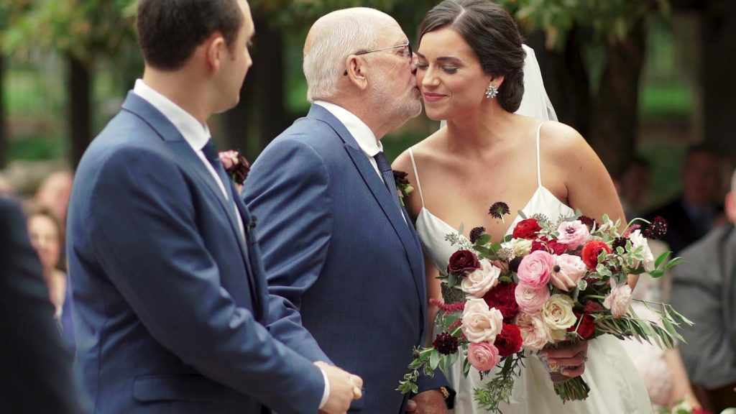Gus is allowed to kiss my beautiful wife Paulette.

