Fate  Inspired by a Captioned Image by Tiffany  By Maryanne Peters  Who was it who said it: “Accept the things to which fate binds you, and love the people with whom fate brings you together, but do so with all your heart.” A Roman Emperor, I think.  First: Drawing the compulsory costume out of the hat: “Bride”. There is no male equivalent. No swapping allowed.  Second: My girlfriend at the time was a bridal consultant. How about that?  “You cannot do this half-heartedly,” she said. “I have a reputation to protect.”  Was I fated to be small and slightly built? Probably genetics dealt me that hand. But I had my mother’s features. If I had my father’s features I would have been the ugliest bride on earth. If those genes are lurking inside me there is no chance of passing them on now. | 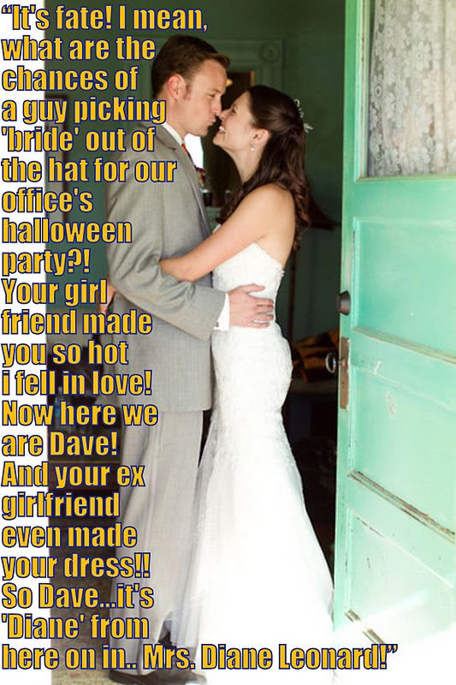

Karl Johnson saw me and came over, and he would not let me go. He spent the whole night introducing me to his friends as “Diane, my future wife”. It seemed like fun, but my girlfriend was not at all happy about it.

The wedding gown that I wore for that Halloween was just an old thing discarded after an aborted wedding, but I had one made for the real deal. My ex-girlfriend made that one too. We are still close even after all that has happened to me.

Karl would never let me go and finally he won me over. But he is not gay so surgery and hormones were needed to get me ready for the wedding. It was just that he was fated to fall in love with a person, not yet a woman. Once he loved me, he did so with all his heart.

And I was fated to return love in the same measure. With so much love who is going to let a little anatomy stand in the way?

The End

Fifties Girls  Inspired by a Captioned Image by Tiffany  By Maryanne Peters  Here is a story: Two guys, Glen and Ken, best of pals who never knew that they shared the same secret – they were really women underneath.  And not just women, but the kind of women that their grandmothers were – two very stylish women who were in their prime in the 50’s. Both men had learned from their grandmothers how women should dress and behave, and sadly in their own lives that had never met any woman who came close to those ideals.  And then, over few beers the conversation turned to the lack of class displayed by their wives and by modern women in general.  “You should see what my wife proposes to wear to that 50’s party next month. It is simply awful. Not something I would wear.” | 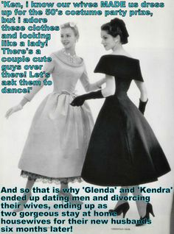

So there it was, the unspoken at last spoken. But the response was equally surprising: “Nor me. I think we would make much betters fifties girls that those hags.”

It was simply a question of steering their wives into thinking that cross-dressing their husbands for the party was their idea. It was so easy. What would fifties men be wearing anyway? Cardigans, pipes and partings?

Now that they were being MADE to dress up. It their call to get it right. Real hairstyles, real skin treatments, and a secret prescription that would go some way to softening them in the weeks prior to the costume party.

“A simply time, the fifties. Good skin with not too much make up. A good hairdo and a great frock. That is how we play the game.”

“Quite right Kendra, but the real secret is to know our place. We exist to attract and please men, and to give them everything they desire.”

“Are you really ready for that, Glenda? I have never even kissed a man before.”

“Do you want to?”

“God, yes. So much it hurts.”

Even well before the party their wives became worried. Their husbands were going way over the top, but now refusing to back down, saying that it was their idea and that prizes were at stake. On the night neither woman wanted to accompany their overtly effeminate husbands.

But no matter, as far as Glenda and Kendra were concerned those women were dead weight. And it happens the women were spared further embarrassment.

It was not that Glenda and Kendra threw themselves in front of men.

“Such behavior is so typical of modern women and shows a distinct absence of class.”

“True femininity attracts men,” said Kendra. They were happy standing together chatting to one another and even dancing a little in a restrained and ladylike way.

How right they were. “You girls look like the real deal,” one of the men said.

“We are the real deal,” Glenda said. “True women in every sense but one. Women who know that the right man is to be honored and obeyed. Could that be you?”

“Nobody seems to want a housewife these days,” Kendra complained. “Somebody committed to the comfort and pleasure of her man.”

“In every sense but one?”

“Make honest women out of us and that little thing will be gone quicker than a spot on your shirt.”

And sure enough, within just six months it was.

It seems that for every old fashioned woman there is a old fashioned man. Perhaps more than one.

The End

© Maryanne Peters 2020

Take your Daughter to Work
Inspired by a Captioned Image by Tiffany
By Maryanne Peters

He told me about the ‘take your daughter to work’ day, and I wanted to go. My Dad works in TV and I have always wanted to be with him at the studio. It is just that his work is very particular about other people in the building, but it was being relaxed just for that day.

“I am sorry, Honey,” he said. “It is a female only thing. Mothers and daughters. No fathers allowed. That rules us out. I have checked already. I’m sorry. It’s a non-starter.”

“You can be a woman for the day Dad,” I said. “I am really good with makeup and that stuff. Please?”

I actually knew that my Dad had a cross-dressing thing going on. It was just the two of us now, so it is hard to keep secrets. He kept all of Mom’s clothes after she died, and various items were still going in the wash.

“Sweetie, that’s a crazy idea,” he said, but I could see that even the idea of it was a bit exciting. “I don’t have a wig or anything.”

“We can use Mom’s clip in extensions Dad. You hair has enough length. We just need a little of her hair color. I am sure that I can make it work. Would you do it for me Daddy? Would you take your daughter to work by being like Mom for a day?”

I may have had a tear in my eye when I mentioned Mom. I often did. Him too. When we are both a bit sentimental like that neither of us can so no to the other.

Dad had to pretend to be a secretary named Joanne. He could use his pass card but walk in with me as his daughter. He could then go right up to his boss and say: “Hey it’s me, John, and this restricting daughter days to mothers only is just unfair.”

In the wardrobe was a suitable black skirt and white blouse, but I needed to get the shoes in his slightly larger size online with his credit card.

“Those are crazy high!” Dad said.

“But they will make your legs look fantastic,” I explained. Tell me if I am not right. And with those extensions cascading down Joannes’s back, and the makeup I had done looking like a professional job, ‘she’ was ready.

I know that he was loving it. I really don’t understand cross-dressing, but I figure that being able to walk around as a woman unnoticed has to be the ultimate.

He did go up to his boss to reveal himself, but I don’t recall Joanne making any progress. One of the junior guys working in the studio offered to show me around, and being closer to me in age I was happy to go with him, and so was Joanne to see me in his company. That left Joanne in the company of her boss, who seems like a nice guy.

I sure hope he is, because Joanne is Joanne full time now, and from next week we are moving in to live and Her boss’s house.

The End

*© Maryanne Peters 2020

Drag Race
Inspired by a Captioned Image by Tiffany
By Maryanne Peters

I don’t know anything about cars. They are just not my thing. My thing is art. Drag is an art form. That is my thing.

I didn’t even know that a drag race was about two automobiles driving down a length of roadway in front of a grandstand. All I saw was that it was an afternoon evening thing, there were big prizes, and everybody would be wearing black.

I just thought: ‘That’s me. The short black dress will be perfect for day and evening, and I can wear my lace elastic top stockings and my cool Jackie O sunglasses. I thought that I would be sure to win one of those prizes.

Now I felt a real dick. No, I mean there is a first time for everything, and now I have felt a real dick. A real man’s dick.

He was just so nice. I mean, a sissy boy turns up at some petrol-head convention would sure look out of place, but he was in charge of security so before I could make a complete fool of myself he had pulled me to one side to tell me how much he liked my stockings, or their contents.

You don’t get to head the security team at something like that without being tough, and having him as my protector made it so easy for me. He just told me not to embarrass him by acting gay. He said: “Just pretend to be a real woman. Pretend to be my woman.”

So, I did, and after a while I was no longer pretending.

I mean hanging on his arm while he explained all about carbonators and sparky plugs and everything, became fun. And maybe the fear that I might be found out and he would be there to protect me had something to do with it. I discovered that when you are with a man who is so strong and smart, you find yourself feeling weak and dumb, and soooo feminine.

Well, normally I just like to look like a girl, not be a girl. But with him it was different.

He said that he liked the top of my stockings, but he was worried that if his hand went up too far he would find something he didn’t like. I have to say that for the first time I wished that I had a muff there instead. I wanted his hand up there to cup it, maybe even finger me a bit.

So I offered to give him a hand job – just my little way of saying thank you for a wonderful day.

But the day turned into an evening with all the drag-racing guys and all their girlfriends, and he wanted more, and I wanted to give more. So then it was a blow job in his car and my first taste of a man.

Then the evening became a night at his place, and what more can someone like me offer?

All of this from a little misunderstanding. Sure, I feel stupid, but that is the way he likes me.

The End

Thief
Inspired by a Captioned Image by Tiffany
By Maryanne Peters

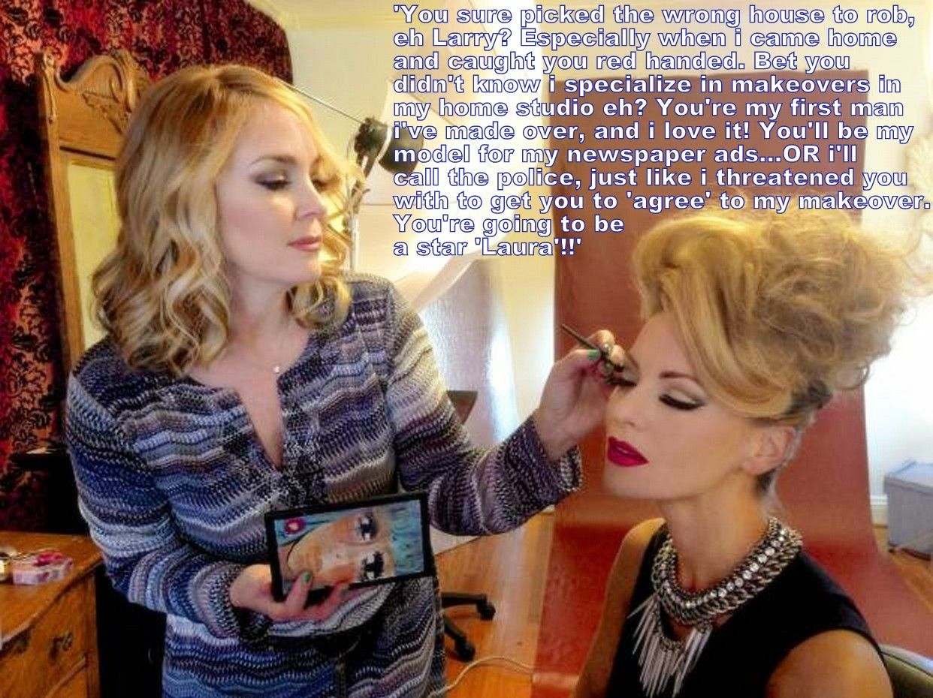

I am just a petty thief. I am not a violent person. Quite the opposite. I am so small and slight that I can slip through gaps that nobody would think a person could squeeze through. I never break in – I slide in.

It was the old story: I watched her leave. It was a warn night and the window was securely locked with only a small gap – but big enough for me. I made my way to her bedroom. But she had left her earrings behind. I did not even notice them on the dressing table. I was so excited I did not even hear the front door. Then she was in the room, and I was done for.

She pointed out that there is video. A camera in a stuffed toy, or so she said. On the cloud, or so she said. She could have called the police and it would be over for me. Two strikes down. Why can’t I give this up?

“You have such long hair,” she observed. “A such a long slender neck for a man. With a neck like that you should be wearing jewelry rather than stealing it.”

I just felt weaker than usual and sat of the edge of the bed. My fate was in her hands. I would wait for the wail of the sirens, doubtless to be followed by my own wailing when I stood to be locked up with rapists. I seemed hardly worth telling her of my sad prospects, but I muttered something pathetic.

“I have a proposal for you,” she said. “I am in the makeup business. I actually have a beauty studio out the back. I am looking for models where I can show a total transformation. If you agree to a makeover and to using the before and after images in my advertising, I will not call the police.

Anybody in my position would have agreed to it. What is the downside? And it my particular case it was the answer to my prayers. I tried to sound a little reluctant, but inside I was overjoyed. I paused, mumbled, then I agreed.

She was and colored my hair, curled it and pinned it up. She shaved and plucked the hair on my face and set about applying makeup with great skill. She was right, I had no idea that she was in this business. Just a lucky break I guess. I had something to trade and I would avoid the police becoming involved.

She showed me myself in the mirror. Her efforts were not only transformational but transformative. You can look at me – I was changed. But the change changed me. Before I had been one person, and now I was something else completely.

Did I say I was a petty thief. I meant a panty thief. But when you have your own, you don’t need to steal.

The End

© Maryanne Peters 2020

Author’s Note:
Now you know the punchline, perhaps read it again.

