Kasumiko’s Birthday Party

It was the 10th December and Kasumiko was totally Happy because she has Birthday tomorrow and she invited all of her Friends to a Birthday Party and she also can’t wait to get her third Tail tomorrow.
Kasumiko: “Tomorrow it’s my birthday. Yaay! I just can’t wait to see all the Others and what they would say to my third Tail when they see it growing. ^^”
And with that Kasumiko is getting everything ready for tomorrows Party.
The Next Day
Kasumiko is getting ready for the Party and just make the last adjustments in the Room when suddenly the Doorbell Rings. Kasumiko walked to the Door and opened it. It was Akira as always; she was way too early but that doesn’t bother Kasumiko instead she was Happy to have already one of her friends here.
Kasumiko: “Oh! Hi Akira you’re a little bit early as always. ^^”
Akira: “Yeah, I know. But you know I hate it to come too late to a Party. Especially when it is a Birthday Party for a good Friend. ^^”
Akira: “Anyway, Happy Birthday Kasumiko!” then Akira hugged Kasumiko and gives Kasumiko her Birthday Gift.
Kasumiko: “Thank you Akira” Kasumiko happily said.
Suddenly the Doorbell rings again and Kasumiko headed back to the Door and as soon as she opened it, she was greeted with a big “Happy Birthday!” from Ray, Rose and Mia.
The first one who hugged Kasumiko was Ray, then it was Mia’s turn and last but not least Rose.
Kasumiko blushed slightly and said: “Thank you all! ^^ And welcome to my Birthday Party!”
Then Ray said: “I have brought Rose with me I hope it’s okay for you. ^^”
Kasumiko: “Yeah sure the more the funnier the Party is. ^^”
Rose: “I know I wasn’t invited but Ray asked me to come with her and I thought yeah why not. ^^”
Mia: “Oh! Akira you’re already here too. ^^”
Akira: “Hi Mia, Ray and Rose. ^^”
Kasumiko: “Now that everyone is here Time for some Party Fun, but first we should eat something. ^^”
Then all goes to the Table with the Food and Kasumiko said: “I hope you like the Food that I have cooked for you. You can choose between fresh Ramen Soup, Sushi or if you don’t like Japanese Food, I also have made some Pasta and Salads. ^^”
Mia: “Wow Kasumiko I didn’t know you can make sushi yourself it looks delicious!”
Ray: “I want some of that Ramen please! :3”
Rose: “That Ramen looks really great, but I think I go with the Pasta and some Salad.”
Akira: “I take something from the Sushi and a bowl of the Ramen. Some Salad would be also nice.”
They all take their favorite Meal and eat it and they all having Fun with chatting to each other, then after the Meal it was Time for some Party Games. They had again another couple of hours of fun doing them and then it was Time for Kasumiko’s special moment.
Kasumiko: “O-oh my it is time already?”
Akira: “Time for what?”
Kasumiko: “Y-you will s-see it soon.”
Mia: “Huh what’s happening with Kasumiko?”
Ray: “W-wait isn’t she a Kitsune Girl? I think she gets another Tail because it’s her Birthday. >//////<”
Rose: “Oh that’s interesting. I never have seen a Kitsune Girl getting a new Tail.”
Kasumiko: ”Huuuummmm…. This feels great!”
Suddenly a third fluffy Fox Tail was growing behind Kasumiko and she feels pure pleasure while it grows. It was a very Special Moment and normally she doesn’t like that people are watching at her, but she was ok with it today, because only her close Friends can see her getting her new Tail.
Then the growing stopped and Kasumiko said: “Wow! That was intense hello my third fluffy Tail! <3”
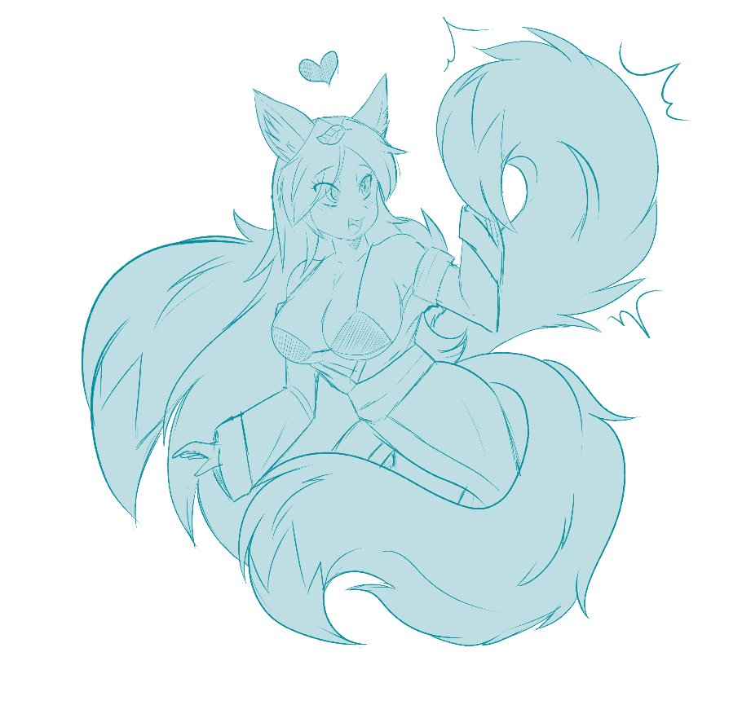

Kasumiko: “I hope you girls enjoyed the show. ^//////^”
Akira: “Wow! I didn’t know that getting a new Tail is such an intense feeling for you.”
Ray: “C-c-can I hug you Kasumiko? >/////<”
Rose: ”It really was an interesting show that you did for us.”
Mia: “Yay! Congratulations to your third Tail Kasumiko it really suits you.”
Kasumiko: ”Ok I’m glad you like my third Tail. But it’s late already and it’s Time for the Last game for tonight.”
After the Tail growing Action, they go to the last Game for Tonight it was called Fun with Masks.
“Ok Time for our last Game for Tonight it’s Called Fun with Masks I hope everyone has their Mask with her” said Kasumiko.
Ray: “Sure I have brought two Masks with me the Foxy Mask and Massa. Two Masks for two guests. ^^”
Mia:” Of course! Without the Mask I don’t leave the House. It’s too dangerous to keep it at home alone with Dan.”
Rose: “I’m glad Ray has brought two masks with her.”
Akira:” Yep I have mine with me too. ^^”
Kasumiko:” I have mine here too, but now we all throw our Masks in this Box then I will shake the Box and after that I place it in the middle of the Room and I turn the Light off so we can’t see the Box. The Goal of the Game is simple: Find the box, pull out one of the Masks and as soon the Light is turned Back on put it on.”
Akira: ”Ohhh that sounds interesting!”
Ray:” K-Kasumiko a-are you s-s-sure about that >//////<”
Mia:” It could make some chaos but it sounds like Fun not to know which Mask you get.”
Rose: “Why not it really sounds like Fun.”
Kasumiko:” Yes Ray I’m absolutely sure with that. Let’s give the Game a Try.”
And so, everyone throws her Mask in the big Box and Kasumiko shakes it carefully then she placed it in the middle of the Room and turns the Light off.
The Room was dark and Kasumiko said: “Ok who wants to pull out the First Mask?”
Akira: “It’s your Birthday why you don’t pull out the First Mask?”
Mia: “Yeah Kasumiko should pull out the First Mask. ^^”
Ray:” O-okay! If Akira and Mia want it that way why not.
Rose: “I’m fine with that idea.”
Kasumiko: “Ok then I go first then Mia, Ray, Akira and Rose.”
Kasumiko approached the Big Box slowly and pulls out the First Mask what she doesn’t know it was not the Mask of Loki that she has pulled out instead she pulled out the Foxy Mask from Ray.
Then it was Mia’s turn and she pulled out a Mask it was a Mask of Loki but she didn’t know that.
After Mia it was Ray’s turn and Ray Pulled out a Mask too luckily for ray it was her own Mask Massa.
Now it’s Akira’s turn and she pulled out a Mask of Loki too.
Last but not least it’s Rose’s turn and she pulled out the Last Mask.
Kasumiko: “Ok girls I hope you’re ready as soon as I turn the Light on with Alexa hold the Mask you got on your Face.”
“Alexa put the Light on!” Kasumiko said.
“Ok I turn the light on.” Alexa replied and with that the light goes on and every girl hold their Mask on her Face and then the Fun begins.
First it was Ray’s turn to get Transformed because Massa can’t wait to get on the Party.
Ray started to moan in pure Pleasure and she can’t hold herself and moans in pure pleasure: “Ohhhh Yessss! Massa give it to me!”
First Ray’s breasts become bigger and then her Butt too, after that Ray’s hair becomes longer and changed the Color to Blond then she gets two Fox ears and nine beautiful Foxtails. After the Transformation finished instead of Ray Massa was standing on the room and said: “Oh yes Baby! Time for Party action with my favorite Sexy Babes!”
Shortly after Ray’s finished Transformation into Massa it was Akira’s turn to get a hot upgrade. First Akira’s already big breasts got two cup sizes bigger and then shortly after that her Ass got bigger too. Then Akira started spinning into a green Twister and instead there stands a completely new Akira in the Room with a much sexier Bombshell figure and a beautiful Sexy Dress and she said:” Time for Party Girls!”.
Then it was Mia’s turn the Mask Jumped on her face and first Mia feels Pain but quickly starts to enjoy it and started to moan in pure please as her Breasts get two Cup sizes bigger and her Butt firms up. As Mia’s Twister stopped there stands an absolutely sexy Fox Girl in a sexy Silver Dress in the Room and she said: “Wow! Always a rush, but now I’m ready for some Party Fun!”
After Mia it was Rose’s turn to get Transformed by her Mask and at first Rose was in completely shock, she feels pain and tried to remove the Mask but without success then she started too fell pure pleasure an she moaned: “ Ohhhh! Yeeeeeesss!”
Rose’s already huge breasts got one Cup size bigger and her but firmed up too, in additional to that she got really sexy female Abs. Then Rose started to spin in a green Twister too and as soon as the Twister stopped there stand a different Version of Rose in the Room. Rose has now an even sexier Body and she wears a Sexy China Dress similar to that of Helena Douglas from Dead or Alive but of course without the Stockings and in Black. And the masked Rose said: ”Wow what a rush but I feel Awesome! Time for Fun Girls!”.
Last but not least it was finally the Turn of our beloved Birthday Fox Girl Kasumiko. First Kasumiko was shocked because instead of the usual pain she instantly feels an good amount of pleasure and then she realized it was not the Mask of Loki instead it looks like she got one of Ray’s Mask.
Kasumiko’s Breasts started to grow several cup sizes until she got an incredible E-Cup then it was the turn of her Butt to get bigger too. After that 4 more Tails growed behind her back but two of them where Blonde with Black Tips and two of them are Black with Blue Tips.
One of Kasumiko’s Tails changed the Color from Blue with Blonde Tips into Black with Blue Tips the other two stayed the same as the were before. Then Finally Kasumiko got two sexy Succubus wings too and shortly after that Kasumiko can’t hold anymore in and cummed with a massive Orgasm and screamed: “Huuummmmm! Yeeeeesss! Yes Yeeeees! Im feeling awesome!” in pure pleasure. Shortly after that Kasumiko was engulfed in a green purple looking mini Twister and then after she stopped an Completely new Kasumiko stand in the Room and she said: “Oh yes´! That was great ok Girls time for some Party action with your beautiful Birthday Diamond!”
Masked Rose: “Wow! You look Hot Diamond I love your look!”
Masked Mia: “I’m ready to make the City unsafe I hope you Girls too. He Hee!”
Massa: “Oh Diamond my dear you turned out Awesome. Let’s have some Fun!”
Masked Akira: “All of you look really hot and ready for an unforgettable Birthday Party!”
Diamond (aka Kasumiko): “Ok Girls! Let’s go to the City and make the Clubs unsafe!”
With that all five sexy Goddesses rushed out of Kasumiko’s apartment and entered the first club then they headed from Club to Club and having extremely much Fun together and Diamond said: “This is the best Birthday Party ever!”
The End!

Thanks to RayDark letting me use her OC’s Ray, Rose and Massa and her two Masks.
Also an Big thanks to CourierDan for letting me use his OC Mia Deltoriis too.
And an Big thanks to you for Supporting me! It really means much to me.

